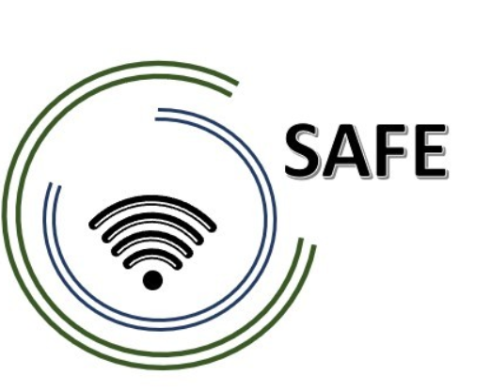

**SAFE**

**Streaming Approaches for Europe**

*Enhancing the digital competences by streaming approaches for schools to tackle the challenges of COVID-19*

**Online article 2**

UPB, Jennifer Schneider

**Project Title:** Streaming Approaches for Europe - *Enhancing the digital competences by streaming approaches for schools to tackle the challenges of COVID-19*

**Acronym:** SAFE

**Reference number:** 2020-1-DE03-KA226-SCH-093590

**Aktenzeichen der NA:**VG-226-IN-NW-20-24-093590

**Project partners:** P0 – UPB – University Paderborn, DE (Coordinator)

P1 – IK – Ingenious Knowlegde, DE (Partner)

P2 – CEIP – CEIP Tomás Romojaro, ES (Partner)

P3 – ZEBRA – KURZY ZEBRA s.r.o., CZ (Partner)

**Streaming Meets School - The Erasmus+ Project SAFE**

**What makes distance learning and teaching successful?**

The Erasmus+ project SAFE ("Streaming approaches for Europe - Enhancing the digital competences by streaming approaches for schools to tackle the challenges of COVID-19"), funded by the European Union, takes on the task of answering this question!

The main objective of the SAFE project is to create a basic concept for the integration of eLearning into daily teaching units. In this basic concept, teachers use tablets or laptops on which, for example, Blackboard applications such as LiveBoard, Doceri or Explain Everythings are streamed. Learners can thus participate in lessons despite spatial separation by streaming the voices of the classroom and the Blackboard application. Nevertheless, the SAFE project aims to provide online teacher training on how to successfully implement streaming approaches.

**But what makes learning successful now?**

One thing we can already say, s there are several factors that contribute to the success of distance learning and teaching:

Flexibility: distance learning offers students and teachers more flexibility in terms of time and space. Students can learn and work when and where it suits them best. Teachers can also design their lessons and activities to fit students' needs and schedules.

Technology: The use of technology, such as video and audio tools, enables interactive and effective communication between teachers and students. The availability of online platforms and tools also facilitates the organisation and management of lessons.

Individualised attention: Distance learning allows teachers to provide individualised attention to their students, as they can more easily address individual needs and create personalised learning plans.

Autonomy: Distance learning also promotes students' autonomy and personal responsibility, as they have to take more responsibility for their own learning and work independently.

Accessibility: Distance education can also provide greater accessibility to education as it can be made available to students who are unable to attend traditional classes due to geographical or physical limitations.

**Want to learn more? Then follow us on social media and visit our project page! We look forward to hearing from you!**

Learn more about SAFE and stay up to date. Visit our website at https://safe.eduproject.eu/ or contact the project partner in your home country directly!