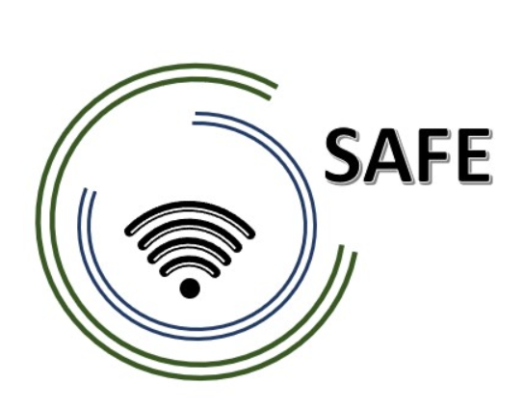
SAFE -Streaming approaches for Europe -
Enhancing the digital competences by streaming approaches for schools to tackle the challenges of COVID-19

Meeting Minutes for the 3rd SAFE partner meeting –
hosted by KURZY ZEBRA s.r.o., Czech Republic
The SAFE implementation and development Meeting!
27th - 29^{td} of June 2022

Meeting Minutes
Date: 27th – 29th of June 2022
Meeting-Room: Zebra Language School Chudim, Czech Republic
Participants: Marc Beutner, Niclas Grüttner, Tim Kreuzberg, Rasmus Pechuel, Maria Jesus Lopez Fernandez, Alberto Copeiro Del Villar Verdejo, Soňa Nekvapilová, Alexandra Izraelova

Name of transcript writer: Niclas Grüttner

Tuesday 28th of June 2022 –
Workshop day!
Approx.  Time | Topic | Chair
10:30 – 10:45 | Welcoming the SAFE Partners  (Soňa Nekvapilová / Marc Beutner)  - Warm welcome  - Schedule of the meeting | UPB / ZEBRA
10:45 – 11:15 | Status of the SAFE project  (Marc Beutner)  - Rationale, purpose, and aims of the project  - Insights into the DISK approach  - Project Website, Discussion, and Q&A | UPB
11:15-11:45 | Status of the SAFE at the partner organisations – Dissemination and integration  - 5 Minute PowerPoint presentation: Every partner presents the activities at the own institution in a max. 5 minutes  - Discussion | CEIP / ZEBRA
11:45-13:00 | Insights into Zebra school  (Soňa Nekvapilová)  - Having a short trip round the school | ZEBRA
13:00-14:00 | Lunch

14:00 – 16:00 | Creation of Statement videos concerning the SAFE project  (Rasmus Pechuel)  - Shooting Statement videos  - Discussion  - To ZEBRA: It would be great if you could provide a video camera. | UPB / CEIP / ZEBRA / IK
16.30 – 17:00 | What´s laying ahead of us? - Next Steps  (Marc Beutner) | UPB
17.00 – 17:30 | Project Evaluation  (Marc Beutner)  Workshop evaluation | UPB
19:00 | Social Dinner

Welcoming the SAFE Partners

- The meeting agenda is presented and explained to the partners.

- A short introduction about the intellectual outputs is made. The National Agency has cut down several IO’s as the validation of the project as well as the implementation and testing of the IO’s.

- The interim report is finished and was send to the National Agency. By now, it has to be approved. The problems such as the cut down of the IO’s has been critically revised in the report. Marc is waiting for feedback now. He thinks it will be provided at the end of July. As soon as the feedback is published, Marc will provide the partners with detailed information.

- The partners have to talk about the SAFE-Handbook. What should be part of it and who creates what parts? A first idea about the handbook does already exist, it must now be sharpened.

- Statement videos should be created at the Meeting where some insights of the project should be given to a broader audience. Some Videos have already been produced about the DISK approach or streaming platforms.

Current status of the SAFE project

- An overview of the intellectual outputs is provided. Ingenious knowledge is providing a website for IO2 and IO3 which are nearly completed. Unfortunately, the National Agency deleted IO1 (Acceptance of eLearning and streaming in school education in times of COVIUD-19), IO4 (Implementation and evaluation at schools) as well as IO7 (SAFE – Policy Paper and Layman’s report learning with streaming tools).

- According to IO5, first videos are already produced. The partners are asked to produce videos of a length of 2-5 minutes and provide them until October/November, as well as the first drafts of the handbooks.

- The handbook should be about 50-60 pages. Further information is given in “Next Steps”.

- According to IO2, the work is lead by the Spanish school. Three activities had taken place: The DISK-online approach was explained, a common streaming concept for schools was developed and finalised in a third activity. Right now, a fourth activity regarding the publication is in progress.

- IO4 is deleted, so, IO5 is in the middle of the making. The main part is to publish the videos, but in the moment, Paderborn University is in the middle of making the videos.

- IO6 has not been started yet, but further information about the structure of the book follows.

- IO7 has been cancelled by the NA, so, it is kept out of the project.

- The DISK-approach has to be described for the handbook. Therefore, it would be good that the partners provide videos about how learners and teachers deal with the streaming at home and in the classroom. So, learner- and teacher related videos have to be produced under IO5.

- In the handbook, some screenshots should be provided in order to see how the approach is used. Therefore, it would be helpful to see some students at home and seeing some interaction as chats or other interactive aspects (e.g. Twitch, YouTube, or other platforms that fit into the concept could be used).

- The focus needs to be on the production of the videos and the handbooks.

Status of the SAFE at the partner organisations – Dissemination and integration

SAFE Approach Implementation at language school ZEBRA (CZ)

- Zebra decided to host guest from different countries (Zebra teachers) to utilise the SAFE approach for the needs of the language school and to student’s benefits. Two days were set up, one with a guest from Cuba and the other one with a guest from the Philippines. The streams were of a duration of about 52 minutes and an average of 31 people were watching at one. But more than 100 people which did not belong to the Zebra language school were watching, which shows the potential of Twitch. The second time, less people showed up to the stream.

- The biggest challenges of the projects are not only the access and connection to the internet, but also the technical furnishing of the streamers and participants. As the teachers might not have a gaming computer, Twitch would not have worked. Another challenge was the delay of the video/audio as well as the interruptions due to network problems.

- Feedback was received after the streams from different participants via E-Mail.

SAFE in CEIP (Spain)

- In February, the 2nd meeting took place in Spain. At first an Scape Room was tried with the students, but it did not work out very well. Unfortunately, the lessons (online/presence)

- Stream lab was also shown to several teachers as to help the, to access it.

- Difficulties laid in the internet connection at the student’s side as well as the technical furnishing.

- Further plannings were made during the meeting to connect with Zebra language school somewhere in September to do an online meeting with students of both of their courses, when the new courses start. They are planning on providing some information to the project then.

Administrative and financial information

- The next SAFE TPM is taking place in Cologne 08th – 10th of February 2023

What is laying ahead of us? – Next steps

- IO5 is now starting. After the meeting, the statement videos are being published and some dissemination is done with the videos. The Spain partners are translating their video from Spanish into English.

- IK and UPB provided the first parts of the SAFE streaming concepts. The translations for ES and CZ need to be submitted to UPB.

- For IO3 the translations are being checked and feedback is provided after it has been revised by UPB.

- The handbook is going to be about 50 pages. Translations for it are requested from the partners until the 1st of February

- All partners should add their additional didactic materials as well as the creation of their interactive online tasks (H5P)

- The handbook (IO6) is a short explanation about the SAFE-approach as well as the DISK-approach. A first draft of the SAFE book is as followed:

- Table of contents
- Overview on the current situation under COVID-19

- Overview on the DISK-Online approach

- Overview on the streaming for Schools European Concept

- Insights in the acceptance research
  - the chances and challenges of the teacher training SAFE course
4.2 the SAFE teacher training curriculum
4.3 Evaluation results of the SAFE Implementation

- A Step-by-Step guide to enter Streamlabs OBS and the streaming platform
5.1 Challenges and Chances
5.2 Future development

- Etc.

- Multiplier events start at the 1st of October 2022 until the end of the project and are listed as followed:

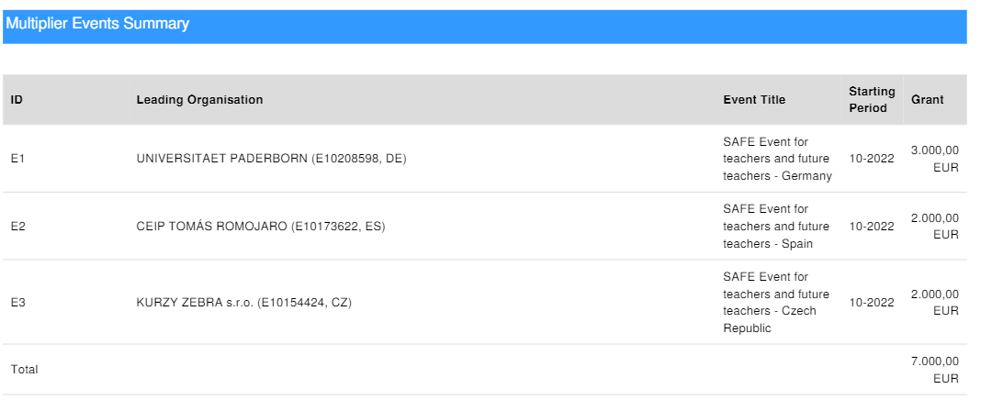

- The best would be to adjust the Multiplier events before the 4th TPM in 2023

- UPB is providing the participants list to all the partners

