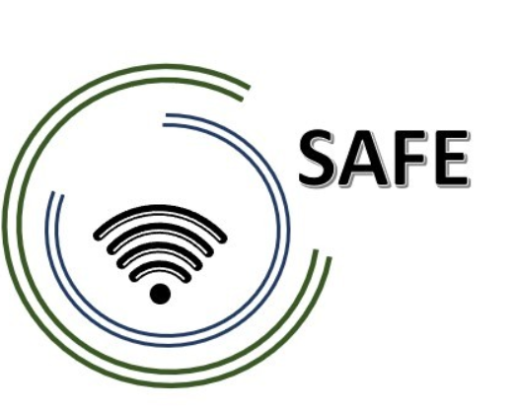

SAFE
Streaming Approaches for Europe
Reference Number:
2020-1-DE03-KA226-SCH-093590
Aktenzeichen der NA:
VG-226-IN-NW-20-24-093590

Video Script
February 2023

University of Paderborn
Jennifer Schneider

Project Title: Streaming Approaches for Europe
Acronym: SAFE
Reference number: 2020-1-DE03-KA226-SCH-093590
Aktenzeichen der NA: VG-226-IN-NW-20-24-093590
Project partners: P0 – UPB – University Paderborn, DE (Coordinator)
P1 – IK – Ingenious Knowlegde, DE (Partner)
P2 – CEIP – CEIP Tomás Romojaro, ES (Partner)

SAFE SKRIPT for Livestreaming Platforms

In the past, live streaming was only possible with extensive prior knowledge and expensive equipment.

Thanks to technological developments in the past years, anyone with a mobile phone or a laptop can start a livestream at any time.

Learning content can best be replayed with a laptop, because tasks can be worked on together and digital content can be used.

If you want to start a livestream with your laptop or PC, you will face several challenges.

First, in addition to your computer, you need a microphone and optionally a camera. Once you have these devices, you're faced with choosing which program to use to curate your content.

The choice here is large and depends on the platform you use, such as Twitch, YouTube or TikTok.

Here you can see a selection of possible programs. In the following, we will focus on the currently free and comprehensive program Streamlabs OBS.

After you download the program, you choose on which platform you want to stream. After this you can adjust your streamed image and start streaming.

SAFE Video Streaming equipment

Working in groups:
Creating individual scripts for the SAFE Learning Videos
What aspects, focal points and special features should be considered in the video?

Sequence 0.35
What makes streaming so successful?
We need end devices
We need reporter / and moderators
We need internet
We need equipment and even a content

Sequence 0.53

Here it is important to be aware of background noises
See that no noise comes from outside
See that the light is greater, if not switch on the light and check how it looks like
Avoid echo in your recording

Check your equipment: Is everything working?
What do you need? Do you have enough battery?
Headphones, earphones can avoid the noise while streaming

Sequence 1.10
How does it work to stream via the internet?
First we need some technique equipment, then the WIFI, and then we can stream through the final device

Streaming over the internet works by breaking down audio or video data into small packets and transmitting those packets from a server to a client device over the internet, where they are reassembled and played in real time. This process allows for near-instant playback without the need to download the entire media file beforehand. The quality of the stream can be influenced by several factors, including the speed and stability of the internet connection, the compression method used for the media data, and the configuration of the server and client devices.

Sequence 1:22
How can you play with the light? Which is useful for your streaming?
Try to find out what light is the best option to spotlight your content.
How can you continue and what do we need next? Let's think about it

Sequence 1.37
Try to find the best position for your lights. Maybe you can avoid shadows by overnighting your working place.

Maybe a friend can help you and make a short test call with you

Sequence 1.52
Take care! If the light or the sun can be to bright i
It could destroy your video stream. This means your face will not be seen.
Make sure, your face and silhouette looks natural and not weird.

Sequence 2.10

So tu sum up: What is very important:
First make sure you have the equipment and devices to stream.
Than check the sound, and avoid noise

And at least/ finally have a closer look at the light. Avoid over tightening and bright sun.

Congratulation – now you are well prepared to start your streaming

