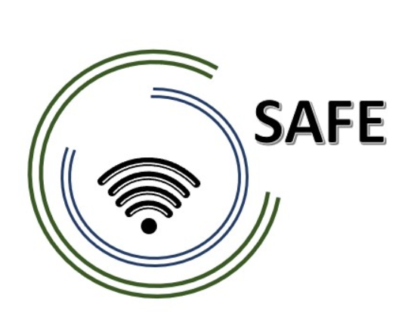
SAFE
Streaming approaches for Europe -
Enhancing the digital competences by streaming approaches for schools to tackle the challenges of COVID-19

Meeting Evaluation
Transnational Partner Meeting 4 – 8th of February, 2023

Project Title: Streaming approaches for Europe -
Enhancing the digital competences by streaming approaches for schools to tackle the challenges of COVID-19
Acronym: SAFE
Reference number: 2020-1-DE03-KA226-SCH-093590
Aktenzeichen der NA: VG-226-IN-NW-20-24-093590

Project partners: P0 – UPB – University Paderborn, DE (Coordinator)
P1 – IK – Ingenious Knowlegde, DE (Partner)
P2 – CEIP – CEIP Tomás Romojaro, ES (Partner)
P3 – ZEBRA – KURZY ZEBRA s.r.o., CZ (Partner)

Host: Ingeniouse Knowledge
Venue: Cologne, Germany

Internal Meeting Evaluation – Final Meeting in Cologne

Evaluation Results

 | Totally disagree | Partly disagree | Partly agree | Totally Agree | I don´t know | ∑
The conference lived up to my expectations. |  |  |  | 8 (100%) |  | 8
The conference objectives were clear to me. |  |  |  | 8 (100%) |  | 8
The difficulty level of this conference was appropriate. |  |  |  | 8 (100%) |  | 8
The conference contents were presented in an engaging way. |  |  |  | 8 (100%) |  | 8
The conference was interesting. |  |  |  | 8 (100%) |  | 8
The coordination was well prepared. |  |  |  | 8 (100%) |  | 8
The coordination was helpful. |  |  |  | 8 (100%) |  | 8
Overall, I am happy with the conference results. |  |  |  | 8 (100%) |  | 8
I have a clear picture now of the projects’ next steps. |  |  |  | 8 (100%) |  | 8
I know what my tasks for the upcoming period are. |  |  |  | 8 (100%) |  | 8

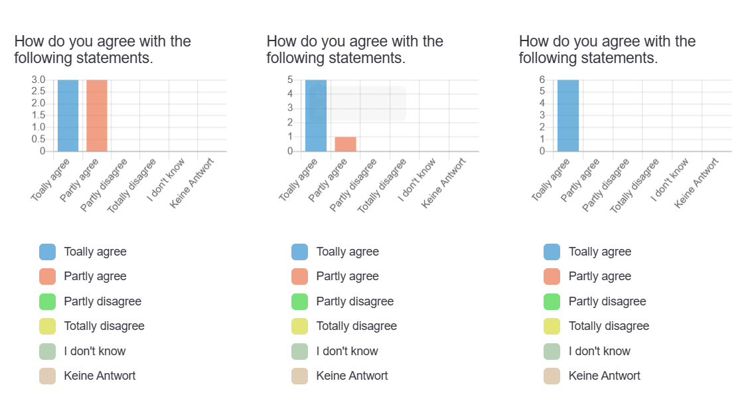

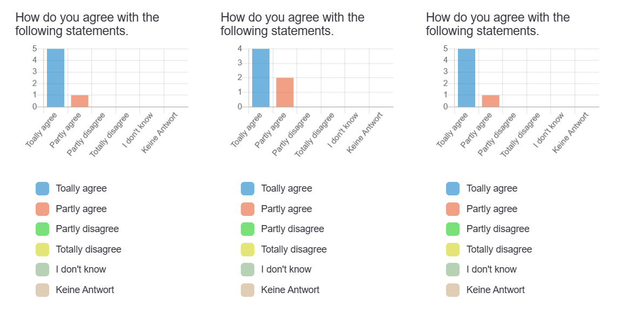

Summary:

Overall, the project is a great success, which is characterised not only by the results of the individual intellectual outcomes, but also by the communication and the generally good exchange within the consortium. The integration and implementation of individual steps and structures were implemented, tested and evaluated independently, unless they were financed by the project organisers. This is one of the outstanding strengths of this consortium!
We look forward to continuing to work in this constellation in the future!

