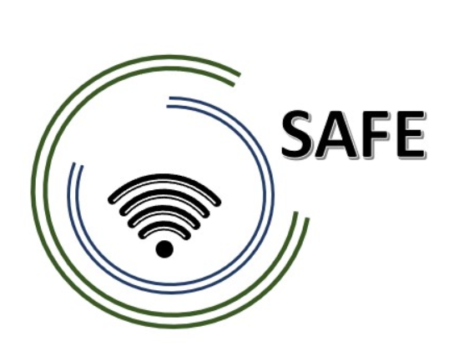
SAFE
Streaming approaches for Europe -
Enhancing the digital competences by streaming approaches for schools to tackle the challenges of COVID-19

Meeting Evaluation
Transnational Partner Meeting 3 -27th till 29th June, 2022

Project Title: Streaming approaches for Europe -
Enhancing the digital competences by streaming approaches for schools to tackle the challenges of COVID-19
Acronym: SAFE
Reference number: 2020-1-DE03-KA226-SCH-093590
Aktenzeichen der NA: VG-226-IN-NW-20-24-093590

Project partners: P0 – UPB – University Paderborn, DE (Coordinator)
P1 – IK – Ingenious Knowlegde, DE (Partner)
P2 – CEIP – CEIP Tomás Romojaro, ES (Partner)
P3 – ZEBRA – KURZY ZEBRA s.r.o., CZ (Partner)

Host: Zebra School
Venue: Face to face meeting in Czech

Internal Meeting Evaluation

 | Totally disagree | Partly disagree | Partly agree | Totally Agree | I don´t know | ∑
The conference lived up to my expectations. |  |  |  | 8 (100%) |  | 8
The conference objectives were clear to me. |  |  |  | 8 (100%) |  | 8
The difficulty level of this conference was appropriate. |  |  |  | 8 (100%) |  | 8
The conference contents were presented in an engaging way. |  |  |  | 8 (100%) |  | 8
The conference was interesting. |  |  |  | 8 (100%) |  | 8
The coordination was well prepared. |  |  |  | 8 (100%) |  | 8
The coordination was helpful. |  |  |  | 8 (100%) |  | 8
Overall, I am happy with the conference results. |  |  |  | 8 (100%) |  | 8
I have a clear picture now of the projects’ next steps. |  |  |  | 8 (100%) |  | 8
I know what my tasks for the upcoming period are. |  |  |  | 8 (100%) |  | 8

Summary:

All Partners are very happy about the coordination, the impacts and looking forward to continue the project!

