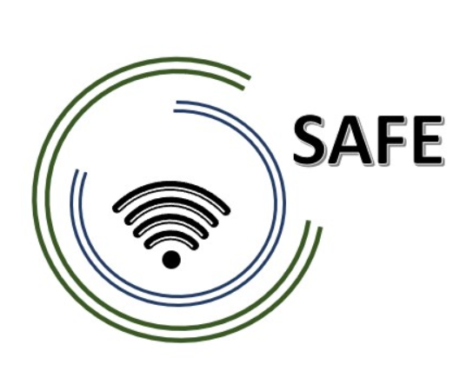
SAFE -Streaming approaches for Europe -
Enhancing the digital competences by streaming approaches for schools to tackle the challenges of COVID-19
M2 – Streaming Concept Meeting
21st to 22nd of February 2022
Meeting Minutes

Project Title: Streaming approaches for Europe -
Enhancing the digital competences by streaming approaches for schools to tackle the challenges of COVID-19
Acronym: SAFE
Reference number: 2020-1-DE03-KA226-SCH-093590
Aktenzeichen der NA: VG-226-IN-NW-20-24-093590

Project partners: P0 – UPB – University Paderborn, DE (Coordinator)
P1 – IK – Ingenious Knowlegde, DE (Partner)
P2 – CEIP – CEIP Tomás Romojaro, ES (Partner)
P3 – ZEBRA – KURZY ZEBRA s.r.o., CZ (Partner)

Host: CEIP Tomás Romojaro,
Venue: Santo Tomás de Aquino, 4; 45510 Fuensalida, Spain

SAFE – Streaming Concept Meeting – Meeting Minutes
Date: 21st to 22nd of February 2022
Start: 11 a.m.
End: 1 p.m.
Participants: Marc Beutner(UPB), Sebastian Koppius (UPB), Maria Jesus Lopez Fernandez (CEIP), Alberto Martinez Verdejo (CEIP), Rasmus Pechuel (IK), Soňa Nekvapilová (ZEBRA), Alexandra Izraelova (ZEBRA)
Name of transcript writer: Sebastian Koppius

These minutes include the main statements from the second SAFE – Streaming Concept Meeting. Due to the Corona Pandemic the Streaming Concept Meeting took place in a hybrid format. While CEIP; IK and ZEBRA met in Fuensalida, UPB had to participate online. Nevertheless, we had a great time with productive discussions and excellent results. These results are fixed in these minutes.

Topic 1: Welcoming SAFE partners
At the beginning, settings and arrangements for a good video transmission were set up.
Sebastian (UPB) and Maria Jesus (CEIP) open the meeting with a warm welcome.
Sebastian (UPB) presents today’s and tomorrow’s agenda:
Meeting agenda
- Welcoming the SAFE partners
- Current Status of SAFE in general
- Current Status of SAFE in the countries
- Theoretical introduction
- Workshop on the use of Streamlabs OBS
- Welcome to working day 2
- Workshop on the use of Twitch and the connection to Streamlabs OBS
- Administrative and financial information
- What’s laying ahead of us? – Next steps
- Meeting Evaluation

The agenda serves as a rough guide. However, Sebastian (UPB) also points out that agenda items can be exchanged if discussions and conversations make it necessary.

Topic 2: Current Status of SAFE in general
Sebastian (UPB) presents the Current Status of SAFE in general. He introduces each of the seven IOs on its own, even though IO1, IO4 and IO7 are not funded by the National Agency. Then he describes the current progress of the respective IOs.
IO1: SAFE- Acceptance of eLearning and streaming
- Completed IO including: Field-Based-Research, Desktop-Research and writing of a summary research report.

IO2: SAFE – The streaming concept for schools
- Completed an intensive exchange on the DISK-online approach
- The development of a common “European” streaming concept for schools is in progress

IO3: SAFE – Teacher training course on Streamlabs OBS and use of streaming platforms
- Completed the creation of the teacher training curriculum.
- The Revision of the curriculum, technical issues and Publication of the teacher training course on Stream labs OBS is in progress

IO4: SAFE – Implementation and evaluation at schools
- Here we aim to implement the teacher training course and online support
- We also aim to implement the streaming in lesson with learners and the online support
- UPB will provide a short survey for this purpose shortly
- CEIP and ZEBRA are testing the DISK approach in 1-2 classes at their schools

IO5: SAFE – Creation of streaming videos, didactic materials
- Some didactic materials have already been produced. A streaming instructional video is also been developed in the workshop of TPM2

IO6: SAFE – The teacher handbook on the eLearning approach and the SAFE- Streaming-in-School-Education-book
- This IO starts next month. Soon UPB will provide with a first rough draft of the two books. The partners are welcome to add suggestions for improvements here or to contribute their own ideas for book chapters.

IO7: SAFE – Policy Paper and Layman’s report learning with streaming tools
- Follows from the previous project results

Topic 3: Current Status of SAFE in the countries
The project partners Maria Jesus (CEIP) and Sona (ZEBRA) present their individual current status and activities. The following points are addressed
- Already done Dissemination activities (social media, newsletter, online article, poster)
- A deeper understanding of the DISK approach
- Translation of teacher training modules in relation to IO3
- Question: The QR code on the poster is not working at the moment
The presentations of the respective partners are uploaded to the project website and to the google Drive folder. Take a closer look when you get the chance.

Topic 4: Theoretical Introduction
Sebastian (UPB) presents a short review of the DISK approach to bring everyone back to the same level of knowledge.
The topics were:
- 2020-2022: European Education meets the COVID-19 Pandemic
- Possible Solution: Mobile Learning
- The DISK-Online Approach (in total)
- Basic structure of the DISK approach
- Dealing with groups in the DISK approach
- DISK 1
- DISK 2
- DISK 3
- DISK 4
- DISK Streaming in class
- DISK Streaming from home
- DISK with several schools
- DISK and the technical requirements
Marc (UPB) continues the presentation with an overview of using streamlabs OBS in relation to the DISK approach.
He introduces
- What is Streamlabs OBS?
- A selection of possible – Streaming Software
- Streamlabs OBS in details
- How to stream on Streamlabs OBS
- Insights into Streamlabs OBS
- And finally, why do we need a program like Streamlabs OBS?
Next, he presents first introduction using twitch and the connection to Streamlabs OBS in relation to the DISK approach.
- What is twitch?
- Insights into Twitch
- Why Twitch of all places?
- And finally, why do we need a platform like Twitch?
Marc (UPB) also makes it clear that the presentation served as an introduction. What is really important is to try it out on your own and gain your own experience.

Topic 5: Workshop on the use of Streamlabs OBS
Rasmus (IK) explained to the SAFE participants how to use Streamlabs OBS in relation to the DISK approach with a step by step guide.
He helps the SAFE project partners individually with the implementation. And dealt individually with questions and problems.

Topic 6: Welcome to working day 2
Maria Jesus (CEIP) and Marc (UPB) open the second working day with a warm welcome.
The partners report on their first experiences with Streamlabs OBS and the implementation of the DISK approach in schools.
As announced the day before, we still want to hold IO4 (Implementation and evaluation at schools), even though the IO was not funded by the National Agency.
Common next step

- CEIP and ZEBRA will try out the DISK approach in 2-3 classes for a few hours and briefly document their experiences.
- UPB will provide a short questionnaire for this purpose to facilitate the documentation

.
Topic 7: Administrative and financial information
Marc (UPB) briefly presents administrative and financial information.
The focus is on the PROM tool, whether there have been difficulties or questions in the preparation of timesheets.

Topic 8: Workshop on the use of Twitch and the connection to Streamlabs OBS
Rasmus (IK) explained to the SAFE participants how to use Twitch and Streamlabs OBS in relation to the DISK approach with a step by step guide.
He helps the SAFE project partners individually with the implementation. And dealt individually with questions and problems.
The partners also took the opportunity to ask their questions with a time delay to the last workshop.
.
Topic 9: What’s laying ahead of us?
To Do-List
Organizational matters
- Please send us a scan of your employment contract as proof for the national agency
- Make sure you fill in your timesheets
Related to the project activities
- CEIP and ZEBRA will try out the DISK approach in 2-3 classes for a few hours and briefly document their experiences.
- UPB will provide a short questionnaire for this purpose to facilitate the documentation
- UPB will provide a first rough draft of the two books.
- The partners (CEIP, ZEBRA, IK) are welcome to add suggestions for improvements here or to contribute their own ideas for book chapters.

Nevertheless, UPB would like to provide information for the next project steps. Difference to the previous meeting is that IO5 has started.

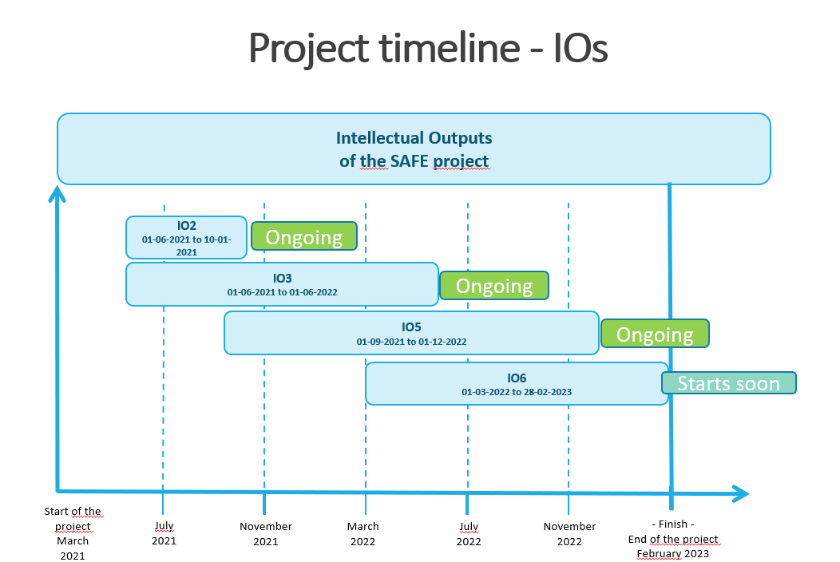

Workplan

Afterwards the tasks and deadlines regarding the IO1 to IO7 are summarised. Please have a closer look into the work plan. Here you can find more detailed information concerning the several tasks, deadlines and responsibilities within the IOs.
Following there is a condensed summary of the next steps:

Dissemination/ organisational activities
- Creation of continuously Dissemination activities like providing newsletter, developing posters as well as developing the project website further
- Creation of continuously Dissemination activities like posting on facebook, linkedin, twitter, instagram as well as offer further information on the project site
- Document the Timesheets in the PROM Tool (http://eduproject.eu/prom/login.php). If you have any questions regarding the PROM Tool or the documentation of Timesheets. Do not hesitate to contact us

IO2:
- Revision of the first version of a common streaming concept for schools
- Finalisation of the streaming concepts for schools
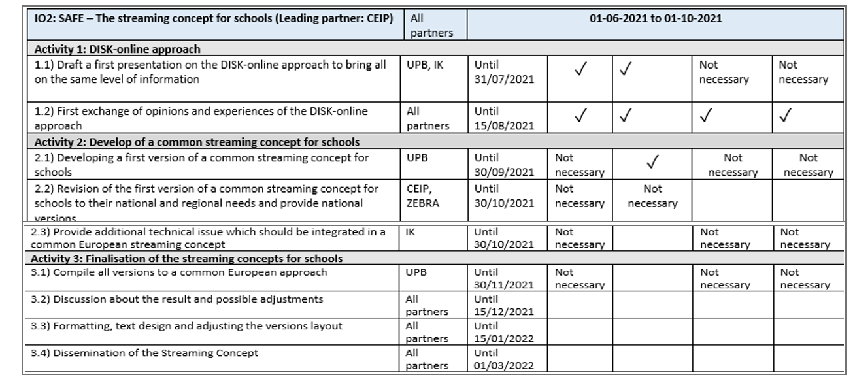

IO3
- Revision of the curriculum
- Technical Issue
- Publication
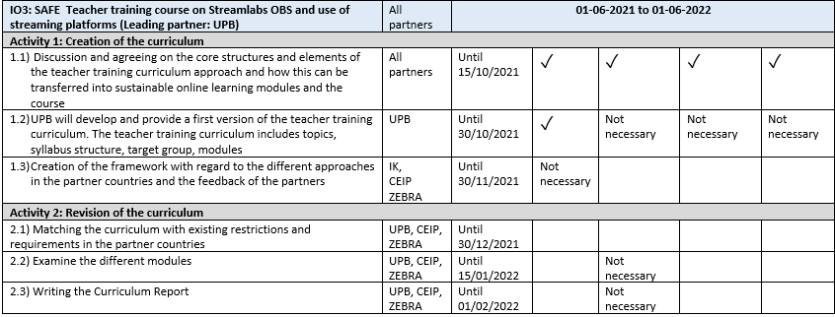
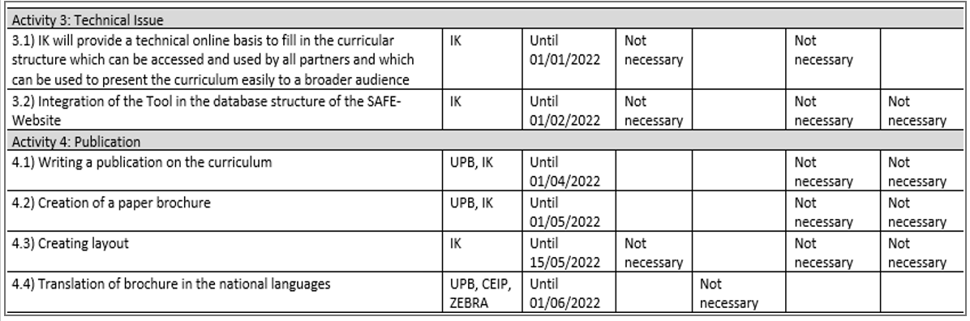

IO4
- Testing the common streaming approaches in schools ( CEIP & ZEBRA)
- Providing a short questionnaire for evaluation and collecting feedbak
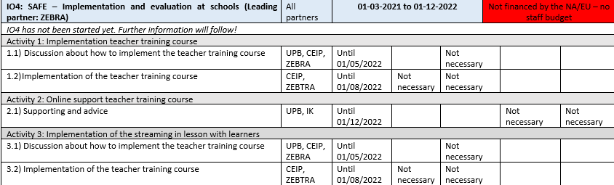
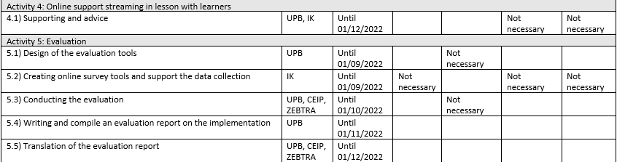

IO5
- Some didactic materials have already been produced
- A streaming instructional video is also been developed in the workshop of TPM2
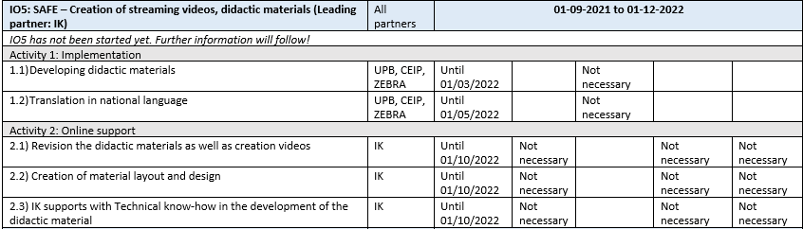
IO6
- UPB will provide a first rough draft of the two books.
- The partners are welcome to add suggestions for improvements here or to contribute their own ideas for book chapters.
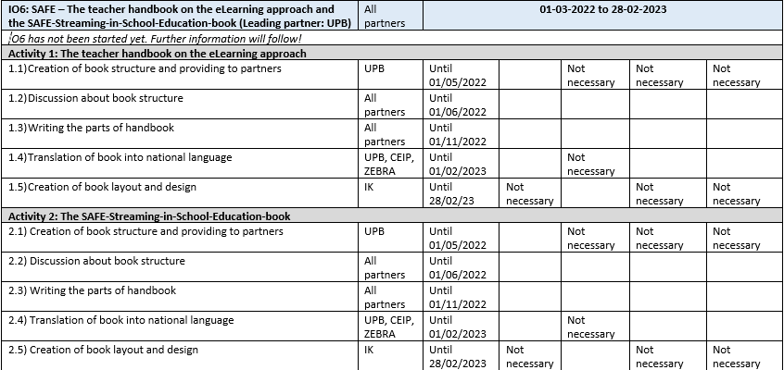
IO7
- IO7 has not been started. More information will follow!

Project timeline
Furthermore, UPB presents the Timeline of Transnational meetings, so that the partners know, when the next meeting will start in which country as soon as the Corona pandemic makes it possible.
- According to the plan, the third project meeting will take place from 27th – 29th of June 2022 in Czech Republic
- We would also like to schedule the last meeting already: Proposed is the meeting from 5th – 7th of December in Germany (Cologne)
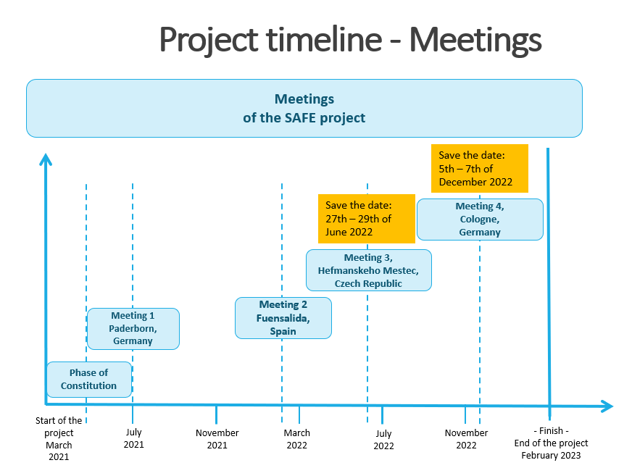

10: Meeting Evaluation
Sebastian (UPB) introduces the Meeting Evaluation. In order to improve and perhaps do things differently at the next meeting, we want to evaluate the meeting.
For this reason: https://umfragen.uni-paderborn.de/index.php/559342?lang=en
Please take 5 minutes and participate at our online survey.

Impressions:
