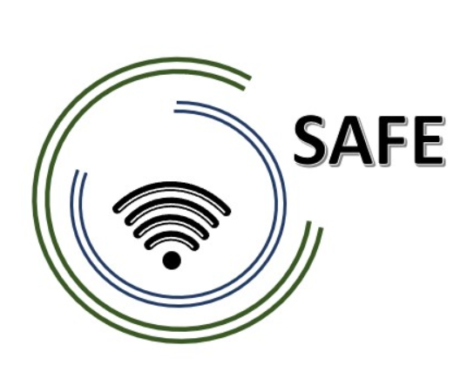

SAFE -Streaming approaches for Europe -
Enhancing the digital competences by streaming approaches for schools to tackle the challenges of COVID-19

Agenda for the 2nd SAFE partner meeting hosted by
CEIP Tomás Romojaro, Spain
The SAFE - Streaming Concept Meeting!
21st to 22nd of February 2022

Project Title: Streaming approaches for Europe -
Enhancing the digital competences by streaming approaches for schools to tackle the challenges of COVID-19
Acronym: SAFE
Reference number: 2020-1-DE03-KA226-SCH-093590
Aktenzeichen der NA: VG-226-IN-NW-20-24-093590

Project partners: P0 – UPB – University Paderborn, DE (Coordinator)
P1 – IK – Ingenious Knowlegde, DE (Partner)
P2 – CEIP – CEIP Tomás Romojaro, ES (Partner)
P3 – ZEBRA – KURZY ZEBRA s.r.o., CZ (Partner)

Host: CEIP Tomás Romojaro,
Venue: Santo Tomás de Aquino, 4; 45510 Fuensalida, Spain

Sunday, 20th of February 2022 – or Monday morning 21st of February 2022
Arrival day
Approx.  Time | Topic | Chair
as you like | Arrival at the hotels in Toledo

Monday 21st of February 2022–
Workshop day!
Approx.  Time | Topic | Chair
13:00 –  13:15 | Welcome Coffee
13:15 – 13:30 | Welcoming the SAFE Partners  (María Jesús Lopez Fernandez/ Marc Beutner)  - Warm welcome  - Schedule of the meeting | CEIP/UPB
13:30 – 14:00 | Status of the SAFE project and insight into the DISK approach  (Marc Beutner / Rasmus Pechuel)  - Rationale, purpose, and aims of the project  - Insights into the DISK approach  - Project Website, Discussion, and Q&A | UPB / IK
14:00 – 14:30 | Status of the SAFE at the partner organisations – Dissemination and integration  - 5 Minute PowerPoint presentation: Every partner presents the activities at the own institution in a max. 5 minutes  - Discussion | all
14:30 – 18:00 | Workshop on the use of Streamlabs OBS  (Marc Beutner / Rasmus Pechuel)  - Each partner has to work online with a computer to get accustomed to Streamlabs OBS (Internet Connection required)  - Discussion | UPB / IK
20:00 | Social Dinner

Tuesday, 22nd of February 2022–
Workshop day!
Approx.  Time | Topic | Chair
09:15 – 09:30 | Welcome to working day 2  (María Jesús Lopez Fernandez/ Marc Beutner)  - Warm welcome  - Discussion on open questions of day 1 | CEIP/UPB
09:30 – 12:00 | Workshop on the use of Twitch and the connection to  Streamlabs OBS  (Marc Beutner / Rasmus Pechuel)  - Each partner has to work online with a computer to get accustomed to Streamlabs OBS (Internet Connection required)  - Discussion | UPB / IK
12:00 – 13:00 | Administrative and financial information  (Marc Beutner / Rasmus Pechuel)  - Project management structure  - Insight into PROM and discussion on open questions  - Discussion on Interim Report and Final Report | UPB / IK
13:00 – 13:30 | Lunch
13:30 – 14:30 | What´s laying ahead of us? - Next Steps  (Marc Beutner)  Workshop evaluation | UPB
14:30 – 15:00 | Project Evaluation  (Marc Beutner)  - Workshop evaluation | UPB

Goodbye,
and let´s start into the next phase of our SAFE project!

