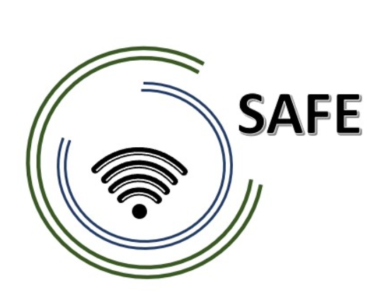

SAFE -Streaming approaches for Europe -
Enhancing the digital competences by streaming approaches for schools to tackle the challenges of COVID-19

Agenda for the 4rd SAFE partner meeting –
hosted by Ingenious Knowledge, Cologne Germany
The SAFE Final Meeting!
7th to 9th of February 2023

Project Title: Streaming approaches for Europe -
Enhancing the digital competences by streaming approaches for schools to tackle the challenges of COVID-19
Acronym: SAFE
Reference number: 2020-1-DE03-KA226-SCH-093590
Aktenzeichen der NA: VG-226-IN-NW-20-24-093590

Project partners: P0 – UPB – University Paderborn, DE (Coordinator)
P1 – IK – Ingenious Knowlegde, DE (Partner)
P2 – CEIP – CEIP Tomás Romojaro, ES (Partner)
P3 – ZEBRA – KURZY ZEBRA s.r.o., CZ (Partner)

Host: Ingenious Knowledge, Cologne Germany
Venue: Friedrich-Karl-Straße 200, 50735 Cologne, Germany.

Monday, 7th of February 2023 – Arrival day
Approx.  Time | Topic | Chair
as you like | Arrival at the hotels in Cologne

Tuesday 8th of June 2022–
Workshop day!
Approx.  Time | Topic | Chair
10:30 | Welcome Coffee | IK
10:30 – 10:45 | Welcoming the SAFE Partners  (Jennifer Schneider / Rasmus Pechuel)  - Warm welcome  - Schedule of the meeting | UPB / IK
10:45 – 11:15 | Presenting the SAFE Handbook  (Jennifer Schneider/ Rasmus Pechuel)  - Information about printing | UPB / IK
11:15-12:00 | Presenting the SAFE Learning Videos  - Showing the SAFE YouTube Channel | UPB
11:45-  12:15 | Presenting the Dissemination Report  (Jennifer Schneider) | UPB
11:15-  13:00 | Presenting the Teacher-Training-Platform on the SAFE Project Website  (Jennifer Schneider) | UPB
13:00-14:00 | Lunch
14:00 – 15:00 | Administrative and financial information  (Jennifer Schneider / Rasmus Pechuel)  - Preparing of the Final Report  - General questions  - Timesheets | UPB / IK
15.00 | Project Evaluation and open questions  (Jennifer Schneider) | all partners

Wednesday, 9th of February 2023–
Departure day!
Approx.  Time |  | Topic |  | Chair
 |  | Have a good journey home / Alternative: Lunch
Goodbye,
and let´s start into the next phase of our
SAFE project!

