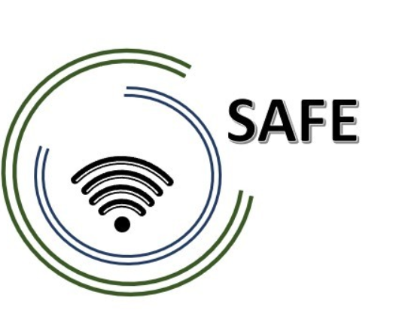

SAFE
Streaming Approaches for Europe – Enhancing the digital competences by streaming approaches for schools to tackle the challenges of COVID-19

O3 Unterrichtsmaterialien
Aspekt (3): Streaming Environment
Module 8
Jennifer Schneider

Project Title: Streaming approaches for Europe – Enhancing the digital competences by streaming approaches for schools to tackle the challenges of COVID-19
Acronym: SAFE
Reference number: 2020-1-DE03-KA226-SCH-093590
Project partners: P1 University Paderborn (UPB), DE
P2 Ingenious Knowledge GmbH (IK), DE
P3 TOMAS ROMOJARO (CEIP), ES
P4 KURZY s.r.o. (ZEBRA), CZ

Classroom material

Aspect (3): Streaming Environment

Module 8: Easy school requirements: Technical and organizational requirements at school and for teachers

Learning- Outcome Matrix (LOM)
The purpose of these information and charts are to illustrate how outcomes align with teaching and learning methods and assessments in the SAFE approach.

The following general aims and objectives are focused with the LOM:
This Learning Outcome matrix is designed to inform about the development of the curriculum structure to integrate Streaming and eLearning approaches in schools.
Focusing on a learning outcomes approach facilitates the tailoring of the pedagogic induction resources. This provides the possibility to suit specific cultural and societal values and ensures that local issues and necessary topics are addressed within the SAFE approach.

SAFE Learning Outcome Matrix for
teachers and trainers in schools
 | Outcome | Teaching and Learning Activities | Assessment
 | Having taken this course, participants (teachers/trainers) will be able to: | The participants (teachers/trainers) will be taught to achieve this specific outcome through the following learning activities: | The participants (teachers/trainers) will be assessed on their achievement of this specific outcome through the following assessment tasks:
 | The participants know the streaming platform Twitch. | They know their way around the platform and find a channel they are interested in. | Participants find a channel of their choice and discuss on the platform.
 | According to this learning material streaming environment, the participants (teachers): | Participants (teachers) are taught to achieve specific outcomes through the following learning activities: | The participants (teachers) are assessed on their achievement of the specific outcome in the following assessment task:
 | Participants find their way around the streaming platform Twitch and can watch a live stream of their choice. | While watching a video of their choice, they can describe what they see, why they think that person chose to stream on that topic and whether they would do so themselves. | With the help of these questions, participants should think about what live streaming is used for. They should ask themselves whether they would do this and argue their decision. The results should be discussed.
 | According to this learning material streaming environment, the participants (teachers): | Participants (teachers) are taught to achieve specific outcomes through the following learning activities: | The participants (teachers) are assessed on their achievement of the specific outcome in the following assessment task:
 | Participants will be able to reflect on the advantages and disadvantages of live-streaming in general and in school. | By filling in two tables, they can find arguments for advantages and disadvantages. The participants learn to position themselves. | The advantages and disadvantages should be discussed and complemented if necessary.

