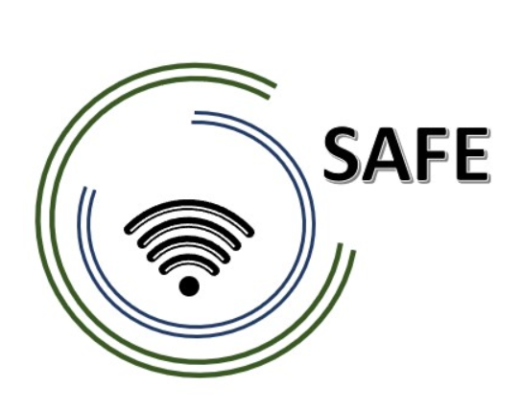
SAFE
Streaming approaches for Europe -
Enhancing the digital competences by streaming approaches for schools to tackle the challenges of COVID-19

Agenda for the first SAFE Online partner meeting hosted by University of Paderborn, DE
The SAFE -KICK-OFF-Conference!
8th of July 2021

Project Title: Streaming approaches for Europe -
Enhancing the digital competences by streaming approaches for schools to tackle the challenges of COVID-19
Acronym: SAFE
Reference number: 2020-1-DE03-KA226-SCH-093590
Aktenzeichen der NA: VG-226-IN-NW-20-24-093590

Project partners: P0 – UPB – University Paderborn, DE (Coordinator)
P1 – IK – Ingenious Knowlegde, DE (Partner)
P2 – CEIP – CEIP Tomás Romojaro, ES (Partner)
P3 – ZEBRA – KURZY ZEBRA s.r.o., CZ (Partner)

Host: University Paderborn, Chair Business and Human Resource Education II
Venue: Online Meeting via ZOOM

ZOOM Invitation

Thema: SAFE Kick- Off Online Meeting
Uhrzeit: 8.Juli.2021 09:00 AM Amsterdam, Berlin, Rom, Stockholm, Wien

Zoom-Meeting beitreten
https://uni-paderborn-de.zoom.us/j/94112252488

Meeting-ID: 941 1225 2488
Schnelleinwahl mobil
+16468769923,,94112252488# Vereinigte Staaten (New York)
+16699006833,,94112252488# Vereinigte Staaten (San Jose)

Einwahl nach aktuellem Standort
+1 646 876 9923 Vereinigte Staaten (New York)
+1 669 900 6833 Vereinigte Staaten (San Jose)
+1 253 215 8782 Vereinigte Staaten (Tacoma)
+1 301 715 8592 Vereinigte Staaten (Washington DC)
+1 312 626 6799 Vereinigte Staaten (Chicago)
+1 346 248 7799 Vereinigte Staaten (Houston)
+1 408 638 0968 Vereinigte Staaten (San Jose)
+49 30 5679 5800 Deutschland
+49 69 3807 9883 Deutschland
+49 695 050 2596 Deutschland
+49 69 7104 9922 Deutschland

Meeting-ID: 941 1225 2488
Ortseinwahl suchen: https://uni-paderborn-de.zoom.us/u/atM6n0FD4

Über Skype for Business beitreten
https://uni-paderborn-de.zoom.us/skype/94112252488

Thursday, 8th of July 2021 – Meeting Agenda Part I
Approx.  Time | Topic | Chair
09:15 – 10:15 | Welcoming the SAFE Partners  (Marc Beutner)  - Warm welcome  - Getting to know each other  - 5 Minute PowerPoint presentation: Every partner presents the own institution in a max. 5 minutes  - Schedule of the meeting | UPB/All partners
10:15 – 11:30 | The SAFE project  (Marc Beutner)  - Rationale, purpose, core ideas and aims of the project  - Role of the partners as per proposal  - Information about the Transnational Project Meetings  - Dates, responsibilities and content  - Overview of the Intellectual Outputs and linkages  - In detail: Focus on IO1, IO2, IO3 and IO4 | UPB
11:30 – 13:00 | The DISK- Online Approach  (Marc Beutner)  - The four DISK implementation levels  - DISK streaming in class  - Disk streaming from home  - DISK with several schools | UPB
13:00 –  13:30 | Lunch

Thursday, 8th of July 2021 – Meeting Agenda Part II
Approx.  Time | Topic | Chair
13:30 – 14:30 | Administrative and financial information  (Marc Beutner / Rasmus Pechuel)  - Project management structure  - Documentary evidence required  - Online finance and project management tool (PROM) | UPB/IK
14:30 – 15:30 | Dissemination and exploitation  - The SAFE project website  - Social Media Roster  - Publications, Newspapers  - Dissemination Plan  - Dissemination Report Template | All partners
15:30 – 16:00 | Project Evaluation  (Marc Beutner)  - Workshop evaluation | UPB

Goodbye,
and let´s start into a great
EDU-VET project!

Meeting Minutes
The first internal project meeting starts at the 08th of July at 9:00 o´clock. Form every partner consortium 2 or at least 3 partners participate the online meeting via zoom.

Zwischenreport/: 30.06.2022

- After a first warm welcome the partners start with a short 5 Minutes presentation to introduce their schools/ organization and partners who will working during the project lifetime in this international consortium.
- The SAFE project:
What intellectual outputs were completely primed by the NA: IO1, IO4 and IO7
Reason: No finance/ No financing for the staff costs

- IO1 SAFE (No finance/ No financing for the staff costs)
  - IO1: Short TAM Modell research
  - IO1-A2: Curriculum and Corresponding
  - IO1- A4 2 pager: What Streaming approaches are you using?

- IO2 SAFE Streaming concept for schools
    - l 01.10.2021
  - The DISK – Online Approach
    - The four DISK implementation levels:
Explaining in detail the DISK 1 / DISK 2 / DISK 3 and DISK 4 approach
- IO3 till IO7
  - explaining the tasks to do, responsibilities and information regarding deadlines etc.
- Administration information of SAFE
  - Prom Tool
  - Documentation of payslips, records etc. (internal documentations)
  - How to fill in the Timesheet
- Dissemination Activities and Plan
  - Introduction in the project and first activities

Some Impression of the Zoom Online Meeting

