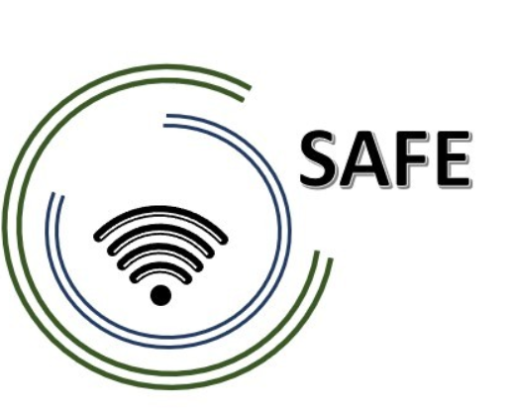

SAFE
Streaming Approaches for Europe – Enhancing the digital competences by streaming approaches for schools to tackle the challenges of COVID-19

IO6 SAFE – The teacher handbook on the eLearning
approach and the SAFE-Streaming-in-School-Education-book

Project Title: Streaming approaches for Europe – Enhancing the digital competences by streaming approaches for schools to tackle the challenges of COVID-19
Acronym: SAFE
Reference number: 2020-1-DE03-KA226-SCH-093590
Project partners: P1 University Paderborn (UPB), DE
P2 Ingenious Knowledge GmbH (IK), DE
P3 TOMAS ROMOJARO (CEIP), ES
P4 KURZY s.r.o. (ZEBRA), CZ

HANDBOOK
SAFE Streaming in School Education

Marc Beutner, Jennifer Schneider, Sebastian Koppius, Helene Lindenthal, Niclas Grüttner, Ilona Petsch, Tim Eickels

Marc Beutner

Soňa Nekvapilová
alexandra izraelová

Maria Jesus Lopez Fernandez
Alberto Copeiro del villar verdejo

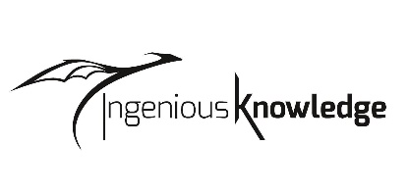
Rasmus Pechuel

Table of Content

A short introduction on behalf of the project coordinator Prof. Dr. Marc Beutner 1
1 About the SAFE Project Handbook 1
1.2 Introduction to the Erasmus+ Project SAFE 2
1.3 Introduction to the Erasmus+ Project Safe consortium 2
1.4 Short introduction to didactical background of the Erasmus+ project – The DISK Approach 3
2 Streaming in school in times of COVID- 19 4
2.1 Key skill areas, the DISK Approach and the use for the Erasmus+ Project SAFE 5
2.1.1 Key skill levels for local teachers 10
2.1.2 Key skill levels for local learners 13
2.2 Media formats for learning content 14
3 The SAFE Streaming for Schools European Concept 16
3.1 The SAFE teacher training curriculum 17
3.2 Insights into the SAFE Teacher Training Courses 19
3.2 Insights into SAFE teacher training Teaching materials for face-to-face teaching 23
3.3 Insights into the SAFE Teacher Training Courses 26
4 Blended Learning as part of eLearning 28
5 General information on dealing with adapted existing course structures 30
5.1 Redesign of existing course structure 30
5.2 Assessment framework for measurement of attainment 31
5.3 Pedagogic Supports for Streaming in school approaches 32
6 SAFE- Insights into the testing phases of the streaming for Schools European Concept 33
6.1 Insights into the testing phases of the Czech schools 33
6.2 Insights into the testing phases of the Spanish schools 40
References 46

List of figures

Figure 1: DISK- Online (total) – Beutner, M.; Pechuel, P. 2021b, p. 181. 3
Figure 2: SAMR-Model by Ruben Puentedura (cf. 2006 / cf. 18.06.2021) 9
Figure 3: (DigCompEdu 2021a) - Overview 12
Figure 4: SAFE Teacher training course on Streamlabs OBS and use of streaming platforms 19
Figure 5: SAFE – Teacher Training Module 7 Easy school requirements: technical and organisational requirements at school and for teachers I 20
Figure 6: SAFE – Teacher Training Module 7 Easy school requirements: technical and organisational requirements at school and for teachers II 21
Figure 7: SAFE Project Curriculum and Competence Profile 22
Figure 8: SAFE – Teacher Training Module – Classroom Materials 23
Figure 9: SAFE Classroom Materials 24
Figure 10: SAFE teacher training Teaching materials for face-to-face teaching 25
Figure 11: SAFE - Learning Outcome Matrix 26
Figure 12: SAFE- Learning Outcome Matrix. 27

A short introduction on behalf of the project coordinator
Prof. Dr. Marc Beutner

Streaming is becoming crucial in European education. With regard to the challenges of the Covid-19 Pandemic, and the impact of it to the field of school education, it is clear that teachers al over Europe face a new situation concerning remote teaching and digitisation issues. The Erasmus+ project SAFE-Streaming in school education takes these challenges for teachers for serious. Due to the fact that not all learners and teachers are always able to take part in the lessons in face-to-face manner, a discussion about the use of conferencing tools like Zoom, Teams, WebEx etc. and the need to stream educational activities and courses to different places and learners, was increasing. The SAFE approach, provided in this handbook, is based on the DISK approach created by Beutner/Pechuel (2020) and has to be adapted to the curricular situations in the different European countries as well as to the needs of European teachers.
When working on international projects, it can sometimes be tedious to keep everyone who is involved in the project up to date with the processes, and to make sure that the work orders are always carried out on time and with care. This was not the case in the SAFE project. Therefore, I would like to express my sincere thanks to all the people involved in the project, first and foremost my colleagues, who were also contact persons for the partners in the project at all times and contributed to the fact that the coordination of the project succeeded so well.
The outcomes of the project have proven to be excellent and can be used for follow-up projects. The different options of the DISK approach could be adapted to the international situations and proofed as an perfect opportunity to deal with today’s challenges. Therefore, I especially have to thank our school partners for the national adjustments, the testing in the partner countries, the feedback, and the amazing collaboration.
SAFE offers a tool and concept which can easily be integrated in European school education and supports both target groups, teachers and learners. Moreover, it is an important contribution to a sustainable way of improving pedagogical approaches in European school education and helps European educators to work on a common basis and to foster the competences of European learners.
Enjoy reading this handbook and using the SAFE approach also in your contexts.

Paderborn, December 2022
Marc Beutner

1 About the SAFE Project Handbook

The handbook 'SAFE Streaming in School Education' contains information about the project, implementation, a checklist for teachers, guidance for teachers, survey as well as evaluation results and insights into the innovative SAFE concept. An acceptance study in the partner countries to get a European overview of acceptance, experiences, problems and opportunities in the fields of eLearning and streaming in school education, will also be part of the SAFE project. The main target groups are teachers, learners and educators.

The SAFE Handbook about eLearning approaches and the SAFE Streaming Approach:
  - provides information about innovative learning processes using streaming at school.
  - Provides hints, help and guidelines which will be available on the book market.
Target group: teachers, trainers and schools as well as all interested readers about streaming approaches in school

About the basic structure of the SAFE manual:
All documents and content are licensed under the Creative Commons licence CC- BY SA and can be used, distributed, edited, remixed or modified without further restrictions.
Further information on the use of Open Educational Resources under a Creative Commons licence can be found on the website:
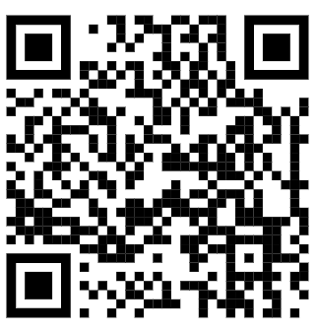
https://creativecommons.org/licenses/?lang=en.

1.2 Introduction to the Erasmus+ Project SAFE

COVID-19 affects the daily work in all schools. In the current situation, strongly marked by the impact of contact restrictions due to the Corona pandemic, it is clear that schools at all levels, i.e. primary, secondary and upper secondary, are facing the challenge of teaching in online formats.

The Erasmus + SAFE project addresses this new and innovative way of learning and teaching in the age of digitalisation and COVID-19 and is located in the school education programme area of ERASMUS+.

The partnership raises awareness of the need for a didactic approach to eLearning. SAFE's approach focuses on the use of streaming in school education. The project is working on a basic concept for integrating e-learning into daily classroom work.

In this basic concept, teachers use tablets or laptops on which, for example, Blackboard applications such as `LiveBoard`, `Doceri` or `Explain Everything` are streamed, with the information on these devices and the teacher's language streamed directly to the learners. In this way, teachers can implement familiar teaching formats, such as writing on the blackboard or on an overhead projector in a similar way and provide explanations and embed them didactically. Participation can optionally take place online via a live stream or by creating a recording that is later available and viewable on a server (as a repository) via a video or film for learners at any time.

1.3 Introduction to the Erasmus+ Project Safe consortium

The Erasmus+ project SAFE is a European project that consists of different partners. Each partner has been selected to fulfil a specific role and at the same time task in the project. For example, the IT partner 'Ingenious Knowledge' was selected for the technical implementation of the project, as it already has several years of experience in the implementation of digital strategies in education. For the project, this partner, in addition to technical integration, can therefore also show didactic understanding and the specifics of the challenges that they can handle. Furthermore, the consortium consists of two schools that already deal intensively with the difficulties of distance learning and teaching. They are testing the SAFE concept with their students and give us insights into the observations of their work.

The project team is rounded off with the University of Paderborn, with the chair of Prof. Dr. Marc Beutner, who is responsible for the entire didactic development of the training, learning concepts, materials and recommendations for action. His team, consisting of young scientists, supports the schools and cooperates with the technology partner, so that a holistic digitalization concept for distance learning could be developed.

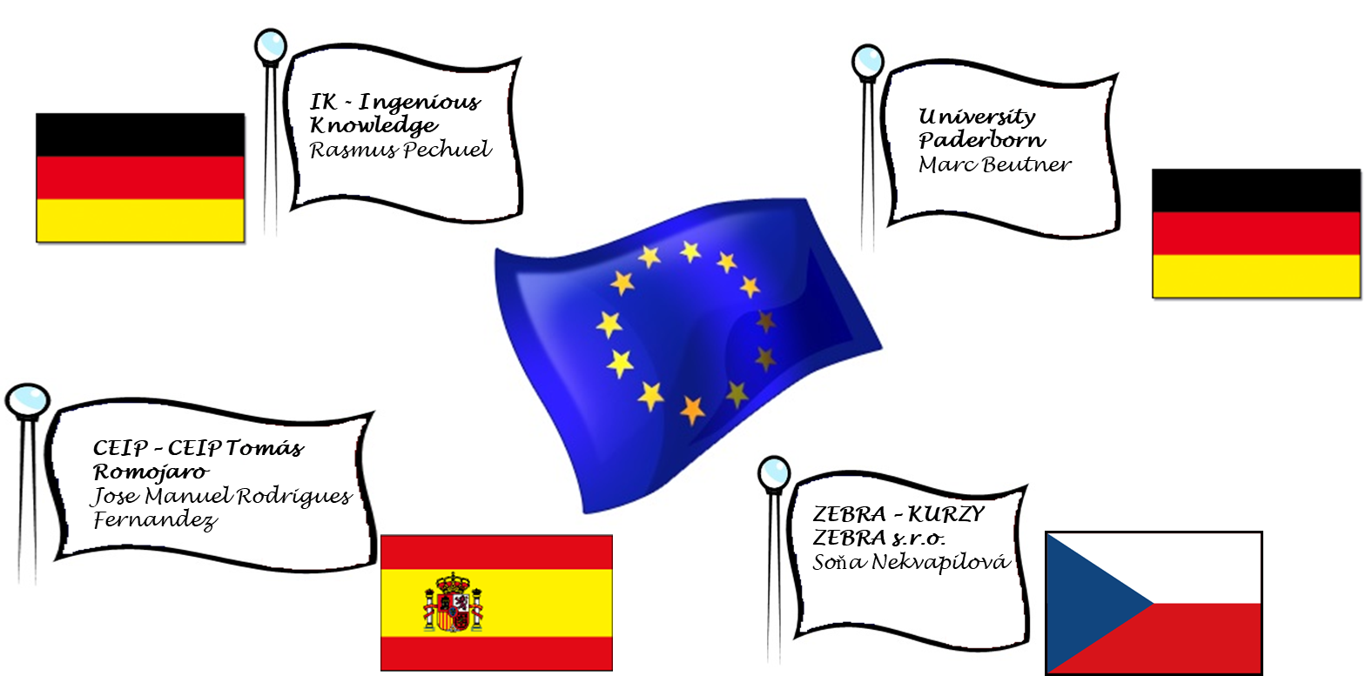

1.4 Short introduction to didactical background of the Erasmus+ project – The DISK Approach

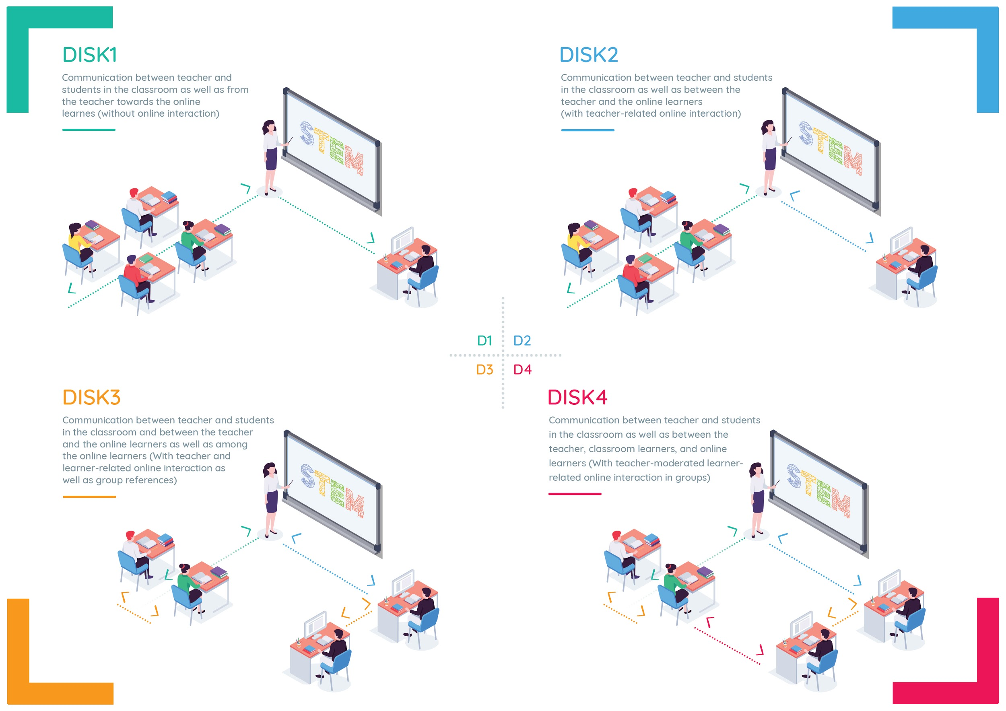
The SAFE streaming concept is created on the basis of the DISK-Online model. DISK-Online stands for Didaktisch-Interaktives-Streaming-Konzept-Online (DISK-Didactic-Interactive-Streaming-Concept-Online). This approach was developed to deal with the challenges of COVID-19 and the technological challenges for schools and education.
Figure 1: DISK- Online (total) – Beutner, M.; Pechuel, P. 2021b, p. 181.
The DISK-Online model by Beutner, M. Pechuel, R. was already presented to the Ministry of Education (NRW) in October 2020 and was presented to the German Bundestag (Enquete Commission for Digitalisation) in November 2020. The DISK online approach was developed and tested in 2020 under the constraints of COVID-19 and was successfully presented at the SITE Interactive Conference USA and the Innovate Learning Conference USA in 2020. The feedback was excellent and the first implementations in schools brought excellent results and support from teachers and learners.
The DISK online approach is aligned in its basic design in terms of 4 scenarios with increasing levels of interaction. Increasing interaction is described in the DISK approach from DISK1 (low teacher-centred interaction) to DISK4 (learner-centred interaction) and can be used in different schools to adapt teaching to technical constraints and digital literacy. Teachers need an approach that can be used in the classroom with learners who are

(a) not all present in the classroom or with learners who are
(b) only partially present in the classroom or that is geared towards teachers
(c) who want to add e-learning elements to their teaching method portfolio now and in the future.

The SAFE project, using Streamlabs OBS and the streaming platform Twitch, is creating an approach that teachers can use to overcome the challenges of COVID-19 and integrate eLearning. And this is done in a sustainable and transferable way in school education and in the classroom. Teachers are trained in the use of Streamlabs OBS and the streaming platform as part of the SAFE project. In addition, multipliers are also trained. This is a way of dealing with e-learning where learners only need a browser and no specific technical or e-learning knowledge, and teachers implement a rather simple approach to deal with new demands.

2 Streaming in school in times of COVID- 19

The COVID-19 pandemic prompted a digitisation shift in schools and universities.
In Germany, attempts were made to continue teaching both at schools and universities, although distance regulations and hygiene rules became more and more stringent. For this reason, online and hybrid teaching formats were introduced.
In Online Learning, the whole class is at home and is trained by the teacher. Hybrid learning is a combination of learners learning on-site, e.g. in a classroom or lecture hall, and learners participating from home via a computer (cf. Heinrich 2021). Here, teachers had to become creative themselves and to come up with suitable didactic implementation strategies. There was no uniform proposal or model, however.
A great difficulty for the students who attended the lessons from home was to keep their motivation and attention high. Sitting in the children’s room at home from 8 a.m. to 4 p.m. doing schoolwork, playing video games or reading exciting books instead, required a huge potential of discipline and motivation from many students. It is more motivating for the students to follow the lessons via stream instead of working on worksheets independently. Especially because in their free time, the students themselves like to watch streams or even stream themselves while playing video games, assembling something or learning by doing tutorials. The streaming platforms YouTube and Twitch deserve special mention. These are very popular with the students and becoming more and more popular.
In addition, in times of COVID-19, the social contacts of many students have minimised and diminished. Students who previously saw each other every day in the classroom and interacted with each other, have not seen each other for a long time.
Often the lessons were not designed for exchanging ideas with classmates.
All in all, a digital concept is needed that motivates students, promotes interaction and can be used flexibly, especially with regard to the different competences of teachers and students as well as different teaching formats.

2.1 Key skill areas, the DISK Approach and the use for the Erasmus+ Project SAFE

What key competencies are focused on in the
teacher education curriculum?

During the project lifetime of SAFE, we have dealt with this question and have come across the following concepts:

- MUDRA's competence concept (cf. MUDRA 2004, p. 364)
- HEYSE's and ERPENBECK's competence concept (cf. ERPENBECK & HEYSE 2004, p. XXI)
[Both concepts are already considered in the curriculum of teacher education].

The focus should also be emphasized in a hybrid learning format on the digital competence. The Media Competence Framework NRW (2018, p.4), for example, can be used for this purpose. When designing digital teaching/learning arrangements, the Media Competence Framework NRW provides a systematic overview. The Media Competence Framework NRW (cf. 2018, p.4ff) is divided into six areas. The teacher must take the six areas into account when planning their lessons with digital elements for the pupils on site, and especially for the pupils who follow the lessons online.

Within the framework of the SAFE project, the DISK (Didactic Interactive Streaming Know-how) -online approach of Beutner and Pechuel from 2020 is focused on hybrid learning and therefore offers opportunities for eLearning which combines face-to-face learning with online learning via a streaming concept. The DISK model consisting of four stages, which are also called DISK1 to DISK4. The different DISKs indicate different levels of interaction and digital settings (cf. Beutner & Pechuel 2020a; 2020b; 2021, p. 163).
In relation to Beutner and Pechuel’s DISK-Online approach, teachers need to deepen the six previously mentioned areas when designing their long-term teaching arrangements (see chapter 2.2).
In the following, exemplary individual sub-items for the six areas are mentioned, which are relevant fort the implementation of the DISK approach

- Operate and apply –
- Is the media equipment of the students (PC, webcam, microphone, stable internet connection) and the teacher (webcam, tablet, recording programs, etc.) sufficient for the planned use of online teaching?
- How will the data created online be stored?
- Is data protection and information security guaranteed?

- Inform and research
- Are students given enough time to research information?
- The exchange of information among the pupils must be initiated (at the beginning certainly controlled by the teacher).
- What needs to be considered when evaluating information?
- How are students prepared for fake news and information selection?

- Communicate and cooperate
- Should only the students from the online group chat with each other and the others can talk to each other normally?
- Are groups mixed? Do you have to raise your hand before you are allowed to speak?
- Can they also talk on the phone or video chat with each other?
- What are the communication rules?
- How practicable are the communication rules and how do they prepare students for private communication on Facebook, Instagram etc.?
- How can you prevent cyberbullying?

- Produce and present
- Both teacher and students need to be able to create and share presentations to show their results.
- Also, design functions of media should be known and used reflectively.
- The teacher in particular, but also the students, should handle the use of materials from the internet carefully and record all sources.
- Aspects of the legal basis, especially when using images, must be made clear and addressed.
- This includes aspects of personal rights, rights of use and copyright.

- Analyse and Reflect
- All participants in the DISK-model should be aware of the diversity of media, their development and meanings.
- Nevertheless, when providing materials and videos, the teacher must be aware of the interest-driven setting and dissemination of topics in the media, and in in relation to the formation of opinion asses.
- The identity-creating opportunity to express oneself creatively through media (the students can become creative in the DISK approach for example, through pictures, symbols, music, and videos).
- The teacher has to draw attention to the unlimited spread of media and the assessment of what should be spread and what not to his/her students.

- Problem solving and modelling
- The DISK approach also prepares for an increasingly digital world in the future. It allows to identify basic principles and functions of the digital world.
- Makes algorithmic structures comprehensible, which is very important for professions related to digitalisation 4.0.
- It can be combined with actions skills or occupational references to develop problem strategies.

While the aforementioned Media Competence Framework NRW provides a good overview of the functionality and diverse application perspectives of digital media in the classroom in general, the SAMR model by Ruben Puentedura (2006) can be used in relation to the DISK model as well.
At this point it must be said that Ruben Puentedura’s SAMR Model (2006) is not a model that is suitable for science. It has only proven to be very practicable and has enjoyed high recognition in teaching practice in recent years due to its simple illustration (cf. Braun 2019, p.6).

SAMR is an acronym for the four components:

The higher the level, the higher the digital use in the classroom. In the following, the four levels are presented in ascending order of digital use.

At the lowest level, it starts with the simple replacement (substitution) of analogue tasks/materials with digital representations. As example, Puentedura lists reading digitized text or using a computer instead of a typewriter (cf. Puentedura 2006). This does not bring about any functional improvements, only the representation or the medium changes. At this level, the use of digital media can be practiced. In addition, digital content is available for further use.
An enhancement becomes visible on the second level augmentation. Basic functions such as a grammar and spell checker or the cutting and replacing of content can be used. The integration of technologies also plays a role. Multimedia content (textual, auditory, visual) can be linked and embedded. Puentedura lists, for example, the creation of digital maps and a combination with interactive timelines (cf. Puentedura 2006).
The area of transformation of tasks begins at the level of modification. Tasks that could also be set in analogue form are reformulated in such a way that digital support is required and its advantages are to be used explicitly by learners. Any available software and hardware can be used. Puentedura lists as examples the integration of communication tools (mail), spreadsheets, graphical representations as well as textual, visual and auditory tools. The social aspect an also come to the fore here. The mutual commenting on blog posts and the resulting discussion can be used to build shared knowledge. The focus here is on the redesign of assignments, considering the technical possibilities. The implementation is left to the teachers via the elaboration of concrete tasks (cf. Puentedura 2006).
Tasks that would not be possible without technological support are part of the redefinition level. Instead of writing essays, for example, digital storytelling can be chosen. This does not mean monotonous PowerPoint presentations in which one shimmies from slide to slide, but e.g. a combination of pictures and videos with which a story of the personally most excitingly perceived impressions and information is told. Tools for visualizing content that is difficult to understand can also be used here (cf. Puentedura 18.06.2021).

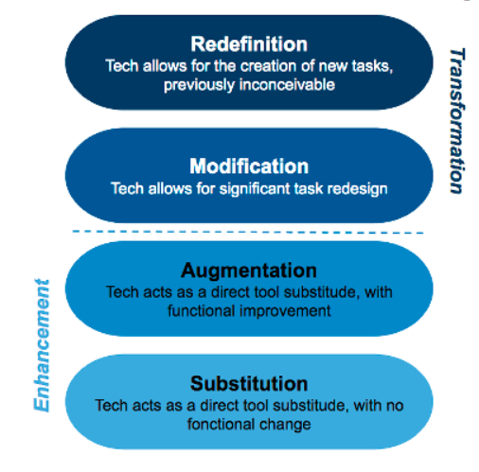
Figure 2: SAMR-Model by Ruben Puentedura (cf. 2006 / cf. 18.06.2021)

The DISK model by Beutner and Pechuel also aims at the levels of modification and redefinition. Overcome the barriers and draw from the advantages and benefits of digital tools. The technical possibilities with the help of apps, high performance computers and fast internet can promote interactions and modify school learning to a new level.

2.1.1 Key skill levels for local teachers

In general, regardless of the teaching format, teachers should have well-developed methodological, communicative, social and pedagogical skills, as well as the ability to reflect and, for example to question their actions or their teaching.

However, what needs to be more developed, especially in relation to a hybrid streaming approach, is the deepening of technical and digital skills. The German Conference of Ministers of Education and Cultural Affairs (in short KMK) describes ten points in which teachers should be able to teach when using digital elements (KMK 2017, p.26-28).

  - continuously develop their own general media competence, i.e. to handle technical devices, programs, forms of learning and workplaces etc. with confidence, to be able to carry out preparatory activities, also in collegial coordination groups, administrative tasks as well as the smooth use of digital media in lessons and the safe handling of data,

  - to recognize the importance of media and digitalization in the life world of pupils in order to develop effective concepts for media education and to support the acquisition of competences for the use of digital media in a didactically reflected and prepared manner,

  - to plan, implement and reflect on the adequate use of digital media and tools in view of changing individual learning requirements and communication behavior in the digital world. This includes a positive effect on individualized, self-directed and collaborative learning processes and results and open up new design possibilities overall,

  - the learning-theoretical and didactic possibilities of digital media for the individual and didactic possibilities of digital media for the individual support of individuals in and outside the classroom,

  - to choose from the large number of educational media on offer (open educational resources / OER) on the basis of appropriate quality suitable materials and programs for individual or group work, and to identify suitable materials and programs for individual or group work,

  - to support pupils in learning with and through media as well as in designing media, so that they can reflect critically on the growing range of media on offer and choose from them in a meaningful way and use them appropriately, creatively and socially responsibly,

  - on the basis of their subject-related expertise with regard to the planning and design of lessons to cooperate with other teachers and other school and non-school experts on the basis of their subject-related expertise in planning and designing lessons, and to develop and implement learning and support opportunities together with them,

  - to deal with the results of current research on education in the digital world
to take responsibility for their own competence growth and to use it for their own further education and training,

  - through their knowledge of copyright law, data protection and data security and the protection of minors in the media, and to enable pupils to deal consciously and thoughtfully with media and their own data in digital spaces.

In relation to the hybrid streaming approach, it is worth noting that few teachers cover all ten points straight away. These are not meant to be a deterrent, but rather to be highlighted as goals and an incentive to start the development process. Sharing experiences among colleagues, visiting each other’s classes and shadowing in class, taking advantage of further training opportunities and teaching teams are helpful here. Especially the last point regarding the knowledge of copyright law, data protection and data security are important, but its specific to each country and many teachers forget the direct rules.

Another method of assessing teachers' digital competences is described below.

At the European level, the DigCompEdu (The European Framework for the Digital Competence of Educators) project was outstanding. The DigCompEdu project is a project funded by the European Commission and investigated digital competences of teachers. They have identified 22 digital competences from 6 categories, which are divided in 3 areas. In the following, the 3 areas as well as the 6 categories are illustrated (cf. DigCompEDU 2021a).
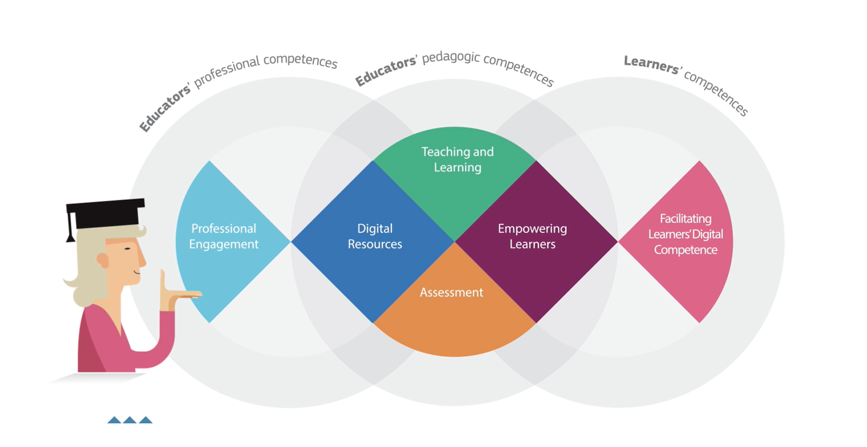
Figure 3: (DigCompEdu 2021a) - Overview

Particularly interesting is the possibility for teachers to independently determine their own digital competence level. The following QR code leads to the assessment procedure.

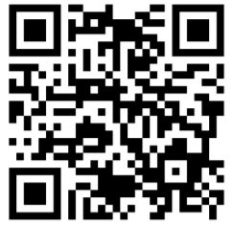
The DigCompEdu CheckIn Tool exists in three versions adapted to the respective educational sector (cf. DigCompEDU 2021b).

- For teachers at general or vocational schools: http://europa.eu/!cG34MH
- For teachers at universities or universities of applied sciences: http://europa.eu/!gh46kD
- For teachers in adult education: http://europa.eu/!ut86vP

During the assessment, teachers are classified in categories A1, A2, B1, B2, C1 and C2. Starting with A1 (entry level) up to C2 (proficiency level). The concept of grading is based on the Common European Framework of Reference for Languages (cf. DigCompEDU 2021b).

2.1.2 Key skill levels for local learners

While planning digital lessons for teachers is a challenge, based on the lack of digital competences. Students in the user role are less affected by digital literacy.
There are four aspects that prepare students in contemporary society and which also come into play in the hybrid streaming approach. The four aspects are:
The 4Cs go back to the US initiative P21 (Partnership for 21st Century Learning), in which experts from business, education and politics have joined forces to reflect on education in the digital age (cf. P21 2019)
The 4Cs are not clearly distinguishable from each other (cf. Kembara et al. 2019, p. 23), but a brief description with regard to the hybrid stream approach follows.

Critical Thinking
“Students must be triggered to think outside of their existing habits by involving new ways of thinking.”(Kembara et al. 2019, p. 23). In relation to the hybrid streaming approach, a space for freedom of expression must be created. Teaching topics must be adapted to critical, complex situations.

Communication
“The ability to communicate and collaborate is important because students are required to be able to be part of the community.” (Kembara et al. 2019, p. 23). Also, in the hybrid streaming approach, the possibility for interaction, exchange of opinions and positioning must be given, i.e. the teacher must not only stream the lessons but must also design appropriate discussion rounds.

Collaboration
Working in teams is becoming increasingly important from a business perspective. The students have to exchange ideas in groups and work on an overall result, such as a model, a poster, a presentation or similar. Each member of the group makes his or her own contribution.

Creativity
“Creativity and innovation will develop if students have the opportunity to think divergently.” (Kembara et al. 2019, p. 23). The promotion of creativity is also given in the hybrid streaming approach, if the teacher allows for it. For example, students can create their own explanatory video on a topic instead of a simple oral presentation.

2.2 Media formats for learning content

The most suitable formats within teacher training in Germany are learning videos and streams. Not only students aged 12 to 19 want to be taught with audiovisual tools and materials (cf. Liebau 2019, p.7-9).

Teachers are also increasingly using learning videos and streams for their own professional development. While many German teachers were very reluctant to take the initiative in training until a few years ago, the COVID-19 pandemic and videoconferencing have led to an increased demand for training (cf. Daschner 2019, p.13).
The factors that influence why teachers use learning videos seem to be analogues to the factors that influence students. Learning through videos is also more motivating for teachers. But that should not be the main reason. On the one hand, teachers can play the video in their free time when it suits them. Many teachers do not have time to prepare lessons until late in the evening because they have to take care of their families, to meet family responsibilities after school.
On the other hand, the in-service training often does not focus on `what something is` but rather on `how something works`. For example, how this app works, how to deal with `such´ pupils/to handle students in certain situations, how to improve digital mind mapping or how to keep a digital class register.
This way, the teacher can pause, rewind or skip the video as often as they want if they need the instructions again or already know the procedure.
The video platform YouTube, but also the site Twitch.tv, which is very popular with students, have a large selection of videos. The statistics show the ever-increasing popularity of the two platforms. While Twitch recorded 611.5 million visitors in Nov 2019, it already has an incredible 1230 million visitors in August 2021 (cf. Statista 2021a). This can only be topped by the giant YouTube. In comparison YouTube recorded 28,44 billion visitors in Nov 2019, it already has an incredible 35,11 billion visitors in August 2021 (cf. Statista 2021b).

In addition to the usual providers such as YouTube and Twitch, the streaming website Fobizz (https://fobizz.com/lehrerfortbildung-online/) has become popular among teachers for professional development in recent months.
Fobizz provides videos, live-chats as well as teaching materials for teachers on all sectors. Mainly from Germany, but teachers all over the world can exchange new teaching techniques, materials, tips and tricks.
So there are learning videos about for example: digital tools for class, creating movies in class specific on storytelling and movie language, learning to program at primary school, creating quizzes and tests with Microsoft Forms and much more. The website is specific on teachers’ demand.

It is worth mentioning here that a large part of the Fobizz site is chargeable. However, schools often have funds left over for training that are not fully used, so that it is still possible to use them (cf. Fobizz 2021).
In addition to a wide range of German teachers, Fobizz is also being used more and more abroad. Over 1,000 teachers and schools aboard use Fobizz. These include countries such as Argentina, Paraguay, Singapore and Turkey (cf. Fobizz 2021)

For example, Fobizz specializes in professional development with videos for teachers, but as already indicated at the beginning, platforms such as YouTube and Twitch are more popular with students. We also think that a free training method in the sense of an Open Educational Concept – OER concept for schools, provided by the state – would be a good idea.

3 The SAFE Streaming for Schools European Concept

As already described in the previous chapters, the development of a "streaming concept" and the development of a teacher training is a fundamental role of the whole project. The potentials and opportunities that exist within the framework of the streaming concept are used and the challenges and difficulties of the concept are taken into account.
Overall, the "SAFE - The streaming concept for schools" was developed in Intellectual Outcome 2. According to this, every school has the possibility:
Each school has to adjust the concept to the local and regional requirements and the technical equipment. Therefore, the different step-by-step solutions within the DISK-Online approach
(DISK1, DISK2, DISK3 and DISK4) can be the basis for the national approaches and in combination of the SAFE results a common European approach
can be created.

The SAFE Teacher Training Curriculum will now be presented. The course structure is explained as an example, the supplementary classroom material is described and an insight into the learning outcome matrix of the course is presented.

3.1 The SAFE teacher training curriculum

The idea of the SAFE Teacher Training Curriculum: to support the acquisition of key high-value competences necessary for the establishing modern and innovative learning with as comparable European focus which works under COVID-19.

The SAFE Teacher Training Course is structured in such a way that a total of three core areas are part of the course. The courses represent the scope of the project "Intellectual Outcome 3".
The teacher training courses comprise a total of three and two modules respectively, which have been developed for each core area and explain the relevant learning content to teachers. In addition to the presentations, classroom exercises are developed for individual work or group work in the course room. The materials are structured in such a way that they complement the learning content of the presentation and extend it in the context of self-study. In addition to the paper-based classroom tasks, web-based, digital H5P tasks were also created. These tasks are also complementary and extend the learning content of the module presentations.
In summary, the SAFE Teacher Training Curriculum consists of
(I) the "Teacher Training Courses" with the focus on
- (I.I) Aspect (1): Streaming platform
- (I.II) Aspect (2): Streaming software
- (I.III) Aspect (3): Streaming Environment
(II) Classroom materials for face-to-face teaching
(III) Web-based, digital H5P tasks
(IV) Learning Outcome Matrix for the entire Teacher Training Course

What is special about the SAFE Teacher Training courses is that they are translated into the national partner languages. This also applies to the classroom materials and supplementary materials, as well as the Learning Outcome Matrix (LOM).
Languages of the Course: English, German, Rumanian, Czech
All modules, concepts, face-to-face materials and H5P assignments are available on the SAFE website:
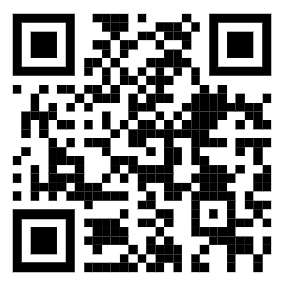
https://safe.eduproject.eu/

3.2 Insights into the SAFE Teacher Training Courses

As explained earlier, the teacher training courses include a total of three and two modules respectively, developed for each core area and explaining the relevant learning content to teachers. The figure graphically represents the different focus areas and at the same time defines the module contents in their headings. These courses are also available in all partner languages.
Course languages: English, German, Czech

Figure 4: SAFE Teacher training course on Streamlabs OBS and use of streaming platforms
Exemplary structure of a Teache- Training-Moduls
Example Module 7:
Easy school requirements: technical and organisational
requirements at school and for teachers

Each module refers to a thematic focus that must be taken into account in the context of distance learning and teaching.
For example, the course structure "Module 7: Easy school requirements: technical and organisational requirements at school and for teachers", which will now be discussed, first provides an overview of the learning objectives and contents. Then the thematic contents are dealt with and explained successively.
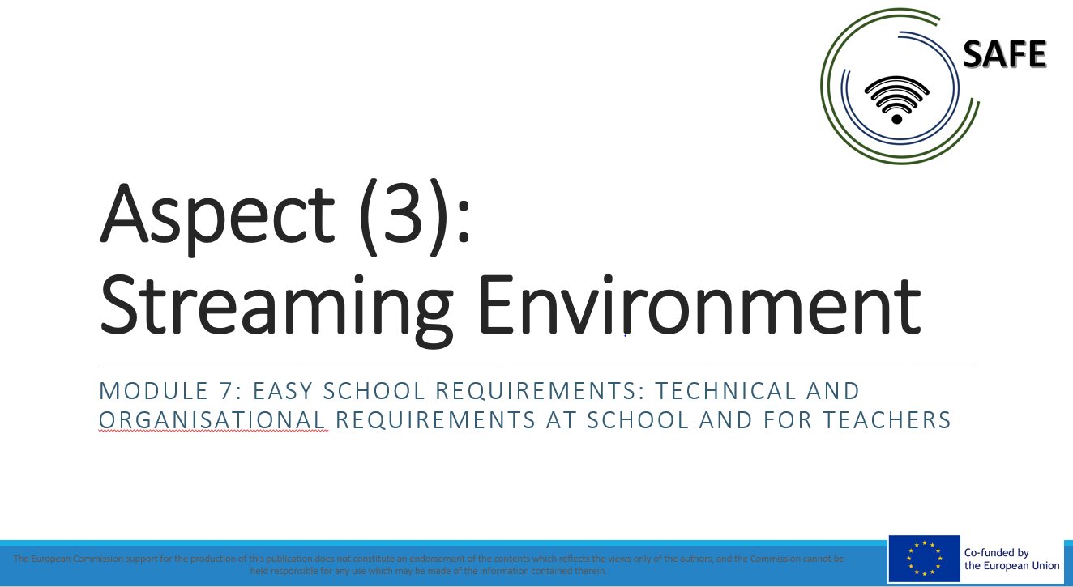
Figure 5: SAFE – Teacher Training Module 7 Easy school requirements: technical and organisational requirements at school and for teachers I
The following screenshots show excerpts from Teacher Training Module 7, which is also available on the project page and can be downloaded.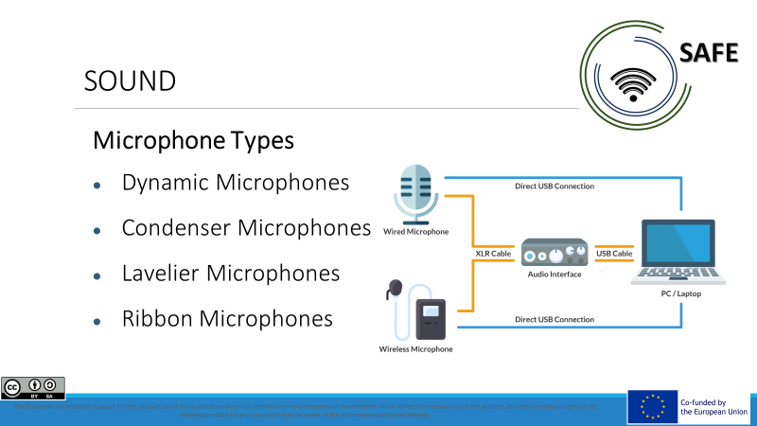
Screenshots excerpts from Teacher Training Module 7
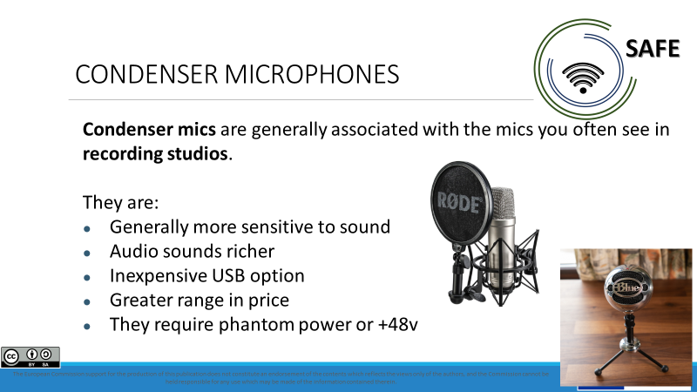
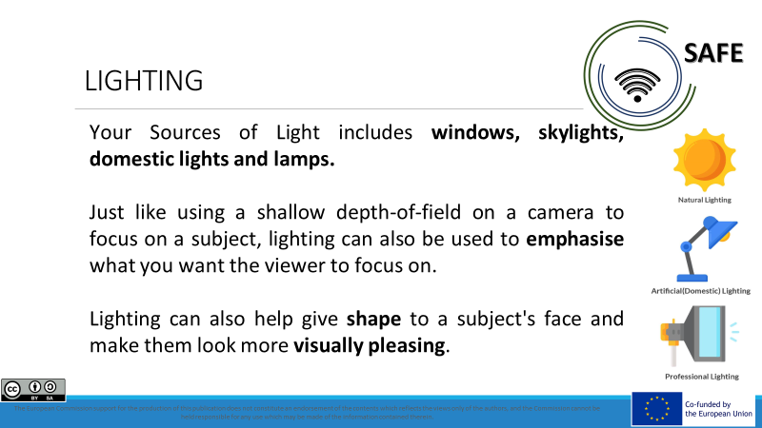
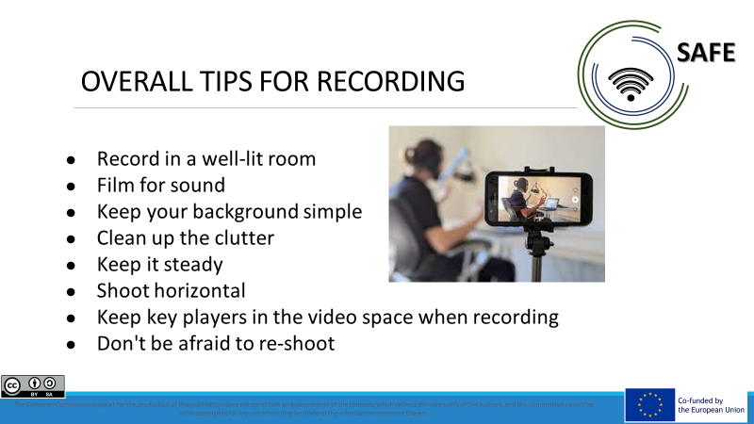
Figure 6: SAFE – Teacher Training Module 7 Easy school requirements: technical and organisational requirements at school and for teachers II

The teacher training modules are finalised with a comprehensive Teacher Training Competence Profile in the form of a paper-based version and an accompanying PowerPoint presentation of the most important contents. Again, all documents are available in all partner languages.

Course languages: English, German, Czech

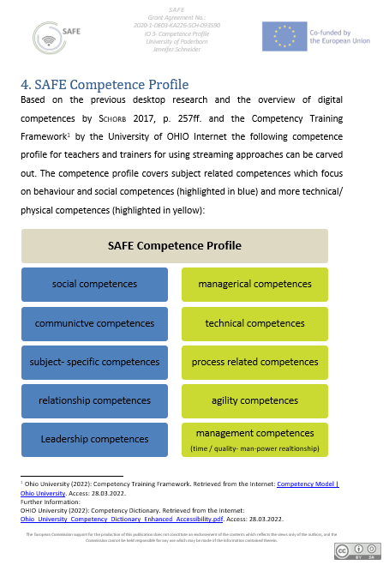

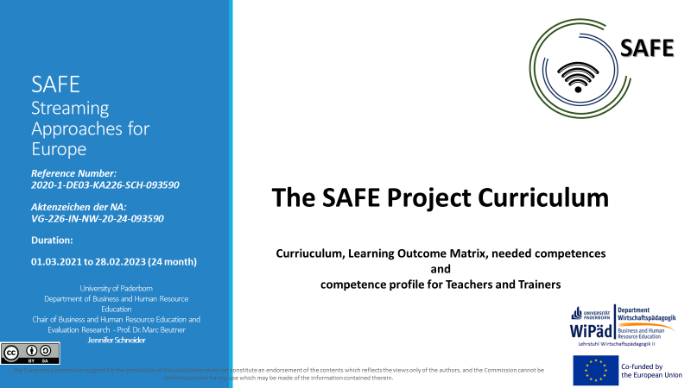

Figure 7: SAFE Project Curriculum and Competence Profile

3.2 Insights into SAFE teacher training Teaching materials for face-to-face teaching

Identical to the structure of the Teacher Training modules, the classroom materials are developed to complement the content and structure of the previous modules. In total, there are 8 classroom materials translated into the known partner languages. All versions are available on the website under the CC licence and can be downloaded.

The figure below shows the topics of the classroom materials:

Figure 8: SAFE – Teacher Training Module – Classroom Materials

The materials are structured as follows:
All materials begin with a short, concise introduction to the topic to be worked on. At the same time - if possible - supplementary literature or corresponding further internet sources are given.
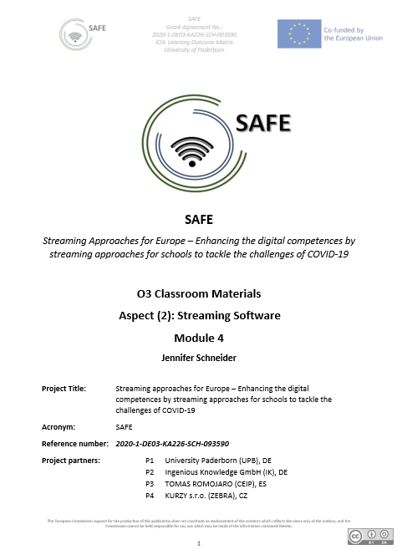
Figure 9: SAFE Classroom Materials

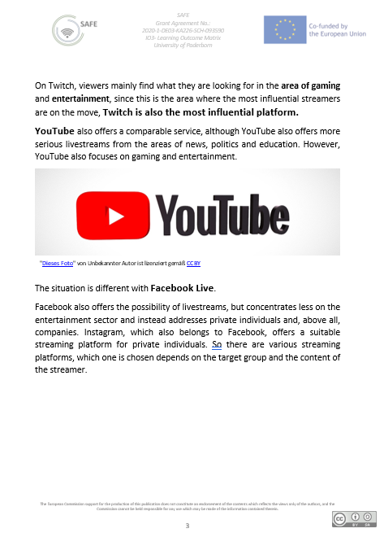
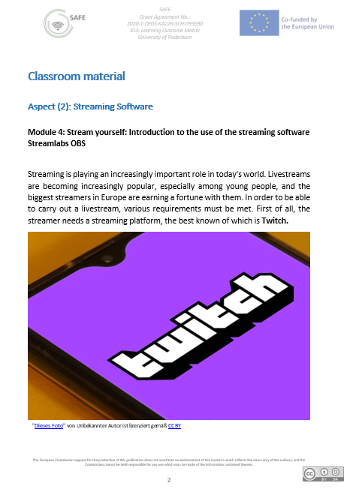
Figure 10: SAFE Teacher Training Teaching materials for face-to-face teaching

3.3 Insights into the SAFE Teacher Training Courses

What are the objectives of a Learning Outcome Matrix (LOM for short)?

The purpose of these information and charts are to illustrate how outcomes align with teaching and learning methods and assessments in the SAFE approach.

The following general aims and objectives are focused with the LOM:
This Learning Outcome matrix is designed to inform about the development of the curriculum structure to integrate Streaming and eLearning approaches in schools.
Focusing on a learning outcomes approach facilitates the tailoring of the pedagogic induction resources. This provides the possibility to suit specific cultural and societal values and ensures that local issues and necessary topics are addressed within the SAFE approach.

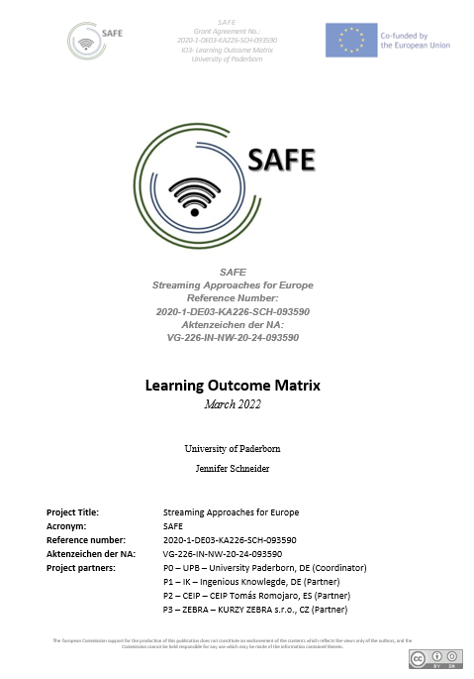
Figure 11: SAFE - Learning Outcome Matrix

The structure of the SAFE Learning Outcome Matrix is as follows. First, the "outcomes" are described briefly and concisely. In the first place, verbs are chosen that allow a good description of the situation. Then, the "Teaching and Learning Activity" is described, where the choice of learning method is also mentioned and a short overview is described.
Finally, the "Assessment" column describes how the examination can be taken. The following figure shows a section of the SAFE Learning Outcome Matrix.
This document is also available in all partner languages and can be downloaded from the SAFE website.
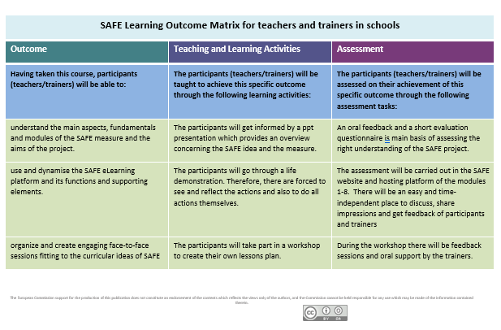
Figure 12: SAFE- Learning Outcome Matrix.

4 Blended Learning as part of eLearning

The eLearning approach is the answer to the developments in digitalization. Today’s learning and teaching needs to be digitalized due to the necessity of the learners becoming workers of tomorrow (cf. Damnik, Riebeck, Hoffmann, Nenner & Bergner 2020). They will find a working environment which is constantly changing because of new technological innovations (cf. Becker & Schassen 2021). It can be emphasized that competence, as in agency or ability to act in open professional job situations and cope with these accordingly, is becoming increasingly essential in coping with modern work processes that are digitally shaped (cf. Erpenbeck & Sauter 2020). Therefore, they need to be familiar with digitalized working. As today’s learning tools are based on various digital technologies, and digital technologies pervade working environments (cf. Euler & Wilbers 2020), there is an undisputed need for embedding digital learning and teaching in today’s classrooms. In vocational and further education a growing number of learning environments no longer take place at fixed locations only, therefore digitalization offers unlimited options for online courses (cf. Georg & Sattel 2020). Arnold has long been an advocate for blended learning at universities also in Germany (i. e. distance learning universities), and has endorsed this approach for course options (cf. Arnold 2015). Every learning approach with additional electronical media is called eLearning (cf. Schulz & Martsch 2011). Digital learning and teaching scenarios can help learners and create flexibility and individual support in their processes. Positive learning effects do not come from using electronical devices but from having a beneficial learning concept (cf. Kerres 2018). A concept like this is Blended Learning. The idea of Blended Learning is to have online and offline learning offers in order to combine advantages of classroom learning and eLearning (cf. Horz 2020). This combination in teaching-learning events are thus the hope of the future, as they enable study for people with diverse life situations. Blended learning has already been in use in foreign language teaching programmes for instance across Germany and Europe. Language schools had already successfully implemented this innovative learning and teaching approach way before the COVID-19 pandemic. It also has many advantages in school and higher education. It depends on the use as a complementary support, as a methodological tool and its implementation within the didactic concept. As long as didactics and methods are coordinated, the learning processes can be supported and the learning goals can be achieved. Arnold stresses the necessity of arranging didactics regarding acquisition, practice and competence development in digital arrangements or learning environments, as he puts it (cf. Arnold 2015). This again supports the idea of a coordinated setting in digital learning environments – a term that is used in vocational education all the same (cf. Euler & Wilbers 2020).

The streaming concept of SAFE is well structured and can be coordinated as a Blended Learning format. There can be classes in school and also online when using a streaming platform. The structure of online and offline classes can change regularly or irregularly whenever needed. As soon as the class feels comfortable with the program and streaming sessions, the teacher can decide on the format due to didactical reasons. This offers different kinds of course structures.

5 General information on dealing with adapted existing course structures

5.1 Redesign of existing course structure

What course structures which already exist
in your country?

In addition to traditional teaching, where all students and the teacher are in the classroom, online teaching has become increasingly popular in recent months due to Corona. In online lessons, all students and the teacher are in front of the computer.
In the course of the transition to normal teaching to comply with minimum distances and hygienic regulations, class structures were also developed where students of one class were divided into two to three groups of equal size. The division was done in different ways

- Alphabetically
- Homogeneous ability
- Heterogeneous ability
- Gender
- Location-specific
- Residence-specific
- Pupil preference

Thus, the divided groups were divided into group A and B. While in week 1 group A went to school and took part in the lessons on site, in week 1 group 1 was given tasks to work on independently. They had to work on these tasks while the lessons for group A took place. In week 2, the groups changed. Now group B took part in the lessons on site and group A worked on the tasks independently.

The problem with this approach was that the lessons progressed very slowly. The teacher only progressed with the lessons every fortnight. The lessons were mainly used to clarify questions of understanding and to check the tasks that had been worked out independently. For these situations, a streaming approach, as already suggested by Beutner and Pechuel, would have been effective and promising.

5.2 Assessment framework for measurement of attainment

What type of assessment framework would be most
appropriate to facilitate the measurement of attainment?

In fact, assessing student performance proves to be the most difficult challenge in three ways.

First of all, in the first trials of hybrid teaching formats by teachers with classes, a proper performance evaluation can hardly be recorded. The teacher has to get used to the format, as do the students. This takes time and reflection processes. At the same time, it is difficult for the teacher to conduct the lessons smoothly. Observations take place only marginally.

Second, depending on the circumstances, students who do not have sufficient technical equipment at home, such as a constant internet connection or a laptop, may be in a worse position than those with good equipment. Here a fair assessment is difficult. Likewise, depending on the streaming experience of the teacher, on-site teaching in the teacher’s classroom may be excellent, but only a fraction may be streamed. In this case, the students in the classroom would be able to follow and participate in the lessons, and the online group would unfortunately only partially participate.

Third, the NRW School Act (BASS) states that performance assessment is based on "written work" and "other achievements". "Both assessment areas are taken into account appropriately in the performance assessment.” (SchulG NRW §48 Abs. 2). In most cases, the performance assessment is made up of 50% written exercises and 50% other work, which includes, for example, oral participation in class and small tests. The teacher is only able in few lessons, to create an assessment about the participation. Nevertheless, a written exercise is heavy to handle for the teacher. Due to the fact that he has to create three different exercises to avoid copy the answers. For the reason, that he cannot assess.

5.3 Pedagogic Supports for Streaming in school approaches

What types of pedagogic supports are needed to facilitate the schools, teachers and tutors? What has to be focused? What is important? What guarantees success?

The types of pedagogic support, which are needed to facilitate the schools can be divided between school and teachers

School
In Germany, many schools do not have a stabile Internet connection. This requirement is absolutely necessary. Schools have to clarify that they got a stable and expandable internet connection.
Nevertheless, schools also differently technical equipped. Some classes are perfectly equipped at the state of the art, others work with old techniques like beamers.

Technical equipment

Privacy policy

Teacher
The most important fact for the teachers is to be able to get back to a clear digital concept.
Clear presentation of the concept
- Trials in small teams to share experiences
- Expert FAQ TEAM for technical questions
- Exchange of created materials (OER concept)

To sum up:

6 SAFE- Insights into the testing phases of the streaming for Schools European Concept

6.1 Insights into the testing phases of the Czech schools

To utilize the SAFE approach for the needs of our language school and to our students’ benefits we decided to implement it to host Twitch streams with guests (Zebra teachers) from different countries. Main goal was to further trigger interest in learning languages and foreign countries and entertain and motivate our students outside their regular classes.
We used DISK 3 approach and adjusted it to our need: we did not have students in the classroom as the host was streaming from her home. Instead, the teacher connected to a host via Teams.
Modified DISK3 approach plan:
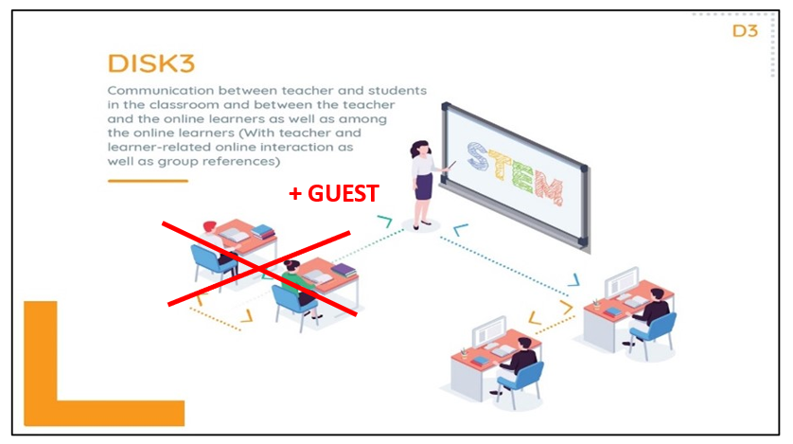
Setup: 1 host in place A, 1 guest in place B, connected via Teams, presentation with photos and graphics created in Canva Pro, streaming software Streamlabs, streaming platform Twitch (https://www.twitch.tv/jazykova_skola_zebra), host’s internet connection via ethernet cable (prepaid 1GB/s package with high upload and download).
For I give lessons solely online, I was already familiar with using some technical solutions on everyday basis (I use a webcam and condenser microphone, have generally steady internet). Installing and creating accounts (Twitch, Streamlabs OBS) was easy. However, working in Streamlabs combing all sources & layers and actually going LIVE could not be more different, it was extremely technically challenging for my devices. First, I tried the laptop I use for most of work, an intel Core i3 laptop, 8GB RAM with no success, same with i5 laptop, so eventually I fixed my gaming computer (i7 core, 16 GB RAM) and finally this one was able to withstand connecting with the guest via Teams and using Streamlabs and going live without freezing, overheating, interruptions (at least during the test phase) etc. I enjoyed learning how to work in Streamlabs OBS, about use of different sources, themes and layers and was able to create there a visually pleasant layout.

II.the chances and challenges of the teacher training SAFE course
What are the opportunities of Streaming Approaches in Classrooms?
Person I: In my eyes the greatest opportunity of Streaming in Classrooms is shortening the physical distance between students and teachers. On the other hand is a funny and interesting way to motivate students to learn languages.
Person II: It’s a very good medium for distance education, especially for young learners who constantly use these platforms. (i.e. twitch, youtube, etc.)
It can be used as a very good substitute for face-to-face learning. There are instances when it is physically impossible to do face-to-face instruction due to outside factors (i.e. pandemic, war) and it can be a very good substitute for it.
Using it simultaneously with face-to-face learning can be very beneficial as well. The benefits can be felt by students who aren’t able to physically come to class due to illness, injury, or family emergencies. The same is true for the teacher.
Streaming approaches also allow schools to offer courses to the international community. Students don’t have to be present in class. They just need to have access to a computer with a good internet connection. I think it would be the mode of learning in the future.
Person III: Motivate students, trigger interest, attract new viewers
Person IV: It is easy for students to get connected as no invitations are needed. Many participants can take part in the stream. If you want to invite many participants, you do not require to have control over their presence and you can cope with the high technical requirements, it can be used for some specific situations. However, in my view not for general classes.
The feedback from participants was very positive, enthusiastic – they really admired we did something new and attractive.

What are the challenges of Streaming Approaches in Classroom?
Person I: The main challenge is the technological one. Streaming requires good equipment, sometimes out of the reach of some teachers in poorer countries and advanced IT skills from teachers and/or organizers.
Person II: Perhaps the biggest challenge is the personal approach that face-to-face lessons provide. Even though it is possible to see facial expressions, I think there is no substitute for the personal approach.
The quality of the students’ and teachers’ internet connection can also pose a challenge, especially in rural areas where infrastructure is not so good.
I personally think that streaming approaches can only be 100% effective for academic purposes, but not for lessons that require physical movement. (i.e., physical education, dance lessons, yoga, etc.) These lessons would require the physical presence of the teacher and student to ensure a safe and proper form.
Person III: Technical difficulties with setup – high PC/laptop requirements, internet connection, good webcam/microphone.
Most of our students are adults unaware of Twitch existence and unfortunately, they found it difficult to interact on this platform (creating an account, following our account, being active in the chat). We anticipated that this might happen, so we included a QR code to Mentimeter for the purpose of asking questions.
When going online we were aware that there would be around 20 seconds delay and we tried to work with it. I think the audio and video quality was good and I did not experience any trouble while LIVE. Sadly, we encountered interruptions I could not influence as a host (2 or 3 internet interruptions during the 1st stream and even more during the 2nd one). I am not sure about the specific length of each of them. Streamlabs notified me about them, but I could not be sure which exact moment we got interrupted or got back online. Unfortunately, some of them might have been even longer than a minute. I am curious to learn what else I could have done to prevent it from happening, I assume a better computer would work. Technical difficulties could negatively influence viewers’ overall experience and could be one of the factors of lower participation and activity in the chat section and Mentimeter.
Person IV: High risk that unwanted participants join your stream. We had some unwanted comments in the chat during a trial stream and it is really disturbing in the context of education.
You have no control of participants, you even do not know who is present, which makes it difficult in terms of teaching. None of participants probably had an account and therefore could not participate in the chat. We had to interact with them through Mentimeter (QR code for questions), which increases the technical requirements.
Interaction with students is very difficult, so usage for classes where you need to interact with students is not recommended in my view.
To prepare one streaming session of good quality was EXTREMELY time demanding – actually impossible in normal operations in terms of time and finances. Several tens of hours for one stream of 45 minutes. However, it is true that first we had to learn a lot, also there were two teachers participating in the stream and one more taking care of chat and giving them instant real time feedback. We also spent much time on creating the concept of the stream – in which context to introduce it, for what reasons, prepare teachers, communicate with students etc.
If I compare it with the usage of generally available videoconferencing tools like Zoom, MS Teams, Skype etc., the usage of OBS StreamLabs and Twitch has very few competitive advantages. It can be used for some specific situations – like we did – but anyway it is not easy. It is too difficult for untrained teachers. If the teacher is a fan of technologies, like Alex is, then she takes it as an opportunity and fun. For teachers not interested in technologies it would be a nightmare to fully work with it. It is true that you can prepare a computer for a teacher and she just comes and teaches. But then the lesson quality will be very low. If I consider that most teachers can use videoconferencing tools nowadays without bigger problems, it is really not easy to find a situation or opportunity where OBS StreamLabs and Twitch would offer advantages and would be useful. For the purpose of the project, I recommend to define a suitable situation, or at least offer some hints how to identify a good opportunity.
I participated in the stream as a viewer and was supposed to help with real time feedback (I can hear you and see you) and with chat. However, there were no comments in the chat as none probably had an account on Twitch. From the perspective of a viewer, I had a feeling to be really out – similar feeling like watching TV. You can leave anytime; you can do whatever you want and nobody will know. I think that this feeling is really important to consider from an educational perspective. It can have positive and negative impacts on the educational process and I think it deserves attention in the project.

IV.Evaluation results of the SAFE Implementation
1st Twitch streaming summary:
First Zebra language school LIVE stream was 52 minutes long, on average 31 people were watching at once (more below). More than a hundred people peeked in to have a look, some of them were certainly random Twitch visitors (not our students) which shows big potential Twitch has.
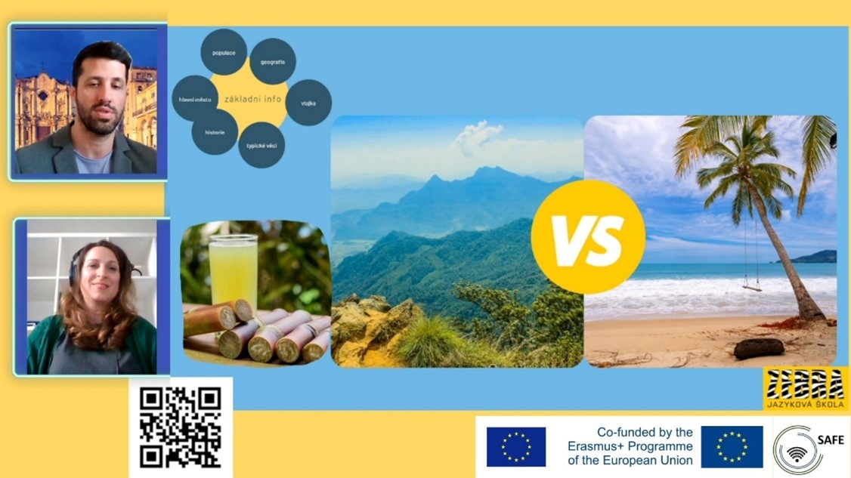

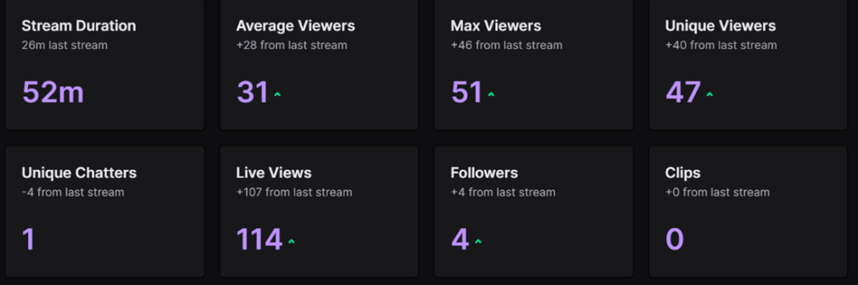
2nd Twitch streaming summary:
We were live for 1h3m, on average 14 people were watching at one time. The weather was lovely on the evening of the second stream, we suspect that could be a reason for the lower number of people watching. Still compared with the first stream there were many new viewers and still statistics are not too bad considering we are in the learning phase.
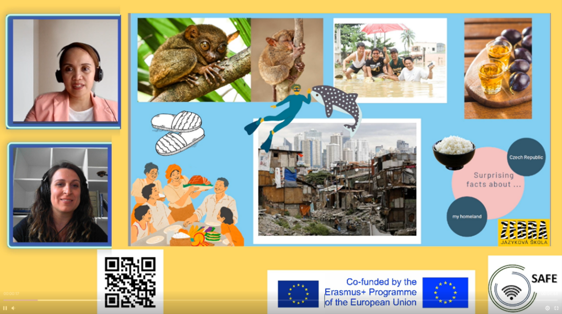
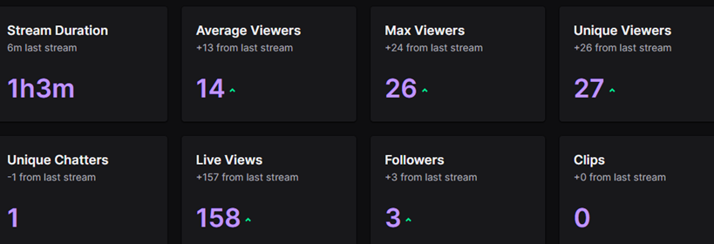

Mentimeter:
1st Twitch streaming:
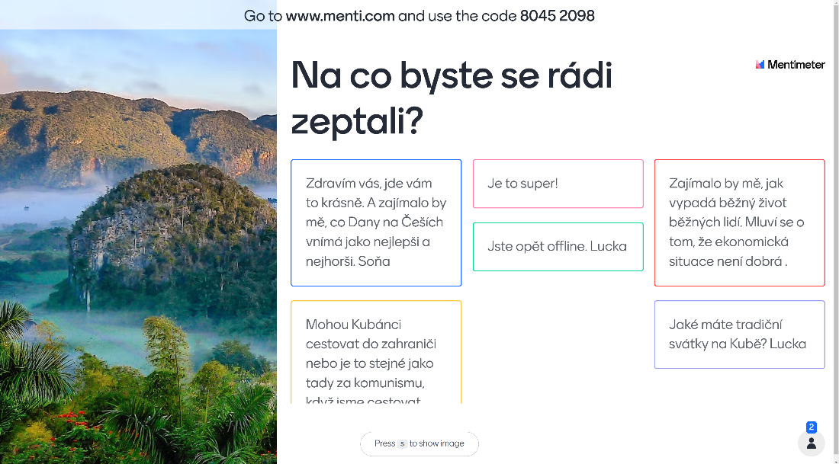
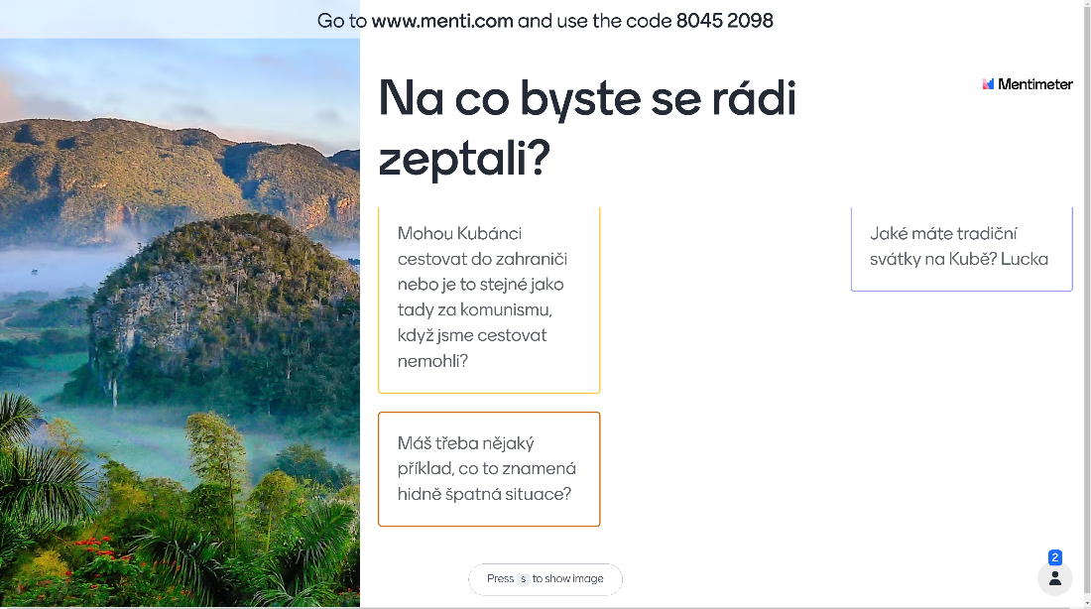

2nd Twitch streaming:

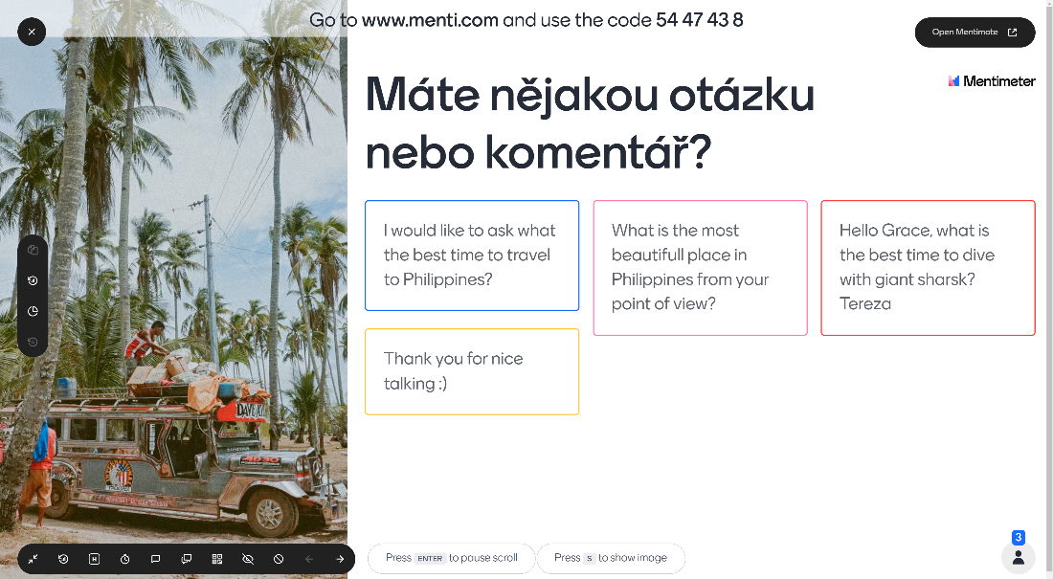

6.2 Insights into the testing phases of the Spanish schools

The use of this approach caused in our students a high degree of curiosity and motivation. It is an environment in which they are familiar and they were nervous to see how it could work in their educational day to day.

One of the most important thing: it caused a high degree of curiosity and motivation in our students.

Main aims:
- Increase in our students the interest in learning in a different and attractive way.
- Promote learning when face to face teaching is not possible.

Our main objective was precisely that, to increase in our students the interest in learning in a different and attractive way. For this, we carried out three transmission tests since we found difficulties in each one of them, so we had to modify our transmission programming.
The first problem we found was that we couldn't use OBS using Twich because students couldnot access it at the center with their accounts, so we decided to do it from YouTube.

Possibilities and challenges of the SAFE teacher training course
What are the opportunities for streaming approaches in the classroom?

Person I:
When putting OBS into practice with my 5th grade students in the classroom, I have obtained the following conclusions:
-Carrying out learning using OBS is motivating and fun for students, as it offers them a different way of acquiring content, making them excited and participatory, keeping their attention level high.
- It is an opportunity that adapts very well to extreme situations of pandemic, illness, absences so that both teachers and students can remain connected to their education and maintain the pace of teaching and learning without missing classes.

Person II:
I think it is a perfect opportunity to be able to work on special days such as Environment Day, Europe Day, Earth Day, in conjunction with different centers and all together to be able to carry out joint activities from our places.
It allows us to maintain relationships with other educational systems and also compare, unite and enjoy different experiences.
Person III: Opportunities of Streaming Approaches:
- Flexibility of schedules and location, both for students and teachers.
- Model focused on the student and their needs.

Person IV:
It is a much more profitable system, from the economic point of view. Not everyone can afford face-to-face training and streaming makes things easier for students with fewer resources.

What are the challenges of classroom streaming approaches?

Person I:
Putting into educational practice a Streaming transmission approach offers us different challenges:
-The first of all has to do with technology since it forces us to be equipped, on the one hand, with good equipment that supports OBS in a simple way and, on the other hand, a good internet connection that reliably allows a good connection . In the practice that I carried out in my school, this technological difficulty has been observed, both due to the teams of teachers and students and due to the Internet connection.
-Secondly, my school, like those of the rest of my autonomous community, work with a digital environment, either offered by the regional government, well chosen by the educational school. This domain, dealing with educational centers, has cut certain connections to different sites such as twitch, Facebook…. so the students cannot connect. Specifically, in my practice we had to do it from YouTube through my channel, which was the only place that the students, with their accounts, had access to.

Person II:
A challenge that I realize is that anyone can access the broadcast without you knowing it.
I think that working with OBS is fine, although it is not appropriate for certain subjects. Already in any area, human contact and the consequent personal relationships that have an important role in the transmission of contents are lost, non-verbal language is fundamental and is a great complement to an oral presentation. In addition, the subjects that require physical activity lose all idiosyncrasy with the OBS broadcast.

Person III:
To train effectively and safely for students, teachers and non-teaching staff, this is, in my opinion, the most important challenge that we have as teachers.

Person I:
Increase student confidence in the system, digital literacy of teachers, increased participant engagement, streaming training, autonomous management of training platforms, gamification development, informal learning.

Results of the evaluation of the implementation of SAFE
TEACHER 1:
Below we show the results of the implementation of SAFE in the teaching practice of several teachers of our school:

1st task:
It was the most ambitious of all, we prepared a Scaperoom from Genially where the contents of Maths and language were reviewed in a playful and fun way. We did it in 5 classrooms (5th grade). Each class would be divided into 4 groups that would have to solve the riddles raised and each group would have two tablets, one to follow the live broadcast and the other to be connected to Google meet and where the teacher could follow the performance of each group. We had 90 students connected. At Streamlabs we create several sources for the broadcast, webcam, genially, Google meet, images, countdown clock...
Working with too tasks was impossible, the transmission was very slow, it did not advance, it jumped frames, the frames remained anchored (...) it was not a satisfactory session due to a large number of problems.

2nd task:

In this second taks we were less ambitious, we decided to transmit learning from my face-to-face classroom and at the same time, another class to which I also teach the same subject that will connect online through YouTube. We reduced the layers and sources and to make my laptop lighter, we did the transmission through a webcam with a built-in microphone. It was also not satisfactory because the students who were online did not get the sound. We did not discover the reason because according to Streamlabs everything was correct.

3rd task:

It was similar to the previous one but we turn off everything and we only worked with one or two sources and with the camera and the microphone of my laptop. This time the experience worked and the result of the students was positive when they saw that they had acquired online the same thing as the face-to-face students.

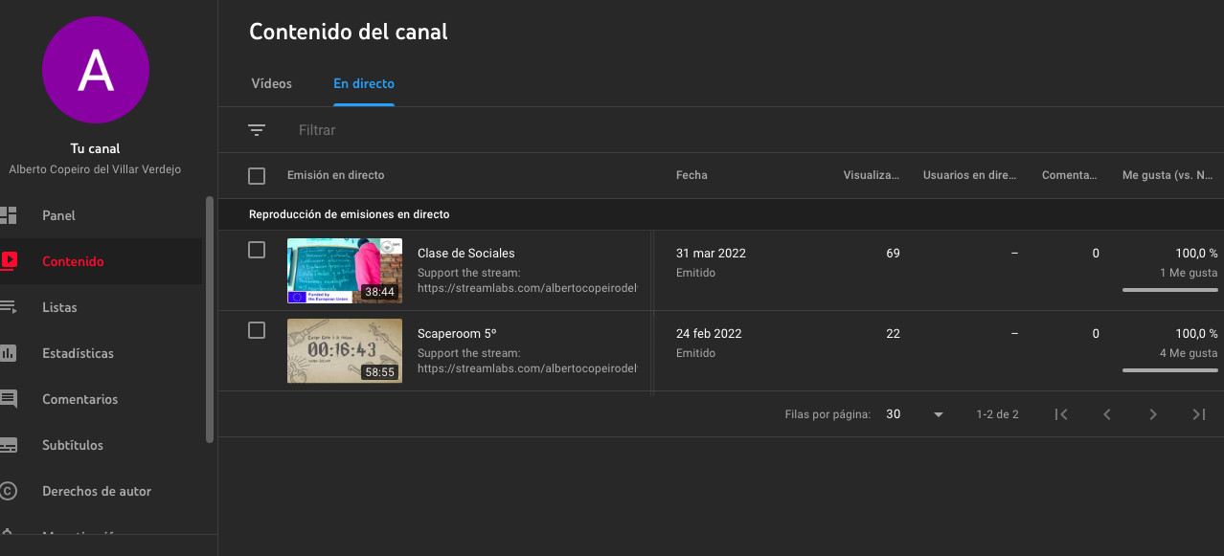

Insights in the Testing Phase in Spain:
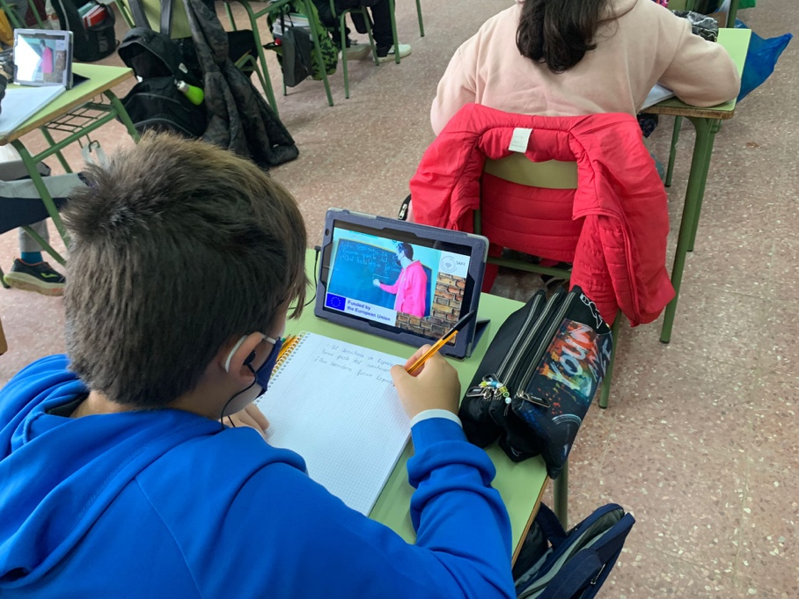

TEACHER 2:
I decided to transmit learning from my face-to-face classroom and at the same time, another class to which I also teach the same subject that will connect online through YouTube. My students (my own class and the other one) was learning an English class at the same time (it is a good way if we want to progress with one classroom that have missed some lesson). I worked with camera and microphone from my own laptop, but I couldn´t use Twitch (due to the school wireless, so I had to use my own youtube channel.
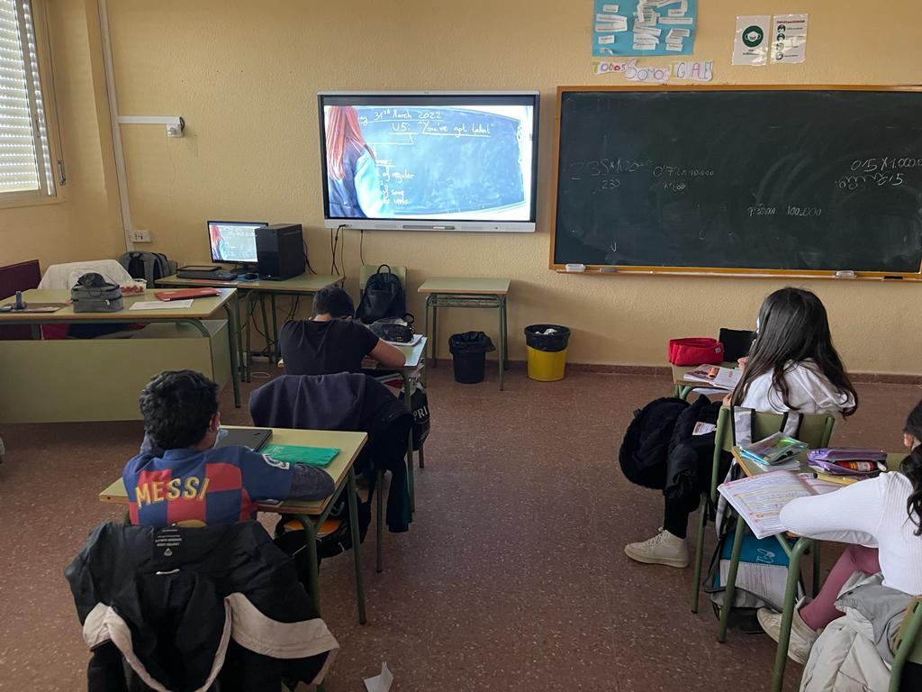
The experience was successful because students with their own devices could follow the lesson properly.
Comments and opinions from our students:
After having carried out the first tests with SAFE in our school, we have collected feedback from our students and most of them have been excited and motivated to work in a more interactive and motivating way. For all of them it has been a great challenge because they have also had to learn to work in this way. Any form of working with devices in the classroom makes the students feel attracted and interested in their work process, even if it was complicated at the beginning, but their motivation and interest makes them solve their doubts in a more entertaining way. All the opinions of our students are similar, none of them felt nervous when working in this way.
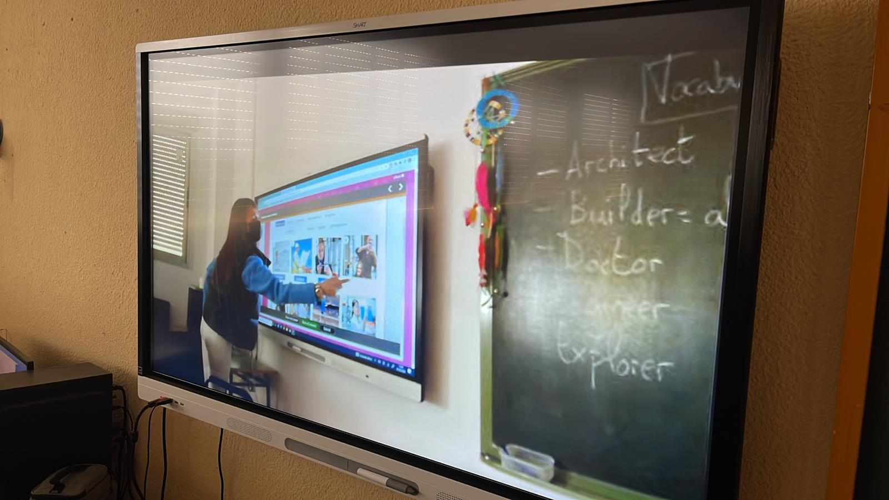

References
ARNOLD, R. (2015): Bildung nach Bologna! Die Anregungen der europäischen Hochschulreform, Wiesbaden 2015, pp. 133, 155.
Beutner, M. & Pechuel, R. (2020a). The use of streaming for online lessons – A basic implementation option in the context of the COVID-19 situation. Proceedings of SITE Interactive Online 2020. Currently in Print.
Beutner, M. & Pechuel, R. (2020b). DISK Online Streaming Concept for hybrid learning – Dealing with the challenges of COVID-19 in learning settings. Proceedings of Innovate Learning Summit 2020 Online. USA 2020. Currently in Print.
Beutner, M. & Pechuel, R. (2021): Easy technology designs for innovative learning. In: Sanchez, Kommers, Issa, Isaias (Eds.): Mobile Learning and Educational Technologies 2021. International Conferences on Mobile Learning 2021 (ML 2021) and Educational Technologies 2021 (ICEduTech 2021), pp. 161-167.
Braun, H. (2019): Mehr Digitalisierung wagen?! – Auf dem Weg zu einer schulbezogenen IT-Strategie. In: https://fcgs-duesseldorf.de/sites/fcgs/files/content/downloads/2019-11-25/e_8_19_it_strategie_braune.pdf (last call: 11.10.2021).
Daschner, P. (2019): Recherchen für eine Bestandsaufnahme der Lehrkräftefortbildung in Deutschland. Ergebnisse des Projektes Qualitätsentwicklung in der Lehrkräftebildung. Teil 1. In: DVLfB – forum Lehrerfortbildung – Heft 47/2018.
DigCompEdu (2021a): Project website. In: https://ec.europa.eu/jrc/en/digcompedu; (last call 12.11.2021).
DigCompEdu (2021b): Digitale Kompetenz Lehrender. In: https://ec.europa.eu/jrc/sites/default/files/digcompedu_leaflet_de-2018-09-21pdf.pdf; last call 12.11.2021)
ERPENBECK, J. / SAUTER, W. (2020): Werte und Normen in der Berufsbildung. In: Arnold, R. / Lipsmeier, A. / Rohs, M. [Ed.]: Handbuch Berufsbildung, Wiesbaden 2020, p. 178.
EULER, D. / Wilbers, K. (2020): Berufsbildung in digitalen Lernumgebungen. In: Arnold, R. / Lipsmeier, A. / Rohs, M. [Ed.]: Handbuch Berufsbildung, Wiesbaden 2020, pp. 430, 432.
Fobizz (2021): https://fobizz.com/lehrerfortbildung-online/; (last call 12.11.2021).
Fobizz (2021): Digitales Fortbildungszentrum für Lehrkräfte rund um IT, Medien und Digitalisierung. In: https://fobizz.com/der-fobizz-jahresruckblick-2020-in-zahlen/, (last call: 11.10.2021).
GEORG, W. / SATTEL, U. (2020): Berufliche Bildung, Arbeitsmarkt und Beschäftigung. In: Arnold, R. / Lipsmeier, A. / Rohs, M. [Ed.]: Handbuch Berufsbildung, Wiesbaden 2020, p. 229.
Heinrich, N (2021): Hybrides Lernen – aber wie? In: Bundeszentrale für politische Bildung: https://www.bpb.de/lernen/digitale-bildung/werkstatt/325751/hybrides-lernen-aber-wie; (last call: 30.09.2021)
Heys, V / Erpenbeck, J (2004): „Vorwort“, In: Heyse, V. / Erpenbeck J. [Ed.]: Kompetenztraining, Stuttgart 2004, S.XI-XXX.
Liebau, E. (2019): Jugend/ Youtube /Kulturelle Bildung. Horizont 2019. Eine repräsentative Umfrage Unter 12- bis 19-jährigen zur Nutzung kultureller Bildungsangebote an digitalen Kulturorten. In: https://www.rat-kulturelle-bildung.de/fileadmin/user_upload/pdf/Studie_YouTube_Webversion_final.pdf, (last call: 11.10.2021).
Medienkompetenzrahmen NRW (2018): https://medienkompetenzrahmen.nrw/medienkompetenzrahmen-nrw/, (last call: 05.10.2021)
Mudra, P. (2004): Personalentwicklung: Integrative Gestaltung betrieblicher Lern- und Veränderungsprozesse, München.
P21 (2019): The 4Cs model. In: https://www.battelleforkids.org/networks/p21; (last call 12.11.2021).
Puentedura, R.R. (2006): Transformation, Technology, and Education. In: http://www.hippasus.com/resources/tte/; (last call: 11.10.2021).
Puentedura, R.R. (18.06.2021): Focus: Redefinition. In: htttp://hippasus.com/blog/archives/68; (last call: 11.10.2021).
Ständige Kultusminister Konferenz (KMK) (2017): Bildung in der digitalen Welt. Strategie der Kultusministerkonferenz. In: https://www.kmk.org/fileadmin/Dateien/pdf/PresseUndAktuelles/2017/Strategie_neu_2017_datum_1.pdf; (last call: 11.10.2021).
Statista (2021a): https://de.statista.com/statistik/daten/studie/1021471/umfrage/anzahl-der-visits-pro-monat-von-twitchtv/, (last call: 05.11.2021).
Statista (2021b): https://de.statista.com/statistik/daten/studie/1021459/umfrage/anzahl-der-visits-pro-monat-von-youtube/, (last call: 05.11.2021).
Becker, P. & Schassen, C. von (2021). Diversität und Digitalisierung. In U. Senger (Ed.). Qualitätsoffensive Diversität- Nachwuchsgewinnung und -bildung in verschiedenen Berufsfeldern, pp. 49-72. Bielefeld: wbv.
Damnik, G., Riebeck, S., Hoffmann, F., Nenner, C. & Bergner, N. (2020). Lehren und Lernen in der digitalen Welt – ein Lernangebot für zukünftige Lehrkräfte im Blended-Learning-Format. In C. Müller Werder & J. Erlemann (Ed.). Seamless Learning – lebenslanges, durchgängiges Lernen ermöglichen, pp. 49-58. Münster: Waxmann.
Horz, H. (2020). Medien. In E. Wild & J. Möller (Ed.). Pädagogische Psychologie (3. ed.), pp. 133-160. Berlin: Springer.
Kerres, M. (2018). Mediendidaktik. Konzeption und Entwicklung digitaler Lernangebote (5. ed.). Berlin: De Gruyter Oldenbourg.
Schulz, A. & Martsch, M. (2011). Blended-Learning – Die neue Rolle der Ausbilder. In D. Frommberger, K. Jenewein & S. Peters (Ed.). Arbeitsberichte des Instituts für Berufs- und Betriebspädagogik. Arbeitsbericht Nr. 79. Otto-von-Guericke-Universität Magdeburg.

