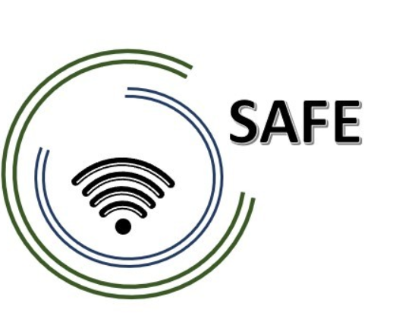

SAFE
Streaming Approaches for Europe – Enhancing the digital competences by streaming approaches for schools to tackle the challenges of COVID-19

IO2 SAFE – The Streaming Concept for schools

Project Title: Streaming approaches for Europe – Enhancing the digital competences by streaming approaches for schools to tackle the challenges of COVID-19
Acronym: SAFE
Reference number: 2020-1-DE03-KA226-SCH-093590
Project partners: P1 University Paderborn (UPB), DE
P2 Ingenious Knowledge GmbH (IK), DE
P3 TOMAS ROMOJARO (CEIP), ES
P4 KURZY s.r.o. (ZEBRA), CZ

Table of contents
Table of contents I
List of figures II
List of tables III
1. Introduction 1
2. DISK-Online Approach (Beutner / Pechuel 2020) 2
2.1 DISK 1 -Guidance 4
2.2 DISK 2 - Guidance 5
2.3 DISK 3 - Guidance 6
2.4 DISK 4 - Guidance 7
3. Technical equipment 8
3.1 Hardware 8
3.2 Software 9
4. Increasing the purpose of use 11
4.1 Streaming of a teacher from home 11
4.2 Streaming lessons in a team 11
4.3 Streaming from different schools 12
5. Example of a teaching synopsis in connection with the DISK-online approach 13
5.1 Example of a teaching synopsis in connection with DISK1 13
5.2 Example of a teaching synopsis in connection with DISK2 14
5.3 Example of a teaching synopsis in connection with DISK3 15
5.4 Example of a teaching synopsis in connection with DISK4 17
6. Equipment checklist for schools 19
7. Equipment checklist for students (online group) 20
References 21

List of figures
Figure 1: DISK- Online (total) (Beutner & Pechuel 2021b, p. 181) 3
Figure 2: DISK1 4
Figure 3: DISK 2 5
Figure 4: DISK 3 6
Figure 5: DISK 4 7
Figure 6: Overview - Necessary Hardware 8
Figure 7: Overview - Necessary Software 9
Figure 8: Streaming of a teacher from home 13
Figure 9: Streaming from different schools 14

List of tables
Table 1: Groups and subgroups within the DISK-Online approach (cf. Beutner & Pechuel 2020a) 2
Table 2: Necessary technical equipment - DISK 1 4
Table 3: Necessary technical equipment - DISK 2 5
Table 4: Necessary technical equipment - DISK 3 6
Table 5: Necessary technical equipment - DISK 4 7
Table 6: Hints for conducting lessons with DISK 1 13
Table 7: Hints for conducting lessons with DISK 2 14
Table 8: Hints for conducting lessons with DISK 3 16
Table 9: Hints for conducting lessons with DISK 4 18

Introduction
In the following, the DISK-Online Approach and its school integration will be explained in more detail. This concept serves as a guideline for the implementation of a streaming concept in hybrid forms of teaching at schools. While the DISK-Online approach is first explained in general terms, the next step will be to give concrete implementation tips. The implementation instructions are to be tested and evaluated in order to anchor the model more firmly in everyday school life.
The concept was initiated by the challenging COVID-19 pandemic in the schools. Due to the virus, schools were partially or completely closed. Some students were taught digitally and others were allowed to go to school in small groups but had to keep their distance from their classmates because of the distance and hygiene rules (cf. Beutner & Pechuel 2021a, p. 161).
The situation was new for all teachers. Many did not know how to continue teaching. There was a lack of concepts for the implementation of digital teaching as well as a lack of digital know-how. In some cases, teachers sent assignments by email and only in a few cases did lessons take place online. As the teachers were not prepared for these changes, lessons progressed very slowly or were even cancelled in some cases. This was to the sorrow of the pupils. Exact figures on how many lessons were cancelled during the pandemic can only be estimated (cf. Helbig 2021, p.2). A study by the Leverhulme Centre for Demographic Science at Oxford University, with a data base of 350,000 Dutch students claim that the “online teaching” was so bad that very few students were able to deepen their subject competences. Others would have forgotten more than they learned in that time (Engzell, Frey & Verhagen 2021; p.1). The consequences for the students are immense. Various measures are being discussed on how pupils can catch up on the lessons they have missed for example, in order not to have any disadvantages on the job market later on or in their studies (cf. Anger & Sandner 2020; p.3-7).
In addition to the lack of didactic models and teachers being unprepared for this situation, there was a lack of technical equipment in schools. In 2015, O’Byrne and Pytas also drew attention that most schools lack technical equipment as well as lacking specific pedagogic or didactic concepts designed for this new method of learning (cf. O’Byrne & Pytash 2015; p. 140).
Thus, schools need a concept where the teacher can teach from the classroom and reach both the students who are present in the classroom and those who need to participate from home via digital channels.

DISK-Online Approach (Beutner / Pechuel 2020)
One possible solution is the DISK-Online Approach by Beutner and Pechuel. “DISK-Online stands for Didactic Interactive Streaming Know-how”(Beutner & Pechuel 2021b, p. 179). It enables a hybrid learning format where face-to-face learning units are combined with online learning via a streaming concept (cf. Beutner & Pechuel 2020c). In designing the DISK-Online approach, Crompton’s social ecological mobile learning integration framework was considered (cf. Crompton 2017, p. 99).
The authors’ aim was to develop a concept that can be used flexibly by schools and pupils. Hybrid learning was a good first step towards this. “The hybrid format applies to any instruction where content is delivered both online and in onsite facilities.” (Mossavar-Rahmani & Larson-Daugherty 2007, p. 67)
In many schools hybrid learning was implemented during the COVID-19 pandemic. The class was divided into two or three large groups. One day one group came to school and the other group/s was given tasks, and the next day the groups changed. The problem here was that the lessons progressed very slowly.
 | Subgroup of the class present in the classroom | Subgroups of the class participating in the class online
First day of teaching | Group A | Group B and Group C
Second day of teaching | Group B | Group A and Group C
Third day of teaching 3 | Group C | Group A and Group B
Table 1: Groups and subgroups within the DISK-Online approach (cf. Beutner & Pechuel 2020a)

The DISK-Online approach can be implemented not only in hybrid learning formats but also in blended learning formats. Horn and Staker developed six models of blended learning in 2011. They are (a) the face-to-face driver model, (b) the rotation model, (c) the flex model, (d) online lab model, (e) the self-blend model and (f) the online driver model (cf. Horn & Staler 2011, p. 4-6). All these different types of blended learning can be combined with the DISK-Online approach.

In order to consider the distance and hygiene rules, digital teaching is the way forward. Streaming lessons, especially on YouTube and Twitch platforms, connect to the students‘ lifeworld and represent the latest state of technology. Many students of all ages enjoy watching streams in their free time or may stream themselves playing video games, for example.

The DISK-online approach has four levels of interaction. A level is also called DISK in this context. Starting with DISK 1 for inexperienced teachers up to DISK 4 for teachers with a lot of experience (cf. Beutner & Pechuel 2021b, p. 180f.). “While in DISK1 a frontal teaching character for the online learners is paired with a teacher- dependent teaching character (from frontal, via activating to experience- oriented designing or moderating for the face-to-face learners), DISK 4 has a clearly group- oriented and target group-related orientation with a clear moderation role of the teachers.” (Beutner & Pechuel 2020c)
Teachers should choose the DISK they are confident in. For example, all teachers have different levels of digital literacy. One should not rush into this. Care should also be taken to ensure that the students can cope with the selected DISK. Pupils are usually more technically proficient than teachers, but students also need support and have to get used to new formats.
The following figure illustrates the individual stages of the DISK-Online approach.
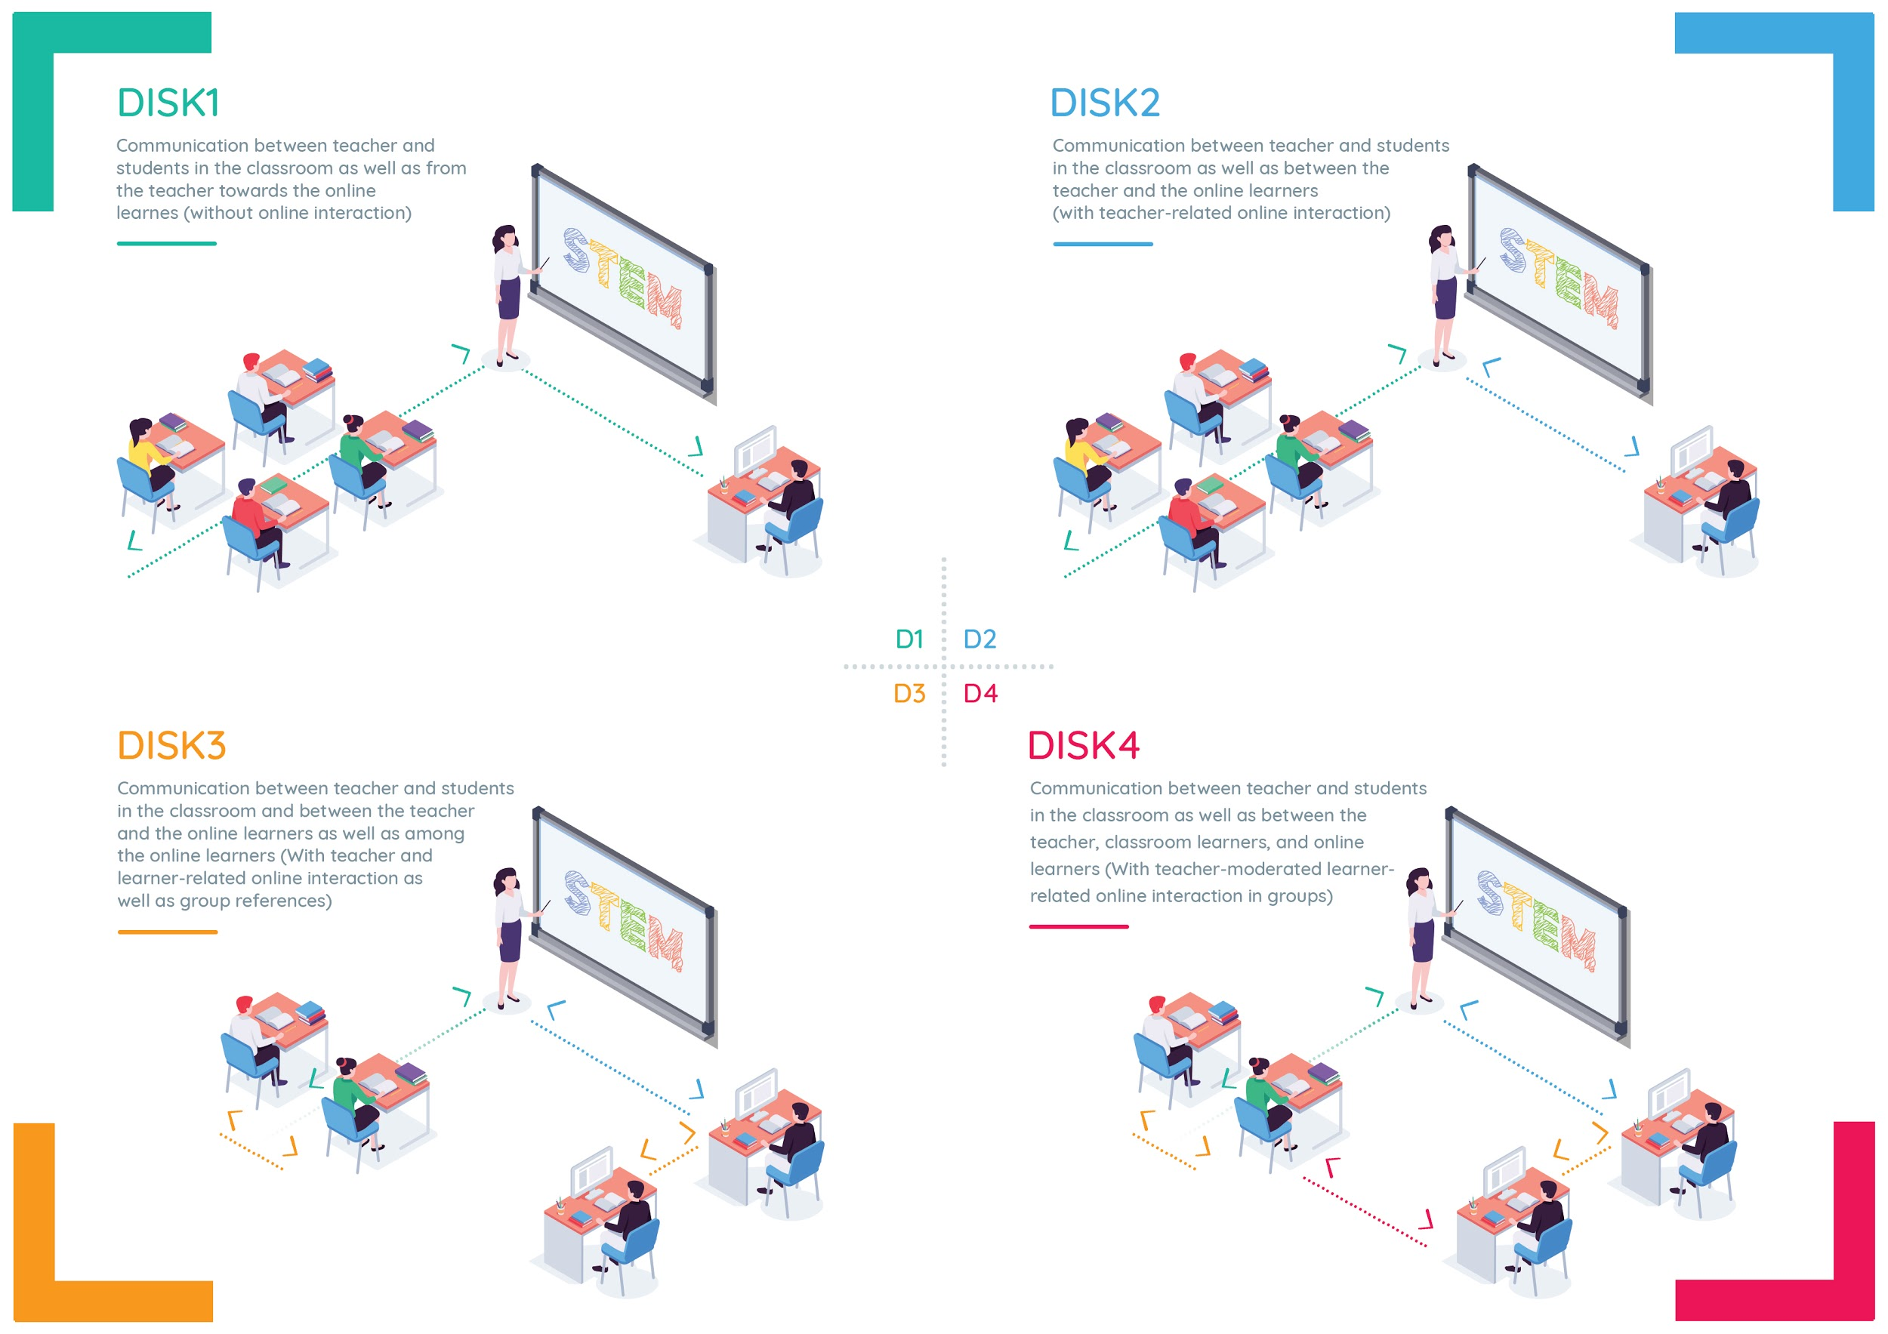
Figure 1: DISK- Online (total) (Beutner & Pechuel 2021b, p. 181)
In a next step, a short summary is presented for the respective DISK-Online approaches DISK 1 to DISK 4.

DISK 1 -Guidance

Level of difficulty for teachers:
Beginner

Degree of interaction:
Low

Figure 2: DISK1
Necessary technical equipment:
Teacher / Schools | Learners
Hardware:  - Internet Connection  - Projection in Classroom  - Tablet / Digital Pen  - Microphone  Software:  - Streaming Software (Streamlabs OBS)  - Streaming Software Access (Twitch)  - Whiteboard Software for better presentation | Hardware:  - Internet Connection  - Computer / Tablet  Software:  - Browser
Table 2: Necessary technical equipment - DISK 1
Description of the DISK 1 approach:
DISK 1 is the first stage of the four-stage DISK-Online Approach. The students are split into an in-class group and an online group. Interaction between learners and the teacher takes place in the classroom (cf. Beutner & Pechuel 2021a, p.163). For the learners, the lesson is streamed through a classroom on the internet. The online group can follow the lesson from home without asking questions or actively participating. The teacher is free to decide whether to record the stream so that the students can watch it again if necessary. It is recommended that learners who follow the stream online take extensive notes to interact with the teacher when groups are switched and they become the in-class group (cf. Beutner & Pechuel 2021, p.163).This should be communicated to the students, as it is difficult for the teacher to evaluate the performance of students who are in the in-class group and do not communicate.

DISK 2 - Guidance
Level of difficulty for teachers:
Normal

Degree of interaction:
Average

Figure 3: DISK 2
Necessary technical equipment:
Teacher / Schools | Learners
Hardware:  - Internet Connection  - Projection in Classroom  - Tablet / Digital Pen,  - Microphone  Software:  - Streaming Software (Streamlabs OBS),  - Streaming Software Access (Twitch),  - Whiteboard Software for better presentation | Hardware:  - Internet Connection,  - Computer / Tablet,  - Video Camera,  - Microphone  Software:  - Browser  - Chat Software, Voice Chat / Video Chat
Table 3: Necessary technical equipment - DISK 2
Description of the DISK 2 approach:
DISK 2 is the second stage of the four-stage DISK-Online Approach. The students are also split into an in-class group and an online group. The teacher offers the lesson via live streaming and the online group are able to communicate in real time with the teacher, just as the students in the classroom do (cf. Beutner & Pechuel 2021, p. 163). This is possible by using tools with chat functions in the streaming service or other messaging services to talk to their teachers. The online learners are now able to make comments or ask questions. In this way the teacher can also see whether the online group is participating (cf. Beutner & Pechuel 2021, p. 163). This is where the opportunity but also the challenge of the DISK 2 approach becomes clear. The teacher can now recognise the comments and questions of the online group and make sure that the students have also understood, but at the same time the teacher has to pay attention to both groups at the same time, which requires practice and flexibility.

DISK 3 - Guidance
Level of difficulty for teachers:
Advanced

Degree of interaction:
High

Figure 4: DISK 3
Necessary technical equipment:
Teacher / Schools | Learners
Hardware:  - Internet Connection  - Projection in Classroom  - Tablet / Digital Pen  - Microphone  Software:  - Streaming Software (Streamlabs OBS)  - Streaming Software Access (Twitch)  - Whiteboard Software for better presentation | Hardware:  - Internet Connection  - Computer / Tablet  - Video Camera  - Microphone  Software:  - Browser  - Chat Software, Voice Chat / Video Chat Software  - Advance Learning Software (e.g. Google Classroom, Microsoft Teams)
Table 4: Necessary technical equipment - DISK 3
Description of the DISK 3 approach:
DISK 3 is the third stage of the four-stage DISK-Online Approach. The students are still split into an in-class group and an online group. The teacher offers the lesson via live streaming and the online group are able to communicate in real time with the teacher, just as the students in the classroom do. In addition, the learners in the online group can now interact with each other as the in-class group can. Chats, voice chats or video chats are suitable for this purpose (cf. Beutner & Pechuel 2021, p. 163). “The learners are collaborating and the role of the teacher transforms from presenting and lecturing to monitoring and guiding the interactions of the peers.”(Beutner & Pechuel 2021, p. 163). The learning process is enhanced with both questions as well as engaging in discussions.

DISK 4 - Guidance

Level of difficulty for teachers:
Expert

Degree of interaction:
Very high

Figure 5: DISK 4
Necessary technical equipment:
Teachers / School | Learners
Hardware:  - Internet Connection  - Projection in Classroom  - Tablet / Digital Pen  - Microphone  Software:  - Streaming Software (Streamlabs OBS)  - Streaming Software Access (Twitch)  - Whiteboard Software for better presentation | Hardware:  - Internet Connection  - Computer / Tablet,  - Video Camera,  - Microphone  Software:  - Browser  - Chat Software, Voice Chat / Video Chat Software  - Advance Learning Software
Table 5: Necessary technical equipment - DISK 4
Description of the DISK 4 approach:
DISK 4 is the last stage of the four-stage DISK-Online Approach. This approach offers the highest level of interaction. In addition to the interaction opportunities of DISK 3 the learners in the classroom now also get the opportunity to discuss and interact with the online learners (cf. Beutner & Pechuel 2021, p. 163). While the students from DISK 1 to DISK 4 are interacting more and more, at the same time the role of the teacher is changing more and more towards a moderator which supervises and fosters the learning processes (cf. Beutner & Pechuel 2021, p. 163).
Even for teachers and students with well-developed digital skills, an immediate successful practice of the DISK 4 approach is not to be expected. The mechanisms need to be practised with the students in advance and planned by the teacher. However, if successfully implemented, the DISK approach of Marc Beutner and Rasmus Pechuel offers the possibility to bring digital added value into the classroom, especially for students who have to travel far to school, are in quarantine but still want to participate in class or want to use the recorded videos to review the lesson content.

Technical equipment
Beutner and Pechuel intend to design the DISK-Online approach in such a way that the teacher only has to switch on the computer and switch it off at the end of the lesson. The rest should be preconfigured. This saves time and makes it easier for students and teachers to use (cf. Beutner & Pechuel 2021, p. 163). Roughly speaking, the required equipment can be divided into hardware and software.

Hardware
The following hardware components are essential for a school-based implementation of the DISK-Online approach and are recommended by the inventors of the model (cf. Beutner & Pechuel 2021, p. 164).
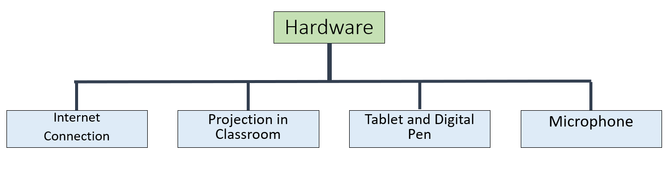
Figure 6: Overview - Necessary Hardware
Internet Connection:
A fast internet connection for schools is necessary to be able to stream videos. Streaming videos requires a minimum of 5 Mbit / s. Especially when several teachers stream their lessons. But the students also need a stable internet connection to follow the lessons without interruptions.

Projection in Classroom
The projector makes the screen of the tablet visible to the students in the classroom. It replaces the board in the classroom. Ideally, a white wall, a bright projector and a Wi-Fi projector are located in the classroom.

Tablet and Digital Pen
In principle, all tablets are suitable for streaming. Previous experience with the Android, Windows or Apple operating system should be recognised here to ensure easier handling. For example, if you already own an Android mobile phone, it is usually easier for you to use an Android tablet. A digital pen is also worth considering. With the pen you are more flexible in writing and at the same time practise handwriting with the students.

Microphone
Often microphones are already integrated in the tablets. However, a separate purchase is also worthwhile. External microphones usually have a better quality and in combination with a Bluetooth function and a clip that can be attached to the shirt, it can be easily moved around the classroom and the students hear you better.

Software
The following software programmes should be installed and configured on the school tablets. These ensure quick use in everyday school life. Once you have become accustomed to the software, you will be able to use it more quickly.
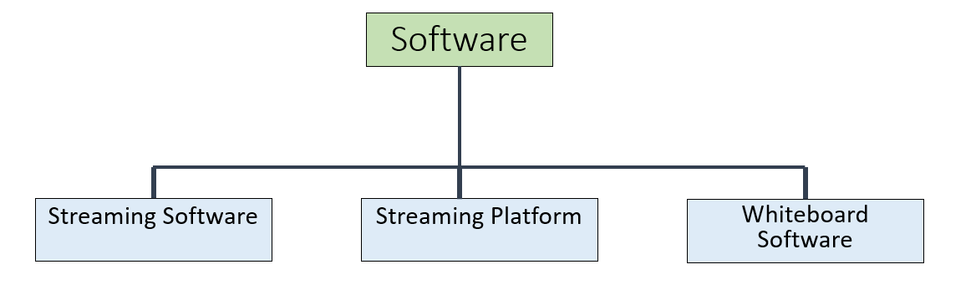
Figure 7: Overview - Necessary Software
Streaming Software
The function of the streaming software is that it records the content of the table screen to a streaming platform as encoded video. This includes the image of the tablet and the voice of the teacher. The authors of the DISK-Online approach recommend Streamlabs OBS (cf. Beutner & Pechuel 2021, p. 164). Streamlabs OBS is free of charge and one of the most popular choices used by many streamers world-wide. The program is available as an app for iOS and Android and already comes with pre-configured settings to connect to some of the most popular streaming platforms.

Streaming Platform
A Streaming Platform is necessary to make the video stream available to the viewers through browsers. Teacher who want to stream need to register an account at a streaming platform (which is normally free). The choice of streaming platforms on the internet is very large. The best-known representatives are YouTube and Twitch. Students in particular will be familiar with these platforms. Both can be used freely and without requiring the students to register. Considering topics such as data security and preserving a protected learning space calls are getting louder for school authorities or ministries to provide a streaming platform solution for schools that takes the difficult decision of how to deal with the aspect of student data on the internet out of the hands of teachers.

Whiteboard Software
Strictly speaking no special software is needed, however, it can support the teacher greatly. The easiest solution would be using any drawing program with a white background that the teacher can write on. More and more apps offer writing support for digital pens though and they have the advantage of making it easier to save the screens or quickly open screens the teacher prepared in advance. There are specific blackboard/whiteboard apps that have more support functions but these are generally not free.

Increasing the purpose of use
So originally the idea of the DISK approach was an initiative to tackle the challenges of COVID-19. But on closer inspection, the streaming approach can take an important step forward in the digital classroom.

Streaming of a teacher from home
If the teacher is in quarantine or has to work from home for other reasons, the DISK-Online approach would allow the teacher to continue teaching from home.
It does not matter whether the students are in school or learning from home. Both work if, for example, a teacher starts the computer / tablet in the classroom at the beginning of the lesson and supervises the class if necessary.
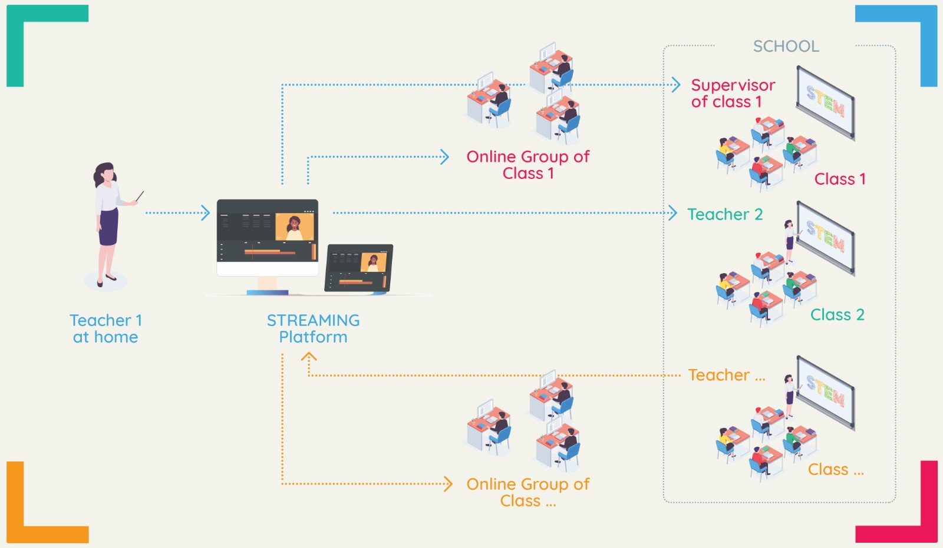
Figure 8: Streaming of a teacher from home

Streaming lessons in a team
At the same time, the DISK-online approach can be used for team teaching. For example, while one teacher is teaching via the stream, the other teacher can clarify individual questions. The same goes the other way around, while one teacher is teaching in the classroom, the other person can serve as a contact person.

Streaming from different schools
The streaming platform can be connected with different schools and not only with one, which brings economies of scale into the learning process (cf. Beutner & Pechuel 2021b, p. 181). For example, the model can be applied if a school lacks teacher for a certain subject or if other schools offer special performance courses and additional courses. Another example can be found for pupils who are talented in some subjects. For example, the pupil can attend mathematics classes at another school without having to change schools completely.
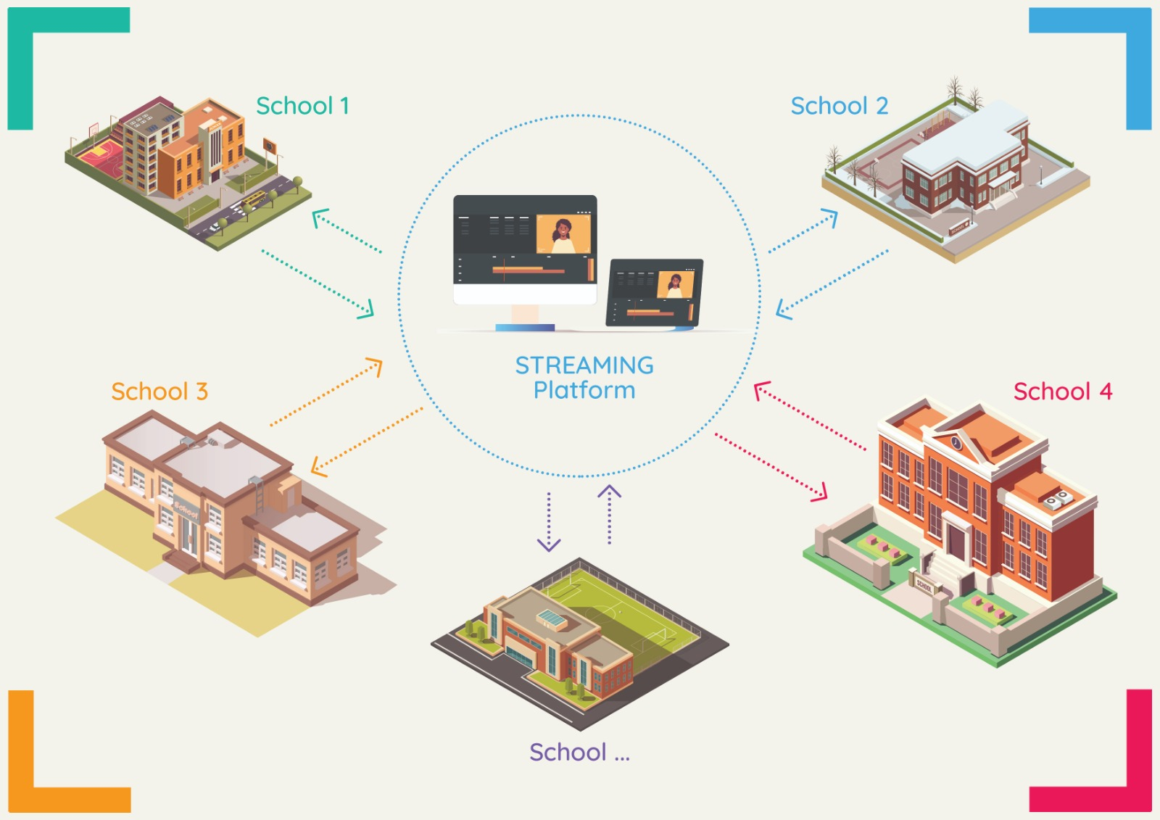
Figure 9: Streaming from different schools

Example of a teaching synopsis in connection with the DISK-online approach
Here you can see a teaching synopsis focussing on the DISK1 to DISK4. Subject-specific content is omitted for the sake of clarity.

Example of a teaching synopsis in connection with DISK1
Phases | Main content / operation | Social form / methods / action form | Media / Material  (memories and comments)
Before class |  |  | - The teacher turns on the projector and the tablet  - The teacher clips on the microphone  - The teacher starts the streaming software, the whiteboard app and logs-in to the streaming platform.  - If worksheets are to be used in the lesson, they should have been given or sent to the pupils in advance
Entry | The teacher welcomes the class and introduces the lesson | Class discussion / Student’s activation | - The teacher initiates a lesson introduction, as usual  - The teacher keeps checking that the internet connection is stable and that the stream is being recorded.
Elaboration | The students analyse the lesson topic | Single work | - The teacher makes sure that the online group can also access the materials  - The teacher helps with the tasks individually
Saving | The students present their results. The teacher supports and corrects if necessary | Student presentation / Class discussion | - The teacher makes sure that the online group can hear the student presentations. With the permission of the students, the teacher may also record the students.
Transfer | The teacher sets a new impulse for a content transfer | Class discussion | - The teacher keeps checking that the internet connection is stable and that the stream is being recorded.
Homework | The teacher provides homework and consolidation texts | Single work | - The teacher makes sure that the online group can get access to the homework sheets or consolidation texts
After class |  |  | - The teacher saves the stream  - The teacher turns off the projector and the tablet  - The teacher clips off the microphone
Table 6: Hints for conducting lessons with DISK 1

Example of a teaching synopsis in connection with DISK2
Phases | Main content / operation | Social form / methods / action form | Media / Material  (memories and comments)
Before class |  |  | - The teacher turns on the projector and the tablet  - The teacher clips on the microphone  - The teacher starts the streaming software, the whiteboard app and logs-in to the streaming platform.  - If worksheets are to be used in the lesson, they should have been given or sent to the pupils in advance
Entry | The teacher welcomes the class and introduces the lesson | Class discussion / Student’s activation | - The teacher asks the online group if he/she can be understood well and asks for feedback (raise hand or make a short comment)  - The teacher initiates a lesson introduction, as usual  - The teacher keeps checking that the internet connection is stable and that the stream is being recorded.  - The teacher pays attention to whether students ask questions in the chat
Elaboration | The students analyse the lesson topic | Single work | - The teacher makes sure that the online group can also access the materials  - The teacher helps with the tasks individually  - The teacher pays attention to whether students ask questions in the chat
Saving | The students present their results. The teacher supports and corrects if necessary | Student presentation / Class discussion | - The teacher makes sure that the online group can hear the student presentations. With the permission of the students, the teacher may also record the students  - The teacher pays attention to whether students ask questions in the chat  - The teacher can also specifically address the online group to activate them
Transfer | The teacher sets a new impulse for a content transfer | Class discussion | - The teacher pays attention to whether students ask questions in the chat
Homework | The teacher provides homework and consolidation texts | Single work | - The teacher makes sure that the online group can get access to the homework sheets or consolidation texts
After class |  |  | - The teacher saves the stream  - The teacher turns off the projector and the tablet  - The teacher clips off the microphone
Table 7: Hints for conducting lessons with DISK 2

Example of a teaching synopsis in connection with DISK3
Phases | Main content / operation | Social form / methods / action form | Media / Material  (memories and comments)
Before class |  |  | - The teacher turns on the projector and the tablet  - The teacher clips on the microphone  - The teacher starts the streaming software, the whiteboard app and logs-in to the streaming platform  - If worksheets are to be used in the lesson, they should have been given or sent to the pupils in advance
Entry | The teacher welcomes the class and introduces the lesson | Class discussion / Student’s activation | - The teacher asks the online group if he/she can be understood well and asks for feedback (raise hand or make a short comment)  - The teacher initiates a lesson introduction, as usual  - The teacher keeps checking that the internet connection is stable and that the stream is being recorded.  - The teacher pays attention to whether students ask questions in the chat  - The teacher initiates exchange phases (murmur phases) for the students on site as well as for the online group.
Elaboration | The students analyse the lesson topic. The teacher can now also initiate partner and group work related to DISK 3 | Single work / Partner work / Group work | - The teacher makes sure that the online group can also access the materials  - The teacher organise the online group into small groups / partners so that the students can exchange ideas better  - The teacher initiates exchange phases (murmur phases) for the students on site as well as for the online group.  - The teacher helps with the tasks individually  - The teacher pays attention to whether students ask questions in the chat  - The teacher increasingly takes the role of the learning initiator.  - The pupils work out the tasks cooperatively.
Saving | The students present their results. The teacher supports and corrects if necessary | Student presentation / Class discussion | - The teacher makes sure that the online group can hear the student presentations. With the permission of the students, the teacher may also record the students.  - The teacher pays attention to whether students ask questions in the chat  - The teacher considers the online group as full students who also present their results.
Transfer | The teacher sets a new impulse for a content transfer | Class discussion | - The teacher pays attention to whether students ask questions in the chat  - The teacher considers the online group as full students who also present their results.
Homework | The teacher provides homework and consolidation texts | Single work | - The teacher makes sure that the online group can get access to the homework sheets or consolidation texts
After class |  |  | - The teacher saves the stream  - The teacher turns off the projector and the tablet  - The teacher clips off the microphone
Table 8: Hints for conducting lessons with DISK 3

Example of a teaching synopsis in connection with DISK4
Phases | Main content / operation | Social form / methods / action form | Media / Material  (memories and comments)
Before class |  |  | - The teacher turns on the projector and the tablet  - The teacher clips on the microphone  - The teacher starts the streaming software, the whiteboard app and logs-in to the streaming platform  - If worksheets are to be used in the lesson, they should have been given or sent to the pupils in advance  - Students also make sure that their tablet, microphone and, if applicable, camera are working
Entry | The teacher welcomes the class and introduces the lesson | Class discussion / Student’s activation | - The teacher asks the online group if he/she can be understood well and asks for feedback (raise hand or make a short comment)  - The teacher initiates a lesson introduction, as usual  - The teacher keeps checking that the internet connection is stable and that the stream is being recorded  - The teacher pays attention to whether students ask questions in the chat  - The teacher initiates exchange phases (murmur phases) for the students on site as well as for the online group
Elaboration | The students analyse the lesson topic. The teacher can now also initiate partner and group work related to DISK 3 | Single work / Partner work / Group work | - The teacher makes sure that the online group can also access the materials  - The teacher organise the online group into small groups / partners so that the students can exchange ideas better.  - Grouping is done between the online group and the students in the classroom to increase interaction between students  - The teacher initiates exchange phases (murmur phases) for the students  - The teacher helps with the tasks individually  - The teacher pays attention to whether students ask questions in the chat  - The teacher increasingly takes the role of the learning initiator  - The pupils work out the tasks cooperatively  - The pupils organise themselves independently  - The students of the online group can report to the students who are on site
Saving | The students present their results. The teacher supports and corrects if necessary | Student presentation / Class discussion | - The teacher pays attention to whether students ask questions in the chat  - The teacher considers the online group as full students who also present their results  - The pupils organise themselves independently  - The students of the online group can report to the students who are on site
Transfer | The teacher sets a new impulse for a content transfer | Class discussion | - The teacher pays attention to whether students ask questions in the chat  - The teacher considers the online group as full students who also present their results.
Homework | The teacher provides homework and consolidation texts | Single work | - The teacher makes sure that the online group can get access to the homework sheets or consolidation texts  - The pupils organise themselves independently  - The students of the online group can report to the students who are on site
After class |  |  | - The teacher saves the stream  - The teacher turns off the projector and the tablet  - The teacher clips off the microphone
Table 9: Hints for conducting lessons with DISK 4

Equipment checklist for schools

Hardware

- Adequate internet connection (at least 5Mbit/s upload speed)

- Projection in Classroom

- Tablet (with a video camera)

- Digital Pen

- Microphone (which can be clipped on to a shirt and has Bluetooth)

Software

- Streaming Software
(installed and configured)

- Streaming Platform
(installed and configured)

- Whiteboard Software
(installed and configured)

Equipment checklist for students (online group)

Hardware

- Adequate internet connection

- PC / Laptop or Tablet (with a video camera)

- Microphone / Headset

Software

- Browser

References
Anger, S & Sandner, M (2020): Schulschließungen, fehlende Ausbildungsplätze, keine Jobs: Generation ohne Zukunft? In: Journal of ifo Schnelldienst, Vol. 73. September, pp. 3-7.
Beutner, M. & Pechuel, R. (2021a): Easy technology designs for innovative learning. In: Sanchez, Kommers, Issa, Isaias (Eds.): Mobile Learning and Educational Technologies 2021. International Conferences on Mobile Learning 2021 (ML 2021) and Educational Technologies 2021 (ICEduTech 2021), pp. 161-167.
Beutner, M. & Pechuel, R. (2021b): Mobile Learning with the DISK-ONLINE approach. In: Sanchez, Kommers, Issa, Isaias (Eds.): Mobile Learning and Educational Technologies 2021. International Conferences on Mobile Learning 2021 (ML 2021) and Educational Technologies 2021 (ICEduTech 2021), pp. 179-184.
Crompton, H (2017): Moving toward a mobile learning landscape: Presenting an mlearning integration framework. In Interactive Technology and Smart Education Journal, Vol. 18, No. 2, pp. 97-109.
Engzell, P., Frey, A., & Verhagen, M.D. (2020): Learning Loss Due to School Closure During the COVID-19 Pandemic. In: https://doi.org/10.31235/osf.io/ve4z7 (last call: 23.09.2021).
Helbig, M. (2021): Als hätte es Corona nicht gegeben. Bildungspolitische Reaktionen auf Schulschließung und Distanzunterricht. In: WZBrief Bildung, No. 43, March 2021, Berlin.
Horn, M.B. & Staker, H. (2011): The Rise of K-12 Blended Learning. Access: https://aurora-institute.org/wp-content/uploads/The-Rise-of-K-12-Blended-Learning.pdf, (last call: 21.09.2021).
Beutner, M. & Pechuel, R. (2020a). The use of streaming for online lessons – A basic implementation option in the context of the COVID-19 situation. Proceedings of SITE Interactive Online 2020. Currently in Print.
Beutner, M. & Pechuel, R. (2020c). DISK Online Streaming Concept for hybrid learning – Dealing with the challenges of COVID-19 in learning settings. Proceedings of Innovate Learning Summit 2020 Online. USA 2020. Currently in Print.
Mossavar-Rahmani, F. & Larson-Daugherty, C. (2007): Supporting the Hybrid Learning Model: A New Proposition. In MERLOT Journal of Online Learning and Teaching. Vol. 3, No. 1, March 2007, pp. 67-77.
O’Byrne, W. I. & Pytas, K. E. (2015): Hybrid and Blended Learning, Modifying Pedagogy Across Path, Pace, Time, and Place. In Journal of Adolescent & Adult Literacy. Vol. 59, No. 2, September / October 2015, pp. 137-140.

