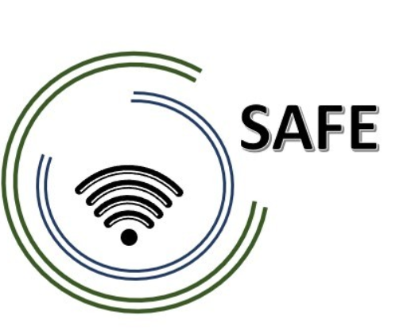
SAFE
Streaming Approaches for Europe
Reference Number:
2020-1-DE03-KA226-SCH-093590
Aktenzeichen der NA:
VG-226-IN-NW-20-24-093590

O1- A4 Desktop Research: Streaming in school education in times of COVID- 19
May 2021
University of Paderborn
Jennifer Schneider

Project Title: Streaming Approaches for Europe
Acronym: SAFE
Reference number: 2020-1-DE03-KA226-SCH-093590
Aktenzeichen der NA: VG-226-IN-NW-20-24-093590
Project partners: P0 – UPB – University Paderborn, DE (Coordinator)
P1 – IK – Ingenious Knowlegde, DE (Partner)
P2 – CEIP – CEIP Tomás Romojaro, ES (Partner)
P3 – ZEBRA – KURZY ZEBRA s.r.o., CZ (Partner)

O1- A4 Desktop Research: Streaming in school education in times of COVID- 19

Table of Content

1. Streaming in school in times of COVID- 19 – Short Introduction 3
2. Key skill areas of teacher training curriculum 4
2.2 Key skill levels for local teachers 5
2.3 Key skill levels for local learners 6
3. Media formats for learning content 7
3.1 Redesign of existing course structure 8
3.2 Assessment framework for measurement of attainment 9
4. Pedagogic Supports for Streaming in school approaches 10

Streaming in school in times of COVID- 19 – Short Introduction
Please, explain why streaming in times of COVID-19 is important and how that can be implemented at your organisation.

Key skill areas of teacher training curriculum

What are the key skill areas that need to be addressed in the teacher training curriculum with regard to hybrid streaming approaches?

Please, address the same question with regard to streaming approaches based on the DISK-model?

Key skill levels for local teachers
Please, refer to specific technological skills, methodological skills, communicative skills, digitisation skills, social skills, topic related skills, pedagogical and didactic skills, (self-)reflection skills.

Key skill levels for local learners
Please, refer to specific technological skills, methodological skills, communicative skills, digitisation skills, social skills, topic related skills, pedagogical and didactic skills, (self-)reflection skills.

Media formats for learning content
What are the most appropriate media formats for learning content within the teacher training in each partner country?

3.1 Redesign of existing course structure and resources

What course structures which already exist in your country?

What existing resources could be used or re-designed for use in the courses and the curriculum to avoid duplication? What is important? What has to be taken into account to guarantee success?

3.2 Assessment framework for measurement of attainment
What type of assessment framework would be most appropriate to facilitate the measurement of attainment?

Pedagogic Supports for Streaming in school approaches

What types of pedagogic supports are needed to facilitate the schools, teachers and tutors? What has to be focused? What is important? What guarantees success?

