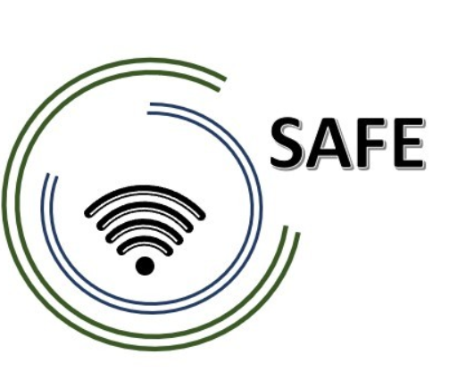
SAFE
Streaming Approaches for Europe
Reference Number:
2020-1-DE03-KA226-SCH-093590
Aktenzeichen der NA:
VG-226-IN-NW-20-24-093590

O1- A2 SAFE Learning Outcomes Approach
Learning Outcome Matrix
July 2021
University of Paderborn
Jennifer Schneider

Project Title: Streaming Approaches for Europe
Acronym: SAFE

Reference number: 2020-1-DE03-KA226-SCH-093590
Aktenzeichen der NA: VG-226-IN-NW-20-24-093590

Project partners: P0 – UPB – University Paderborn, DE (Coordinator)
P1 – IK – Ingenious Knowlegde, DE (Partner)
P2 – CEIP – CEIP Tomás Romojaro, ES (Partner)
P3 – ZEBRA – KURZY ZEBRA s.r.o., CZ (Partner)

The SAFE
Learning Outcome Matrix (LOM)

The purpose of these information and charts are to illustrate how outcomes align with teaching and learning methods and assessments in the SAFE S approach.

The following general aims and objectives are focused with the LOM:
This SAFE Learning Outcome matrix is designed to inform about the development of the curriculum structure to integrate pedagogic strategies and the SAFE eLearning Courses for teacher education. Therefore, we focusing on a learning outcomes approach facilitates the tailoring of the pedagogic induction resources. This provides the possibility to suit specific cultural and societal values and ensures that local issues and necessary topics are addressed within the SAFE approach. It allows individual learning content to be localised to take account of the different cultural patterns in partner countries without compromising the value of the learning resource.

The topics addressed in the SAFE -measures for Persons who are teachers and trainers in school are:
General part of SAFE measures
- A Short overview of project objectives and aims to achieve
- Introduction to the SAFE curriculum
- The target group -
Characteristics of the SAFE target group, their needs and expectations
- Introduction to the eLearning platform

Subject related part of SAFE measures:
- Definitions- of terms
- Description of the history towards digitisations and industry 4.0
- SAFE Streaming in school education – blended learning approach
- SAFE Curriculum, competences and didactical materials (Classroom Materials)

Important Aspects and Challenges for Persons who are teachers and trainers in school are:
Important for teachers and trainer are pedagogical approaches and the idea of being “facilitators of learning” and the different style of learning, the quality of the curriculum and their support especially concerning the use of the e-learning platform and the resources.
A special challenge concerning the SAFE Curriculum could may be the lack of time. Therefore, the main challenge will be the time commitment.
In addition to that, the main challenges are being authentic, the motivation of students, patience in the tutoring and mentoring processes and a stable technology.
It is important that the measures need to be concise, short, relevant and delivered face to face in a flexible way. The benefits of participating have to be emphasized and the opportunities for questions and networking should be raised. It is necessary to allocate appropriate time for the participants’ needs.

Based on the results of the research at of the SAFE partners the following SAFE Learning Outcome Matrix for learners in teacher education could be derived:

Learning Outcome Matrix (LOM) for persons who are teachers and trainers in school (SAFE LOM)
Outcome | Teaching and Learning Activities | Assessment
Having taken this course, participants (teachers/trainers) will be able to: | The participants (teachers/trainers) will be taught to achieve this specific outcome through the following learning activities: | The participants (teachers/trainers) will be assessed on their achievement of this specific outcome through the following assessment tasks:
understand the main aspects, fundamentals and modules of the SAFE measure and the aims of the project as well as the philosophy of SAFE | The participants will get informed by a ppt presentation which provides an overview concerning the SAFE idea and the measure. | An oral feedback and a short evaluation questionnaire is main basis of assessing the right understanding of SAFE
use and dynamise the SAFE e-learning platform and its functions and supporting elements. | The participants will go through a life demonstration. Therefore, the are forced to see and reflect the actions and also to do all actions themselves. | The assessment will be carried out in the SAFE online forum. There will be an easy and time-independent place to discuss, share impressions and get feedback of participants and trainers
organize and create engaging face-to-face sessions fitting to the curricular ideas of SAFE | The participants will take part in a workshop to create their own lessons plan. | During the workshop there will be feedback sessions and oral support by the trainers.
understand key principals of the pedagogical approach of SAFE | This understanding will be raised by discussion groups. These groups work in teams on their expectations and requirements of the curriculum and the pedagogical approach. In presentations, main aspects can be combined and made available as a basis for intensive discussions. | The assessment will be carried out in a wall newspaper of each group on which main key principles are documented. This will be the basis for oral feedback.
adopt the learning content to the needs of graduates | The adoption process will be learned in short case studies which will be analysed and combined with practical experiences. These experiences will be integrated in creating own learning contents and necessary didactical material by the participants. | The assessment of the adopting process will be done in two way, creating an own short learning content and the necessary didactical material by the learners and a group discussion with feedback on these created contents.
know about learning theory and facilitating learning processes as well as implement it in their face-to-face sessions. | The participants can achieve these knowledge aspects via self directed learning with the support of the trainers. They also get role awareness via a roleplay in which they have to act as a learning facilitator. | The assessment will take place in the direct communication situation and can be carried out in discussion forums as well to get direct feedback.
recognise different perspectives on digitization and the different ideas of defining digitization and digitalisation. | The participants are discussion different points of view and take part in a pro-contra discussion. | The assessment of getting to know their own problems with learning can be carried out best in an oral way in a discussion process.

