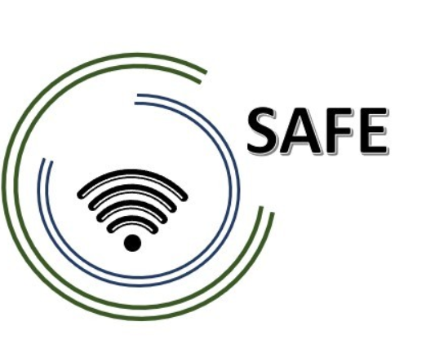

SAFE
Streaming Approaches for Europe – Enhancing the digital competences by streaming approaches for schools to tackle the challenges of COVID-19

IO1 SAFE – A4 Desktop Research:
Streaming in school education in times of COVID-19

Project Title: Streaming approaches for Europe – Enhancing the digital competences by streaming approaches for schools to tackle the challenges of COVID-19
Acronym: SAFE
Reference number: 2020-1-DE03-KA226-SCH-093590
Project partners: P1 University Paderborn (UPB), DE
P2 Ingenious Knowledge GmbH (IK), DE
P3 TOMAS ROMOJARO (CEIP), ES
P4 KURZY s.r.o. (ZEBRA), CZ

Table of Content

1. Streaming in school in times of COVID- 19 – Short Introduction 1
2. Key skill areas of teacher training curriculum 2
2.2 Key skill levels for local teachers 6
2.3 Key skill levels for local learners 6
3. Media formats for learning content 8
3.1 Redesign of existing course structure and resources 9
3.2 Assessment framework for measurement of attainment 11
4. Pedagogic Supports for Streaming in school approaches 12
References 14

Table of figures

Figure 1: SAMR-Model by Ruben Puentedura (cf. 2006 / cf. 18.06.2021) 5
Figure 2: (DigCompEdu 2021a) - Overview 9

Streaming in school in times of COVID- 19 – Short Introduction
Please, explain why streaming in times of COVID-19 is important and how that can be implemented at your organisation.
The COVID-19 pandemic prompted a digitisation shift in schools and universities. In Germany, attempts were made to continue teaching both at schools and universities, although distance regulations and hygiene rules became more and more stringent. For this reason, online and hybrid teaching formats were introduced. In Online Learning, the whole class is at home and is trained by the teacher. Hybrid learning is a combination of learners learning on-site, e.g. in a classroom or lecture hall, and learners participating from home via a computer (cf. Heinrich 2021). Here, teachers had to become creative themselves and come up with didactic implementation strategies. There was no uniform proposal or model.
A great difficulty for the students who attended the lessons from home was to keep their motivation and attention high. Sitting in the children’s room at home from 8 a.m. to 4 p.m. doing schoolwork, playing video games or reading exciting books instead, required a huge potential of discipline and motivation from many students. It is more motivating for the students to follow the lessons via stream instead of working on worksheets independently. Especially because in their free time, the students themselves like to watch streams or even stream themselves playing video games, assembling something or learning by doing tutorials. The streaming platforms Youtube and Twitch deserve special mention. These are very popular with the students and becoming more and more popular.
In addition, in times of COVID-19, the social contacts of many students have diminished. Students who previously saw each other every day in the classroom and interacted with each other have not seen each other for a long time. Often the lessons were not designed for exchanging ideas with classmates.
In sum, a digital concept is needed that motivates students, promotes interaction and can be used flexibly, especially with regard to the different competences of teachers and students as well as different teaching formats.

Key skill areas of teacher training curriculum
What are the key skill areas that need to be addressed in the teacher training curriculum with regard to hybrid streaming approaches?
In addition to Mudra’s concept of competence (cf. Mudra 2004, p.364) as well as Heyse’s and Erpenbeck’s concept of competence (cf. Erpenbeck & Heyse 2004, p. XXI) which are already considered in the teacher training curriculum. The focus should also be emphasized in a hybrid learning format on the digital competence. The Media Competence Framework NRW (2018, p.4), for example, can be used for this purpose. When designing digital teaching/learning arrangements, the Media Competence Framework NRW provides a systematic overview. The Media Competence Framework NRW is divided into six areas. The teacher must take the six areas into account when planning their lessons with digital elements for the pupils on site, and especially for the pupils who follow the lessons online.
The Media Competence Framework NRW names the following six areas (cf. 2018, p.4):

- Operate and apply - includes the technical ability to use media sensibly and the prerequisite of every active and passive media use)
- Inform and research - includes the sensible and targeted selection of sources as well as the critical evaluation and use of information)
- Communicate and cooperate - includes mastering rules for safe and purposeful communication and using media responsibly for cooperation)
- Produce and present - includes knowing media design possibilities and using them creatively in the planning and realisation of a media product)
- Analyse and Reflect - includes on the one hand, the knowledge of the diversity of media, on the other hand, the critical examination of media offers and one's own media behaviour. The aim of reflection is to achieve self-determined and self-regulated media use.
- Problem solving and modelling - includes basic computer literacy as an elementary component in the education system. In addition to problem-solving strategies, basic skills in programming are taught and the influences of algorithms and the impact of the automation of processes in the digital world are reflected upon.

When using digital media, both at school and at home, the six areas should be considered. In daily teaching, teachers should take the areas into account and weight them differently depending on the topic, so that students are trained in all six areas.

Please, address the same question with regard to streaming approaches based on the DISK-model?

The DISK (Didactic Interactive Streaming Know-how) -online approach of Beutner and Pechuel from 2020 is focused on hybrid learning and therefore offers opportunities for eLearning which combines face-to-face learning with online learning via a streaming concept. The DISK model consisting of four stages, which are also called DISK1 to DISK4. The different DISKs indicate different levels of interaction and digital settings (cf. Beutner & Pechuel 2020a; 2020b; 2021, p. 163)
In relation to Beutner and Pechuel’s DISK-Online approach, teachers need to deepen the six previously mentioned areas when designing their long-term teaching arrangements.
In the following, exemplary individual sub-items for the six areas are mentioned, which are relevant fort the implementation of the DISK approach

- Operate and apply –
- Is the media equipment of the students (PC, webcam, microphone, stable internet connection) and the teacher (webcam, tablet, recording programs, etc.) sufficient for the planned used of online teaching?
- How will the data created online be stored?
- Is data protection and information security guaranteed?

- Inform and research
- Are students given enough time to research information?
- The exchange of information among the pupils must be initiated (at the beginning certainly controlled by the teacher).
- What needs to be considered when evaluation information?
- How are students prepared for fake news and information selection?

- Communicate and cooperate
- Should only the students from the online group chat with each other and the others can talk to each other normally?
- Are groups mixed? Do you have to raise your hand before you are allowed to speak?
- Can they also talk on the phone or video chat with each other?
- What are the communication rules?
- How practicable are the communication rules and how do they prepare students for private communication on Facebook, Instagram etc.?
- How can you prevent cyberbullying?

- Produce and present
- Both teacher and students need to be able to create and share presentations to show their results.
- Also, design functions of media should be known and used reflectively.
- The teacher in particular, but also the students, should handle the use of materials frim the internet carefully and record all sources.
- Aspects of the legal basis, especially when using images, must be made clear and addressed.
- This includes aspects of personal rights, rights of use and copyright.

- Analyse and Reflect
- All participants in the DISK-model should be aware of the diversity of media, their development and meanings
- Nevertheless, when providing materials and videos, the teacher must be aware of the interest-driven setting and dissemination of topics in the media, and in in relation to the formation of opinion asses
- The identity-creating opportunity to express oneself creatively through media (the students can become creative in the DISK approach for example, through pictures, symbols, music, and videos)
- The teacher has to dra attention to the unlimited spread of media and the assessment of what should be spread and what not to his/her students.

- Problem solving and modelling
- The DISK approach also prepares for an increasingly digital world in the future. It allows to identify basic principles and functions of the digital world
- Makes algorithmic structures comprehensible, which is very important for professions related to digitalisation 4.0
- It can be combined with actions skills or occupational references to develop problem strategies

While the aforementioned Media Competence Framework NRW provides a good overview of the functionality and diverse application perspectives of digital media in the classroom in general, the SAMR model by Ruben Puentedura (2006) can be used in relation to the DISK model as well.
At this point it must be said that Ruben Puentedura’s SAMR Model (2006) is not a model that is suitable for science. It has only proven to be very practicable and has enjoyed high recognition in teaching practice in recent years due to its simple illustration (cf. Braun 2019, p.6)

SAMR is an acronym for the four components: Substitution, Augmentation, Modification and Redefinition. The higher the level, the higher the digital use in the classroom. In the following, the four levels are presented in ascending order of digital use.

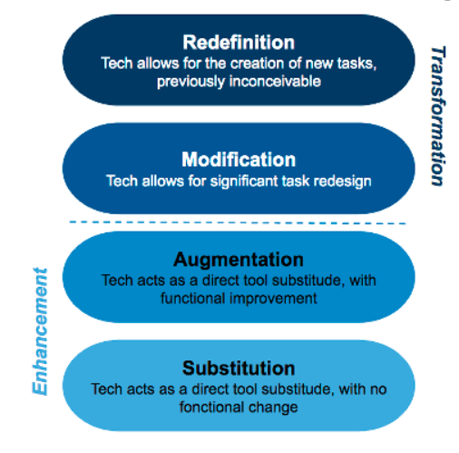
Figure 1: SAMR-Model by Ruben Puentedura (cf. 2006 / cf. 18.06.2021)

At the lowest level, it starts with the simple replacement (substitution) of analogue tasks/materials with digital representations. As example, Puentedura lists reading digitized text or using a computer instead of a typewriter (cf. Puentedura 2006). This dies not bring about any functional improvements, only the representation or the medium changes. At this level, the use of digital media can be practiced. In addition, digital content is available for further use.
An enhancement becomes visible on the second level augmentation. Basic functions such as a grammar and spell checker or the cutting and replacing of content can be used. The integration of technologies also plays a role. Multimedia content (textual, auditory, visual) can be linked and embedded. Puentedura lists, for example, the creation of digital maps and a combination with interactive timelines (cf. Puentedura 2006).
The area of transformation of tasks begins at the level of modification. Tasks that could also be set in analogue form are reformulated in such a way that digital support is required and its advantages are to be used explicitly by learners. Any available software and hardware can be used. Puentedura lists as examples the integration of communication tools (mail), spreadsheets, graphical representations as well as textual, visual and auditory tools. The social aspect an also come to the fore here. The mutual commenting on blog posts and the resulting discussion can be used to build shared knowledge. The focus here is on the redesign of assignments, considering the technical possibilities. The implementation is left to the teachers via the elaboration of concrete tasks (cf. Puentedura 2006).
Tasks that would not be possible without technological support are part of the redefinition level. Instead of writing essays, for example, digital storytelling can be chosen. This does not mean monotonous PowerPoint presentations in which one shimmies from slide to slide, but e.g. a combination of pictures and videos with which a story of the personally most excitingly perceived impressions and information is told. Tools for visualizing content that is difficult to understand can also be used here (cf. Puentedura 18.06.2021).
The DISK model by Beutner and Pechuel also aims at the levels of modification and redefinition. Overcome the barriers and draw from the advantages and benefits of digital tools. The technical possibilities with the help of apps, high performance computers and fast internet can promote interactions and modify school learning to a new level.

Key skill levels for local teachers
Please, refer to specific technological skills, methodological skills, communicative skills, digitization skills, social skills, topic related skills, pedagogical and didactic skills, (self-)reflection skills regard to hybrid streaming approaches
In general, regardless of the teaching format, teachers should have well-developed methodological, communicative, social and pedagogical skills, as well as the ability to reflect and, for example to question their actions or their teaching.

However, what needs to be more developed in many teachers, especially in relation to a hybrid streaming approach, is the deepening of technical and digital skills. The German Conference of Ministers of Education and Cultural Affairs (in short KMK) describes ten points in which teachers should be able to teach when using digital elements (KMK 2017, p.26-28).

  - continuously develop their own general media competence, i.e. to handle technical devices, programs, forms of learning and workplaces etc. with confidence, to be able to carry out preparatory activities, also in collegial coordination groups, administrative tasks as well as the smooth use of digital media in lessons and the safe handling of data.

  - to recognize the importance of media and digitalization in the life world of pupils in order to develop effective concepts for media education and to support the acquisition of competences for the use of digital media in a didactically reflected and prepared manner,

  - to plan, implement and reflect on the adequate use of digital media and tools in view of changing individual learning requirements and communication behavior in the digital world. This includes a positive effect on individualized, self-directed and collaborative learning processes and results and open up new design possibilities overall,

  - the learning-theoretical and didactic possibilities of digital media for the individual and didactic possibilities of digital media for the individual support of individuals in and outside the classroom,

  - to choose from the large number of educational media on offer (open educational resources / OER) on the basis of appropriate quality suitable materials and programs for individual or group work, and to identify suitable materials and programs for individual or group work,

  - to support pupils in learning with and through media as well as in designing media, so that they can reflect critically on the growing range of media on offer and choose from them in a meaningful way and use them appropriately, creatively and socially responsibly,

  - on the basis of their subject-related expertise with regard to the planning and design of lessons to cooperate with other teachers and other school and non-school experts on the basis of their subject-related expertise in planning and designing lessons, and to develop and implement learning and support opportunities together with them,

  - to deal with the results of current research on education in the digital world
to take responsibility for their own competence growth and to use it for their own further education and training,

  - through their knowledge of copyright law, data protection and data security and the protection of minors in the media, and to enable pupils to deal consciously and thoughtfully with media and their own data in digital spaces,

In relation to the hybrid streaming approach, it is worth noting that few teachers cover all ten points straight away. These are not meant to be a deterrent, but rather to be highlighted as goals and to start the development process. Sharing experiences among colleagues, visiting each other’s classes, taking advantage of further training opportunities and teaching team are helpful here. Especially the last point regarding the knowledge of copyright law, data protection and data security are important, but its specific from each country and many teachers forget the direct rules.

Another method of assessing teachers' digital competences is described below.

At European level, the DigCompEdu (The European Framework for the Digital Competence of Educators) project was outstanding. The DigCompEdu project is a project funded by the European Commission and investigated digital competeneces of teachers. They have identified 22 digital competences from 6 categories, which are divided in 3 areas. In the following, the 3 areas as well as the 6 categories are illustrated (cf. DigCompEDU 2021a).
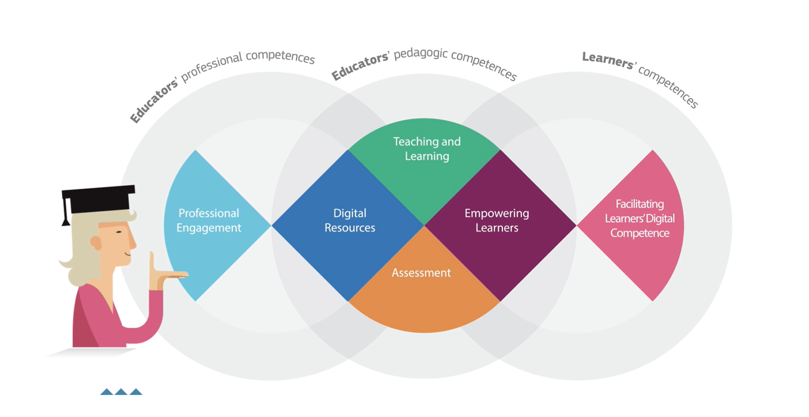
Figure 2: (DigCompEdu 2021a) - Overview

Particularly interesting is the possibility for teachers to independently determine their own digital competence level. The following QR code leads to the assessment procedure.

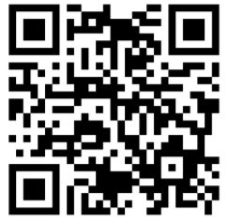
The DigCompEdu CheckIn Tool exists in three versions adapted to the respective educational sector (cf. DigCompEDU 2021b).

- For teachers at general or vocational schools: http://europa.eu/!cG34MH
- For teachers at universities or universities of applied sciences: http://europa.eu/!gh46kD
- For teachers in adult education: http://europa.eu/!ut86vP

During the assessment, teachers are classified in categories A1, A2, B1, B2, C1 and C2. Starting with A1 (entry level) up to C2 (proficiency level). The concept of grading is based on the Common European Framework of Reference for Languages (cf. DigCompEDU 2021b)

Key skill levels for local learners
Please, refer to specific technological skills, methodological skills, communicative skills, digitization skills, social skills, topic related skills, pedagogical and didactic skills, (self-)reflection skills.
While planning digital lessons for teachers is a challenge, based on the lack of digital competences. Students are in the user role less affected by digital literacy.
There are four aspects that prepare students in contemporary society and which also come into play in the hybrid streaming approach. The four aspects are: Critical Thinking, Communication, Collaboration and Creativity
The 4Cs go back to the US initiative P21 (Partnership for 21st Century Learning), in which experts from business, education and politics have joined forces to reflect on education in the digital age (cf. P21 2019)
The 4Cs are not clearly distinguishable from each other (cf. Kembara et al. 2019, p. 23), but a brief description with regard to the hybrid stream approach follows.

Critical Thinking
“Students must be triggered to think outside of their existing habits by involving new ways of thinking.”(Kembara et al. 2019, p. 23). In relation to the hybrid streaming approach, a space for freedom of expression must be created. Teaching topics must be adapted to critical, complex situations.

Communication
“The ability to communicate and collaborate is important because students are required to be able to be part of the community.” (Kembara et al. 2019, p. 23). Also, in the hybrid streaming approach, the possibility for interaction, exchange of opinions and positioning must be given, i.e. the teacher must not only stream the lessons but also design discussion rounds.

Collaboration
Working in teams is becoming increasingly important from a business perspective. The students have to exchange ideas in groups and work on an overall result, such as a model, a poster, a presentation or similar. Each member of the group makes his or her own contribution.

Creativity
“Creativity and innovation will develop if students have the opportunity to think divergently.” (Kembara et al. 2019, p. 23). The promotion of creativity is also given in the hybrid streeaming approach, if the teacher allows it. For example, students can create their own explanatory video on a topic instead of a simple oral presentation.

Media formats for learning content
What are the most appropriate media formats for learning content within the teacher training in each partner country?

The most suitable formats within teacher training in Germany are learning videos and streams. Not only students aged 12 to 19 want to be taught with audiovisual tools and materials (cf. Liebau 2019, p.7-9).
Teachers are also increasingly using learning videos and streams for their own professional development. While many German teachers were very reluctant to take the initiative in training until a few years ago, the COVID-19 pandemic and videoconferencing have led to an increased demand for training (cf. Daschner 2019, p.13).
The factors that influence why teachers use learning videos seem to be analogues to the factors that influence students. Learning through videos is also more motivating for teachers. But that should not be the main reason. On the one hand, teachers can play the video in their free time when it suits them. Many teachers do not have time to prepare lessons until late in the evening because they have to take care of their families after school.
On the other hand, the in-service training often does not focus on “what something is”, but rather on “how something works”. For example, how this app works, how to deal with such pupils, how to improve digital mind mapping or how to keep a digital class register.
This way, the teacher can pause, rewind or skip the video as often as they want if they need the instructions again or already known the procedure.
The video platform Youtube, but also the site Twitch.tv, which is very popular with students, have a large selection of videos. The statistics show the ever-increasing popularity of the two platforms. While Twitch recorded 611.5 million visitors in Nov 2019, it already has an incredible 1230 million visitors in August 2021 (cf. Statista 2021a). This can only be topped by the giant Youtube. In comparison Youtube recorded 28,44 billion visitors in Nov 2019, it already has an incredible 35,11 billion visitors in August 2021 (cf. Statista 2021b).

In addition to the usual providers such as Youtube and Twitch, the streamingwebsite Forbizz (https://fobizz.com/lehrerfortbildung-online/) has become popular among teachers for professional development in recent months.
Fobizz provides videos, live-chats as well as teaching materials for teachers on all sectors. Mainly from Germany, but teachers all over the world can exchange new teaching techniques, materals, tips and tricks.
So there are learning videos about for example: digital tools for class, creating movies in class specific on storytelling and movie language, learning to program at primary school, creating quizzes and tests with Microsoft Forms and much more.
The website is specific on teachers’ demand.

It is worth mentioning here that a large part of the Forbizz site is chargeable. However, schools often have funds left over for training that are not fully used, so that it is still possible to use them (cf. Fobizz 2021).
In addition to a wide range of German teachers, Forbizz is also being used more and morea abroad. Over 1,000 teachers and schools abroard use forbizz. These include countries such as Argentina, Paraguay, Singapore and Turkey (cf. Fobizz 2021)

For example, Forbizz specializes in professional development with videos for teachers, but as already indicated at the beginning, platforms such as Youtube and Twitch are more popular with students. We also think thath a free training method in the sense of an OER concept for schools, provided by the state, would be a good idea.

4. Assessment framework for measurement of attainment
What type of assessment framework would be most appropriate to facilitate the measurement of attainment?
In fact, assessing student performance proves to be the most difficult challenge in three ways.

First of all, in the first trials of hybrid teaching formats by teachers with classes, a proper performance evaluation can hardly be recorded. The teacher has to get used to the format, as do the students. This takes time and reflection processes. At the same time, it is difficult for the teacher to conduct the lessons smoothly. Observations take place only marginally.

Second, depending on the circumstances, students who do not have sufficient technical equipment at home, such as a constant internet connection or a laptop, may be in a worse position than those with good equipment. Here a fair assessment is difficult. Likewise, depending on the streaming experience of the teacher, on-site teaching in the teacher’s classroom may be excellent, but only a fraction may be streamed. In this case, the students in the classroom would be able to follow and participate in the lessons, and the online group would unfortunately only partially participate.

Third, the NRW School Act (BASS) states that performance assessment is based on "written work" and "other achievements". "Both assessment areas are taken into account appropriately in the performance assessment.” (SchulG NRW §48 Abs. 2). In the most cases, the performance assessment is made up of 50% written exercises and 50% other work, which includes, for example, oral participation in class and small tests. The teacher is only able in few lessons, to create an assessment about the participation. Nevertheless, a written exercise is heavy to handle for the teacher. Due to the fact that he has to create three different exercises to avoid copy the answers. For the reason, that he cannot assess.

Pedagogic Supports for Streaming in school approaches

What types of pedagogic supports are needed to facilitate the schools, teachers and tutors? What has to be focused? What is important? What guarantees success?

The types of pedagogic support, which are needed to facilitate the schools can be divided between school and teachers

School
In Germany, many schools do not have a stabile Internet connection. This requirement is absolutely necessary. Schools have to clarify that they got a stabile and expandable internet connection.
Nevertheless, schools also differently technical equipped. Some classes are perfectly equipped at the state of art, others work with old technique like beamer. There is also a need for improvement at this point.
The school also has to set data protection rules to protect teachers and students, but also not too strict measures, because then no personally identified lessons can take place.

Teacher
The most important fact for the teachers is to can get back to a clear digital concept. The concept of Beutner and Pechuel 2020 seems very helpful at this point. The model is clearly laid out and allows for 4 accesses at 4 levels.
It is also advisable to divide the college into small groups for working with a hybrid streaming approach. A division in terms of teachers who teach in the same classes is recommended. These groups can share experiences based on individual class needs. However, in small groups it is easier to talk about challenges and to support each other.
Another helpful support for implementing hybrid streaming approaches is to appoint an expert group of colleagues who are at a very high digital competence level. The experts can, for example, compile FAQs and provide advice and answers to colleagues. Also, a colleague from the expert team should always be available in the school for technical problems in the classroom.
Last but not least, it should be pointed out that implementing hybrid streaming approaches in the classroom is a lot of fun, but requires a lot of commitment and work. Especially for the reason that teaching material often has to be digitised. In this case, jointly provided teaching material in the sense of OER among colleagues is a good way to keep the workload low.

References
Beutner, M. & Pechuel, R. (2020a). The use of streaming for online lessons – A basic implementation option in the context of the COVID-19 situation. Proceedings of SITE Interactive Online 2020. Currently in Print.
Beutner, M. & Pechuel, R. (2020b). DISK Online Streaming Concept for hybrid learning – Dealing with the challenges of COVID-19 in learning settings. Proceedings of Innovate Learning Summit 2020 Online. USA 2020. Currently in Print.
Beutner, M. & Pechuel, R. (2021): Easy technology designs for innovative learning. In: Sanchez, Kommers, Issa, Isaias (Eds.): Mobile Learning and Educational Technologies 2021. International Conferences on Mobile Learning 2021 (ML 2021) and Educational Technologies 2021 (ICEduTech 2021), pp. 161-167.
Braun, H. (2019): Mehr Digitalisierung wagen?! – Auf dem Weg zu einer schulbezogenen IT-Strategie. In: https://fcgs-duesseldorf.de/sites/fcgs/files/content/downloads/2019-11-25/e_8_19_it_strategie_braune.pdf (last call: 11.10.2021).
Daschner, P. (2019): Recherchen für eine Bestandsaufnahme der Lehrkräftefortbildung in Deutschland. Ergebnisse des Projektes Qualitätsentwicklung in der Lehrkräftebildung. Teil 1. In: DVLfB – forum Lehrerfortbildung – Heft 47/2018.
DigCompEdu (2021a): Project website. In: https://ec.europa.eu/jrc/en/digcompedu; (last call 12.11.2021).
DigCompEdu (2021b): Digitale Kompetenz Lehrender. In: https://ec.europa.eu/jrc/sites/default/files/digcompedu_leaflet_de-2018-09-21pdf.pdf; last call 12.11.2021)
Fobizz (2021): https://fobizz.com/lehrerfortbildung-online/; (last call 12.11.2021).
Fobizz (2021): Digitales Fortbildungszentrum für Lehrkräfte rund um IT, Medien und Digitalisierung. In: https://fobizz.com/der-fobizz-jahresruckblick-2020-in-zahlen/, (last call: 11.10.2021).
Heinrich, N (2021): Hybrides Lernen – aber wie? In: Bundeszentrale für politische Bildung: https://www.bpb.de/lernen/digitale-bildung/werkstatt/325751/hybrides-lernen-aber-wie; (last call: 30.09.2021)
Heys, V / Erpenbeck, J (2004): „Vorwort“, In: Heyse, V. / Erpenbeck J. [Ed.]: Kompetenztraining, Stuttgart 2004, S.XI-XXX.
Liebau, E. (2019): Jugend/ Youtube /Kulturelle Bildung. Horizont 2019. Eine repräsentative Umfrage Unter 12- bis 19-jährigen zur Nutzung kultureller Bildungsangebote an digitalen Kulturorten. In: https://www.rat-kulturelle-bildung.de/fileadmin/user_upload/pdf/Studie_YouTube_Webversion_final.pdf, (last call: 11.10.2021).
Medienkompetenzrahmen NRW (2018): https://medienkompetenzrahmen.nrw/medienkompetenzrahmen-nrw/, (last call: 05.10.2021)
Mudra, P. (2004): Personalentwicklung: Integrative Gestaltung betrieblicher Lern- und Veränderungsprozesse, München.
P21 (2019): The 4Cs model. In: https://www.battelleforkids.org/networks/p21; (last call 12.11.2021).
Puentedura, R.R. (2006): Transformation, Technology, and Education. In: http://www.hippasus.com/resources/tte/; (last call: 11.10.2021).
Puentedura, R.R. (18.06.2021): Focus: Redefinition. In: htttp://hippasus.com/blog/archives/68; (last call: 11.10.2021).
Ständige Kultusminister Konferenz (KMK) (2017): Bildung in der digitalen Welt. Strategie der Kultusministerkonferenz. In: https://www.kmk.org/fileadmin/Dateien/pdf/PresseUndAktuelles/2017/Strategie_neu_2017_datum_1.pdf; (last call: 11.10.2021).
Statista (2021a): https://de.statista.com/statistik/daten/studie/1021471/umfrage/anzahl-der-visits-pro-monat-von-twitchtv/, (last call: 05.11.2021).
Statista (2021b): https://de.statista.com/statistik/daten/studie/1021459/umfrage/anzahl-der-visits-pro-monat-von-youtube/, (last call: 05.11.2021).

