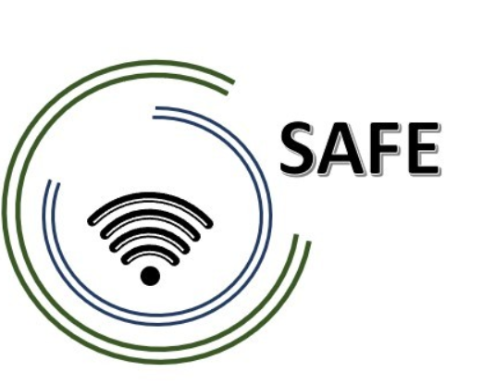
SAFE
Streaming Approaches for Europe
Enhancing the digital competences by streaming approaches for schools to tackle the challenges of COVID-19

Online article 1 (EN)
UPB, Sebastian Koppius

Project Title: Streaming Approaches for Europe - Enhancing the digital competences by streaming approaches for schools to tackle the challenges of COVID-19
Acronym: SAFE
Reference number: 2020-1-DE03-KA226-SCH-093590
Aktenzeichen der NA: VG-226-IN-NW-20-24-093590
Project partners: P0 – UPB – University Paderborn, DE (Coordinator)
P1 – IK – Ingenious Knowlegde, DE (Partner)
P2 – CEIP – CEIP Tomás Romojaro, ES (Partner)
P3 – ZEBRA – KURZY ZEBRA s.r.o., CZ (Partner)

Streaming Meets School - The Erasmus+ Project SAFE
Whether schooling at home, in separate classrooms or in hybrid learning, the COVID-19 pandemic illustrates the lack of digital competences in school classrooms. – The SAFE project tries to learn from the experience of COVID-19 and take a step forward in the digital classroom.
Without doubt, all levels of schools, i.e. primary, secondary and upper secondary level, were affected by contact restrictions and associated digital teaching in the wake of the COVID-19 pandemic and faced the challenge of teaching in online formats.
Lack of technical resources, lack of know-how and no didactic concepts for implementing eLearning in the classroom brought many teachers to despair. The challenge of the pandemic often led to teachers being overwhelmed, so that lessons were sometimes cancelled or progressed only very slowly - also to the chagrin of the pupils.
This is where the Erasmus+ project SAFE ("Streaming approaches for Europe – Enhancing the digital competences by streaming approaches for schools to tackle the challenges of COVID-19"), funded by the European Union, comes in. The project focuses on the use of streaming in school education.
The main objective of the SAFE project is to create a basic concept for the integration of eLearning into daily teaching work. In this basic concept, teachers use tablets or laptops on which, for example, Blackboard applications such as LiveBoard, Doceri or Explain Everythings are streamed. Learners can thus participate in class despite physical separation by streaming the voices of the classroom and the Blackboard application. Nevertheless, the SAFE project wants to offer online teacher training for the successful implementation of streaming approaches.
The basis for the SAFE streaming concept is the DISK online model by Beutner and Peuchel. DISK-Online stands for Didactic Interactive Streaming Know-how and enables a reflective use of streaming applications in relation to the level of interaction between teacher and students. The DISK online model ranges in four levels from DISK 1 (low teacher-centred interaction) to DISK 4 (learner-centred interaction).
The 24-month project (funding period 01.03.2021 – 28.02.2023) is coordinated by the University of Paderborn in Germany and represented by Prof. Dr. Marc Beutner. The other three European project partners are: Ingenious Knowledge GmbH (Germany), CEIP Tomas Romojaro (Spain), and KURZY ZEBRA s.r.o. (CZ).
What are the main objectives?
- Research on acceptance of eLearning and streaming in school education in times of COVID-19
- Development of the streaming concept for schools
- Providing teacher training course on Streamlabs OBS and use of streaming platforms
- Implementation and evaluation of the streaming concept at schools in Europe
- Creation of streaming videos, didactic materials
- Creating the teacher handbook on the eLearning approach and the Safe Streaming-in-School-Education-book
- Creation of policy paper and layman’s reports

What are the project aims to produce?

Based on the main objectives, the following aims are to produce:

(1) SAFE Curriculum based on a SAFE-Learning Outcome Matrix
(2) Streaming concept for School Education in Europe
(3) Online teacher training course on streaming and hybrid learning in school education
(4) SAFE teacher handbook
(5) SAFE policy paper
(6) SAFE Website with all information about the project
(7) SAFE didactic materials for use in schools and SAFE streaming videos with insights in existing streaming scenarios
(8) SAFE research report on the use of eLearning, hybrid learning and acceptance in schools in Europe
(9) SAFE publications in press, newspapers, journals and scientific texts
(10) SAFE Social media presence
(11) SAFE Disseminations materials
(12) SAFE Newsletter
(13) SAFE event reports

What has already happened?
Prior to the first project meeting, all partners will conduct an acceptance study on the use of eLearning and streaming tools in times of the COVID-19 pandemic in their respective region or representative for their country.

What are the next steps?
The SAFE kick-off meeting will start in early July and will be hosted online by the project coordinator (University of Paderborn). In addition to organisational activities and getting to know each other, the meeting will focus on the respective acceptance study and its country-specific experience reports. The results form the basis for the development of the streaming concept and the associated project goals. The project consortium regularly carries out dissemination and dissemination activities.

How can you contact SAFE?
Visit our website https://safe.eduproject.eu/ or contact the project partner in your home country directly!

