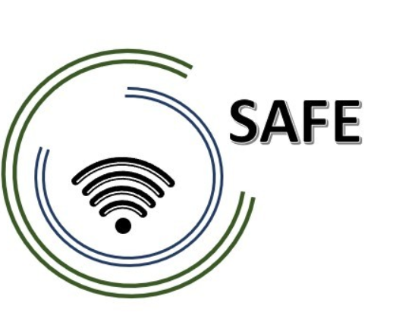
SAFE
Streaming Approaches for Europe
Reference Number:
2020-1-DE03-KA226-SCH-093590
Aktenzeichen der NA:
VG-226-IN-NW-20-24-093590

Title xxxx
May 2021

University of Paderborn
Jennifer Schneider

Project Title: Streaming Approaches for Europe
Acronym: SAFE
Reference number: 2020-1-DE03-KA226-SCH-093590
Aktenzeichen der NA: VG-226-IN-NW-20-24-093590
Project partners: P0 – UPB – University Paderborn, DE (Coordinator)
P1 – IK – Ingenious Knowlegde, DE (Partner)
P2 – CEIP – CEIP Tomás Romojaro, ES (Partner)
P3 – ZEBRA – KURZY ZEBRA s.r.o., CZ (Partner)

