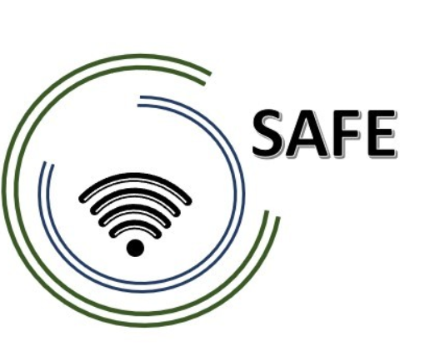
SAFE
Streaming Approaches for Europe
Reference Number:
2020-1-DE03-KA226-SCH-093590
Aktenzeichen der NA:
VG-226-IN-NW-20-24-093590

Social Media Roster
May 2021

University of Paderborn
Jennifer Schneider

Project Title: Streaming Approaches for Europe
Acronym: SAFE
Reference number: 2020-1-DE03-KA226-SCH-093590
Aktenzeichen der NA: VG-226-IN-NW-20-24-093590
Project partners: P0 – UPB – University Paderborn, DE (Coordinator)
P1 – IK – Ingenious Knowlegde, DE (Partner)
P2 – CEIP – CEIP Tomás Romojaro, ES (Partner)
P3 – ZEBRA – KURZY ZEBRA s.r.o., CZ (Partner)

German Project Facebook page: https://www.facebook.com/Streaming-approaches-for-Europe-SAFE-108662398112969/?ref=pages_you_manage

Month | Organisation | Tasks
June 2021 | UPB | Approx. 3 uploads/ posts and 10 Likes
July 2021 | CEIP | Approx. 3 uploads/ posts and 10 Likes
August 2021 | ZEBRA | Approx. 3 uploads/ posts and 10 Likes
September 2021 | UPB | Approx. 3 uploads/ posts and 10 Likes
October 2021 | CEIP | Approx. 3 uploads/ posts and 10 Likes
November 2021 | ZEBRA | Approx. 3 uploads/ posts and 10 Likes
December 2021 | UPB | Approx. 3 uploads/ posts and 10 Likes
January 2022 | CEIP | Approx. 3 uploads/ posts and 10 Likes
February 2022 | ZEBRA | Approx. 3 uploads/ posts and 10 Likes
March 2022 | UPB | Approx. 3 uploads/ posts and 10 Likes
April 2022 | CEIP | Approx. 3 uploads/ posts and 10 Likes
May 2022 | ZEBRA | Approx. 3 uploads/ posts and 10 Likes
June 2022 | UPB | Approx. 3 uploads/ posts and 10 Likes
July 2022 | CEIP | Approx. 3 uploads/ posts and 10 Likes
August 2022 | ZEBRA | Approx. 3 uploads/ posts and 10 Likes
September 2022 | UPB | Approx. 3 uploads/ posts and 10 Likes
October 2022 | CEIP | Approx. 3 uploads/ posts and 10 Likes
November 2022 | ZEBRA | Approx. 3 uploads/ posts and 10 Likes
December 2022 | UPB | Approx. 3 uploads/ posts and 10 Likes
January 2023 | CEIP | Approx. 3 uploads/ posts and 10 Likes
February 2023 | ZEBRA | Approx. 3 uploads/ posts and 10 Likes
March 2023 | UPB | Approx. 3 uploads/ posts and 10 Likes
All Partners will post Dez. 2020 till the end of the project lifetime | UPB / CEIP/ ZEBRA | Approx. 3 uploads/ posts and 10 Likes

