SAFE -Streaming approaches for Europe -
Enhancing the digital competences by streaming approaches for schools to tackle the challenges of COVID-19
Dissemination log
ZEBRA

Project Title: Streaming approaches for Europe -
Enhancing the digital competences by streaming approaches for schools to tackle the challenges of COVID-19
Acronym: SAFE
Reference number: 2020-1-DE03-KA226-SCH-093590
Aktenzeichen der NA: VG-226-IN-NW-20-24-093590

Project partners: P0 – UPB – University Paderborn, DE (Coordinator)
P1 – IK – Ingenious Knowlegde, DE (Partner)
P2 – CEIP – CEIP Tomás Romojaro, ES (Partner)
P3 – ZEBRA – KURZY ZEBRA s.r.o., CZ (Partner)

PARTNER: KURZY ZEBRA s.r.o.
ONLINE
Publishing info/news on project’s website
Titles, short description, names, web-addresses etc. | Date and Place: |  | Target Group(s): |  | Numbers Reached: |  | Kind of documentation available | Level (L = local; R = regional; N = national; E = EU; O = Outside EU )
Czech SAFE-Project website | Feb 2022 |  | Teachers, Learners, interested persons trainees, students |  | Approx. 100  persons per month |  | 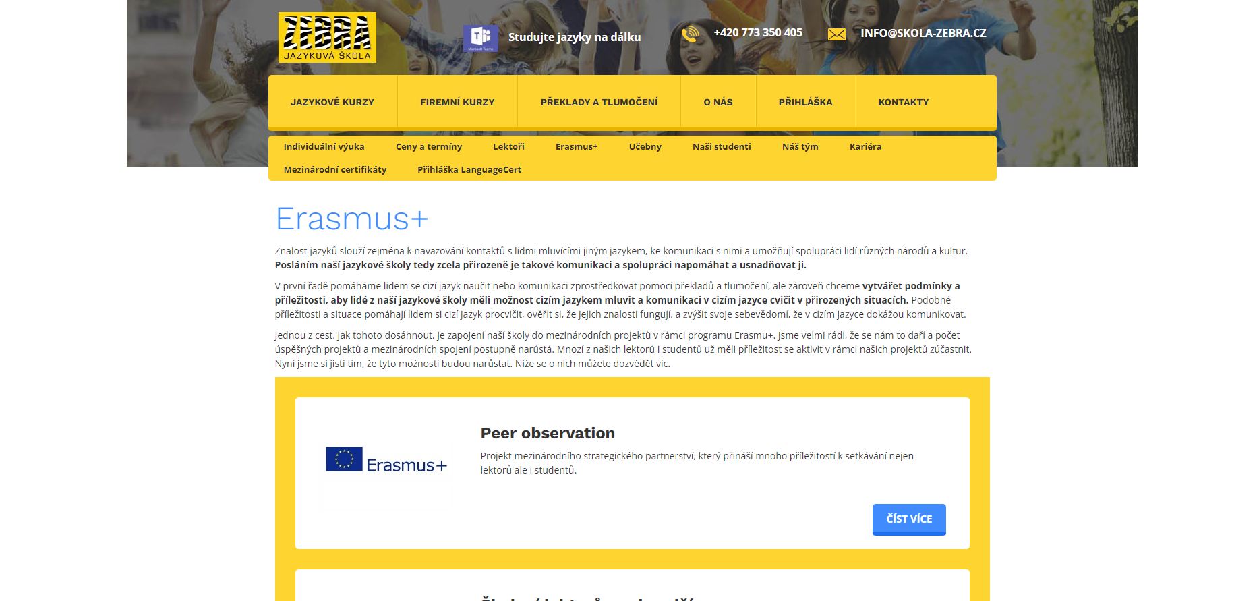  https://www.skola-zebra.cz/erasmus | L, R, N, EU
Establishment of relevant links to the SAFE website from other sites
Titles, short description, names, web-addresses etc. |  | Date and Place: |  | Target Group(s): |  | Numbers Reached: | Kind of documentation available | Level (L = local; R = regional; N = national; E = EU; O = Outside EU )
Presentation of SAFE project on School website  Information of project |  | xxxxx |  | Teachers, Learners, interested persons trainees, students |  | Approx. 100 persons per month | 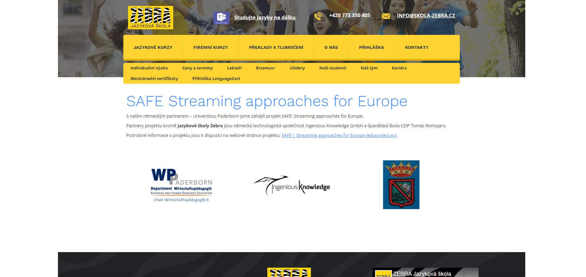  https://www.skola-zebra.cz/safe-streaming-approaches-for-europe | L, R, N, EU
Distribution of digital newsletters, announcements, and info via e-mail
Titles, short description, names, web-addresses etc. |  | Date and Place: |  | Target Group(s): |  | Numbers Reached: | Kind of documentation available | Level (L = local; R = regional; N = national; E = EU; O = Outside EU )
1st Leaflet (Czech version)  Information about project |  | 15.09.2021 |  | Teachers, Learners, interested persons trainees, students |  | Approx. 50 | 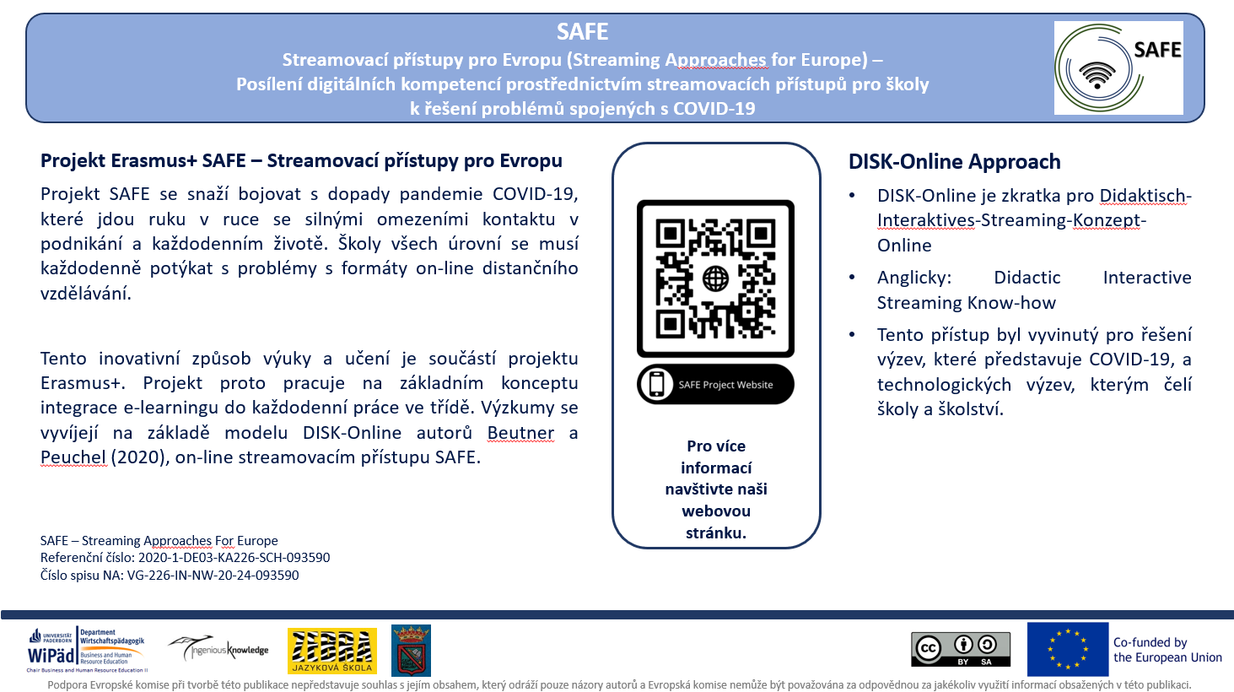 | L, R, N, EU
Use of online social networks to disseminate SAFE info
Titles, short description, names, web-addresses etc. |  | Date and Place: |  | Target Group(s): |  | Numbers Reached: | Kind of documentation available | Level (L = local; R = regional; N = national; E = EU; O = Outside EU )
Post on Instagram  Information about project and Kick-Off Conference |  | 18.08.2021 |  | Teachers, Learners, interested persons trainees, students |  | Approx. 50 persons per month | 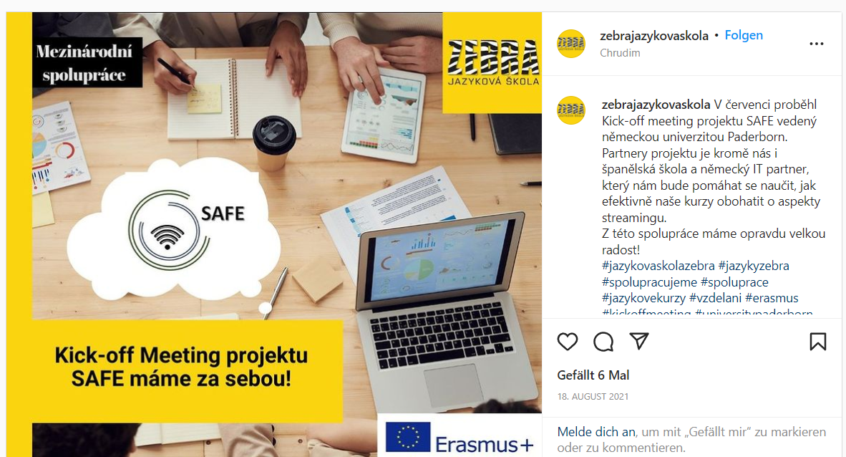  https://www.instagram.com/p/CStVDY7N-tz/ | L, R, N
Post on Instagram  Information about project and Kick-Off Conference |  | 03.08.2021 |  | Teachers, Learners, interested persons trainees, students |  | Approx. 50 persons per month | 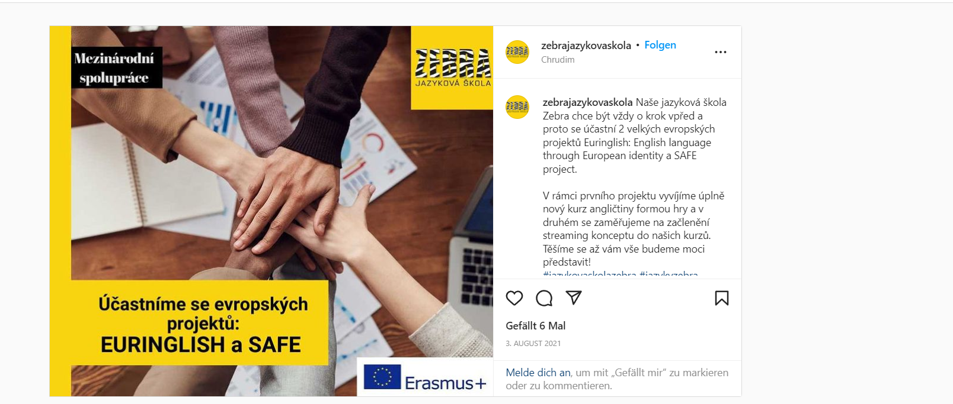  https://www.instagram.com/p/CSGuPfjrkGc/ | L, R, N
Post on ZEBRA Jazyková škola Facebook – Page  Information about project and 1st Newsletter |  | 03.08.2021 |  | Teachers, Learners, interested persons trainees, students |  | Approx. 50 persons per month | 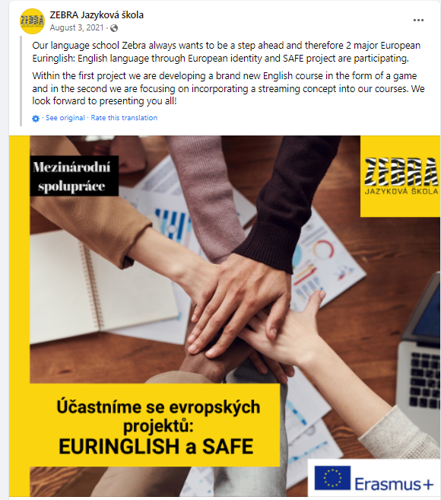  https://www.facebook.com/permalink.php?story_fbid=2274428796021671&id=273795812751656 | L, R, N, EU
Post on ZEBRA Jazyková škola Facebook – Page  Information about project and 1st Newsletter |  | 17.08.2021 |  | Teachers, Learners, interested persons trainees, students |  | Approx. 50 persons per month | 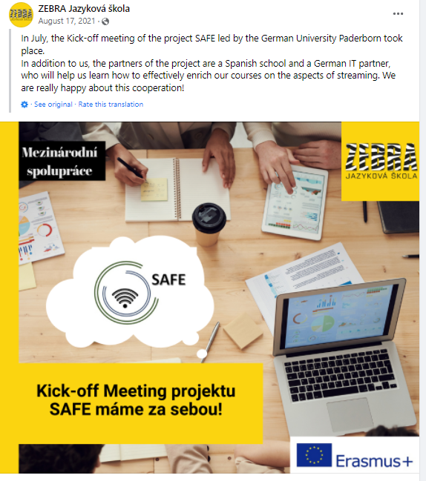  https://www.facebook.com/permalink.php?story_fbid=2274428796021671&id=273795812751656 | L, R, N, EU
Other types of online activities/actions:

Titles, short description, names, web-addresses etc. | Date and Place: | Target Group(s): | Numbers Reached: | Kind of documentation available | Level (L = local; R = regional; N = national; E = EU; O = Outside EU )

PRINT
Distribution of print material and SAFE products at conferences, and meetings,events, etc.
Titles, short description, names, web-addresses etc. |  | Date and Place: |  | Target Group(s): |  | Numbers Reached: | Kind of documentation available | Level (L = local; R = regional; N = national; E = EU; O = Outside EU )
Publishing of SAFE info in newsletters, newspapers, magazines, etc.
Titles, short description, names, web-addresses etc. |  | Date and Place: |  | Target Group(s): |  | Numbers Reached: | Kind of documentation available | Level (L = local; R = regional; N = national; E = EU; O = Outside EU )
Publishing of articles in local and international journals
Titles, short description, names, web-addresses etc. |  | Date and Place: |  | Target Group(s): |  | Numbers Reached: | Kind of documentation available | Level (L = local; R = regional; N = national; E = EU; O = Outside EU )
1st online Article (Czech version) |  | XXXXX |  | Teachers, Learners, interested persons trainees, students |  | Approx. 50 persons per month | 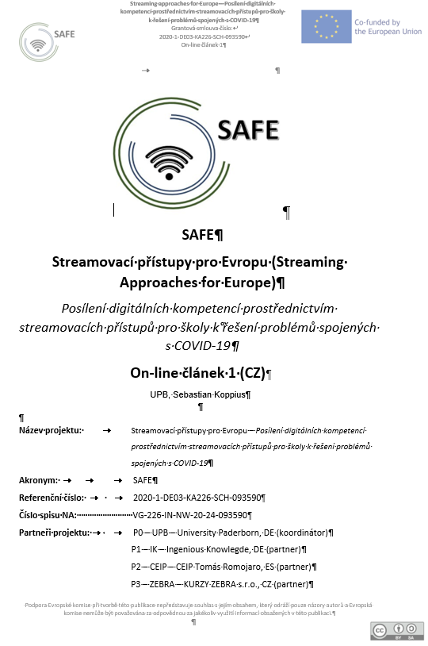 | L, R, N, EU
Distribution of info letters and invitations via regular mail
Titles, short description, names, web-addresses etc. |  | Date and Place: |  | Target Group(s): |  | Numbers Reached: | Kind of documentation available | Level (L = local; R = regional; N = national; E = EU; O = Outside EU )
Other print activities/actions:

Titles, short description, names, web-addresses etc. |  | Date and Place: |  | Target Group(s): |  | Numbers Reached: | Kind of documentation available | Level (L = local; R = regional; N = national; E = EU; O = Outside EU )
FACE-TO-FACE
Organised conferences
Titles, short description, names, web-addresses etc. |  | Date and Place: |  | Target Group(s): |  | Numbers Reached: | Kind of documentation available | Level (L = local; R = regional; N = national; E = EU; O = Outside EU )
Organised seminars, workshops, panels, symposia, etc.
Titles, short description, names, web-addresses etc. |  | Date and Place: |  | Target Group(s): |  | Numbers Reached: | Kind of documentation available | Level (L = local; R = regional; N = national; E = EU; O = Outside EU )
Presentations in local and international conferences
Titles, short description, names, web-addresses etc. |  | Date and Place: |  | Target Group(s): |  | Numbers Reached: | Kind of documentation available | Level (L = local; R = regional; N = national; E = EU; O = Outside EU )
Meetings with VET staff, teachers, VET trainees etc.
Titles, short description, names, web-addresses etc. |  | Date and Place: |  | Target Group(s): |  | Numbers Reached: | Kind of documentation available | Level (L = local; R = regional; N = national; E = EU; O = Outside EU )
Organised exhibitions of IDEAL GAME material
Titles, short description, names, web-addresses etc. |  | Date and Place: |  | Target Group(s): |  | Numbers Reached: | Kind of documentation available | Level (L = local; R = regional; N = national; E = EU; O = Outside EU )
Utilisation of project products in relevant settings
Titles, short description, names, web-addresses etc. |  | Date and Place: |  | Target Group(s): |  | Numbers Reached: | Kind of documentation available | Level (L = local; R = regional; N = national; E = EU; O = Outside EU )
Demonstrations of project material to stakeholders
Titles, short description, names, web-addresses etc. |  | Date and Place: |  | Target Group(s): |  | Numbers Reached: | Kind of documentation available | Level (L = local; R = regional; N = national; E = EU; O = Outside EU )
Other face-to-face activities/actions:

Other dissemination activities:

