SAFE -Streaming approaches for Europe -
Enhancing the digital competences by streaming approaches for schools to tackle the challenges of COVID-19
Dissemination log
CEIP

Project Title: Streaming approaches for Europe -
Enhancing the digital competences by streaming approaches for schools to tackle the challenges of COVID-19
Acronym: SAFE
Reference number: 2020-1-DE03-KA226-SCH-093590
Aktenzeichen der NA: VG-226-IN-NW-20-24-093590

Project partners: P0 – UPB – University Paderborn, DE (Coordinator)
P1 – IK – Ingenious Knowlegde, DE (Partner)
P2 – CEIP – CEIP Tomás Romojaro, ES (Partner)
P3 – ZEBRA – KURZY ZEBRA s.r.o., CZ (Partner)

PARTNER: – CEIP Tomás Romojaro
ONLINE
Publishing info/news on project’s website
Titles, short description, names, web-addresses etc. | Date and Place: |  | Target Group(s): |  | Numbers Reached: |  | Kind of documentation available | Level (L = local; R = regional; N = national; E = EU; O = Outside EU )
Spanish SAFE-Project website | Feb 2022 |  | Teachers, Learners, interested persons trainees, students |  | Approx. 100  persons per month |  | 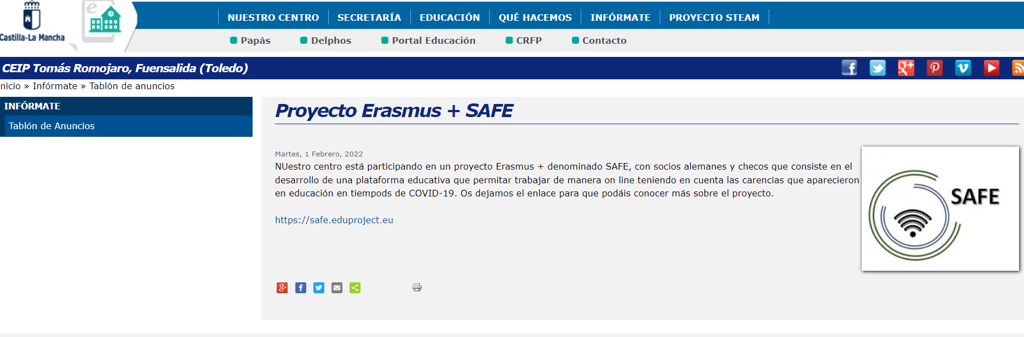  http://ceip-tomasromojaro.centros.castillalamancha.es/anuncios/proyecto-erasmus-safe | L, R, N, EU
Establishment of relevant links to the SAFE website from other sites
Titles, short description, names, web-addresses etc. |  | Date and Place: |  | Target Group(s): |  | Numbers Reached: | Kind of documentation available | Level (L = local; R = regional; N = national; E = EU; O = Outside EU )
Distribution of digital newsletters, announcements, and info via e-mail
Titles, short description, names, web-addresses etc. |  | Date and Place: |  | Target Group(s): |  | Numbers Reached: | Kind of documentation available | Level (L = local; R = regional; N = national; E = EU; O = Outside EU )
1st Leaflet (Spanish)  Information about project |  | 09.08.2021 |  | Teachers, Learners, interested persons trainees, students t |  | Approx. 50 | 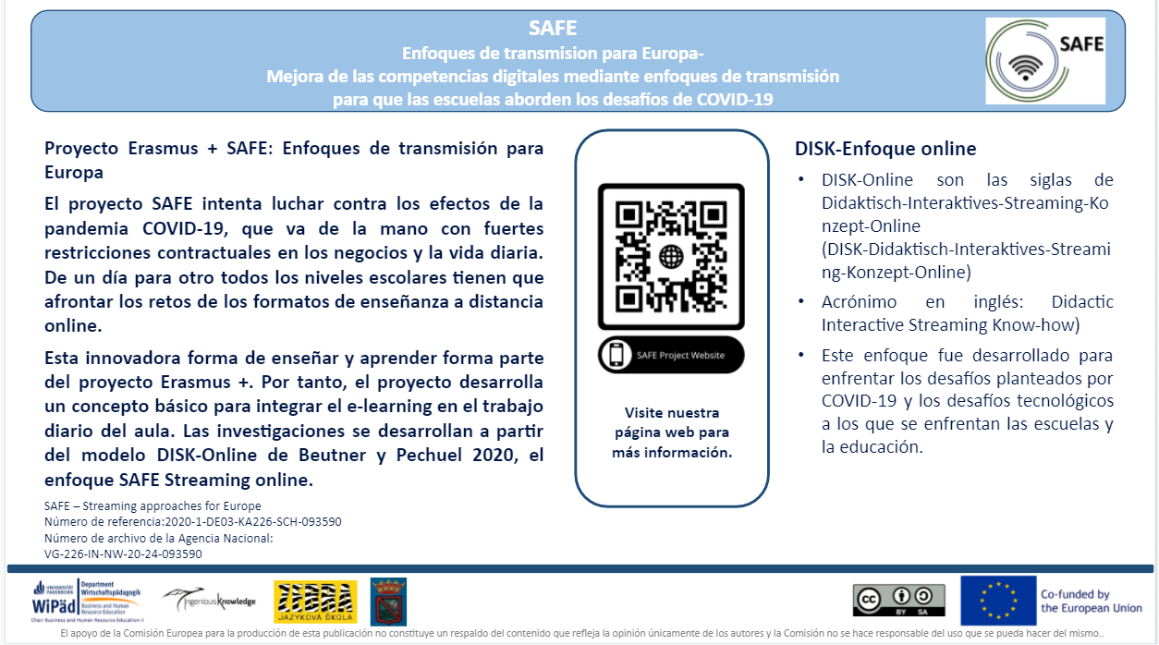 | L, R
Use of online social networks to disseminate SAFE info
Titles, short description, names, web-addresses etc. |  | Date and Place: |  | Target Group(s): |  | Numbers Reached: | Kind of documentation available | Level (L = local; R = regional; N = national; E = EU; O = Outside EU )
Post on Ceip Tomas Romojaro Facebook – Page  Information about project |  | 01.02.2022 |  | Teachers, Learners, interested persons trainees, students |  | Approx. 50 persons per month | 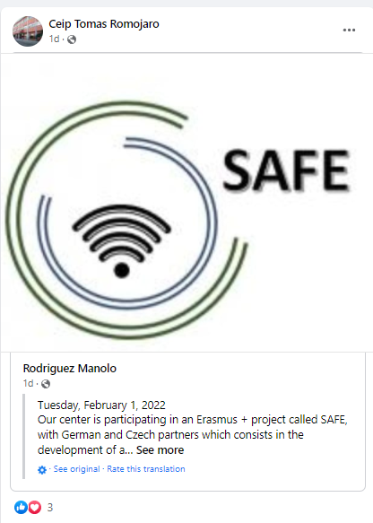  https://www.facebook.com/profile.php?id=100019538765984 | L, R, N, EU
Post on Ceip Tomas Romojaro Facebook – Page  Information about 2nd TPM |  | 01.02.2022 |  | Teachers, Learners, interested persons trainees, students |  | Approx. 50 persons per month | 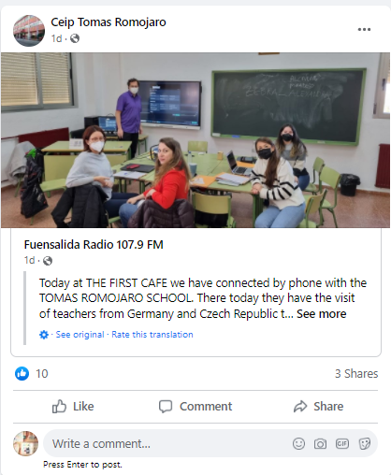  https://www.facebook.com/profile.php?id=100019538765984 | L, R, N, EU
Other types of online activities/actions:

Titles, short description, names, web-addresses etc. | Date and Place: | Target Group(s): | Numbers Reached: | Kind of documentation available | Level (L = local; R = regional; N = national; E = EU; O = Outside EU )

PRINT
Distribution of print material and SAFE products at conferences, and meetings,events, etc.
Titles, short description, names, web-addresses etc. |  | Date and Place: |  | Target Group(s): |  | Numbers Reached: | Kind of documentation available | Level (L = local; R = regional; N = national; E = EU; O = Outside EU )
Distribution of posters in the school |  | XXXX |  | Teachers, Learners, interested persons trainees, students |  | Approx. 100 persons | 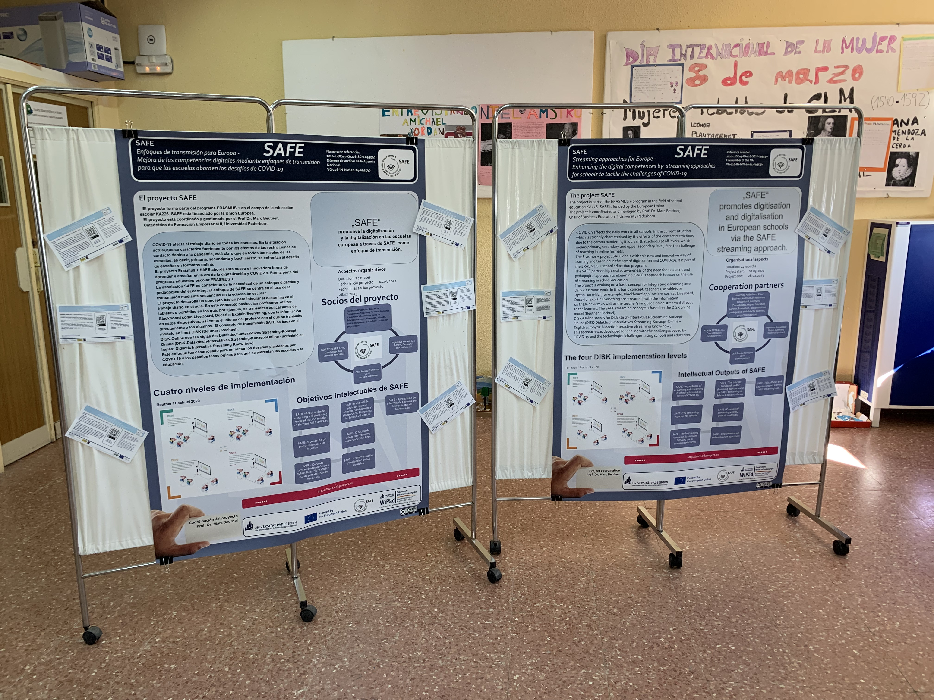 | L, R
Publishing of SAFE info in newsletters, newspapers, magazines, etc.
Titles, short description, names, web-addresses etc. |  | Date and Place: |  | Target Group(s): |  | Numbers Reached: | Kind of documentation available | Level (L = local; R = regional; N = national; E = EU; O = Outside EU )
Publishing of articles in local and international journals
Titles, short description, names, web-addresses etc. |  | Date and Place: |  | Target Group(s): |  | Numbers Reached: | Kind of documentation available | Level (L = local; R = regional; N = national; E = EU; O = Outside EU )
1st online Article (Spanish Version) |  | 09.08.2021 |  | Teachers, Learners, interested persons trainees, students t |  | Approx. 50 persons per month | 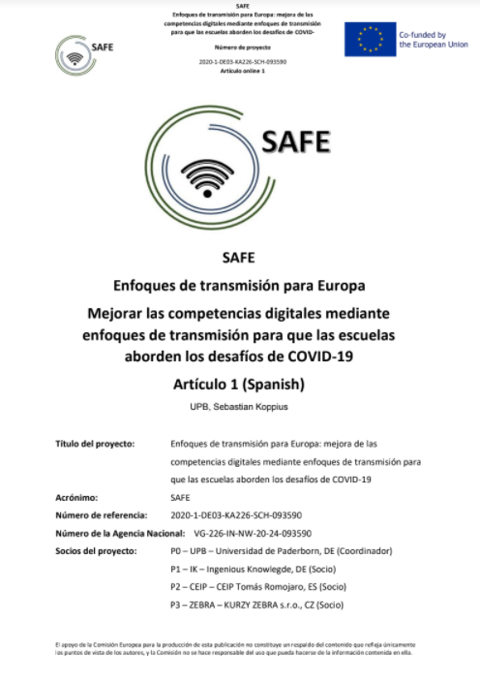 | L, R, N, EU
Distribution of info letters and invitations via regular mail
Titles, short description, names, web-addresses etc. |  | Date and Place: |  | Target Group(s): |  | Numbers Reached: | Kind of documentation available | Level (L = local; R = regional; N = national; E = EU; O = Outside EU )
1st Poster (Spanish)  - Information about project |  | 09.08.2021 |  | Teachers, Learners, interested persons trainees, students t |  | Approx. 50 | 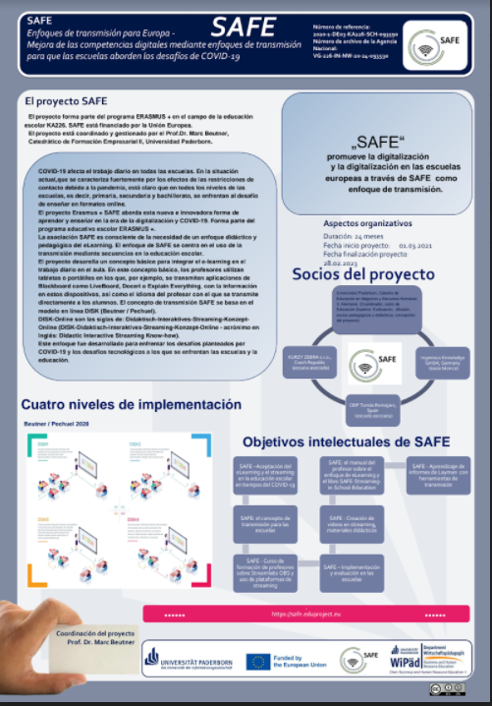 | L, R
Other print activities/actions:

Titles, short description, names, web-addresses etc. |  | Date and Place: |  | Target Group(s): |  | Numbers Reached: | Kind of documentation available | Level (L = local; R = regional; N = national; E = EU; O = Outside EU )
FACE-TO-FACE
Organised conferences
Titles, short description, names, web-addresses etc. |  | Date and Place: |  | Target Group(s): |  | Numbers Reached: | Kind of documentation available | Level (L = local; R = regional; N = national; E = EU; O = Outside EU )
Organised seminars, workshops, panels, symposia, etc.
Titles, short description, names, web-addresses etc. |  | Date and Place: |  | Target Group(s): |  | Numbers Reached: | Kind of documentation available | Level (L = local; R = regional; N = national; E = EU; O = Outside EU )
Presentations in local and international conferences
Titles, short description, names, web-addresses etc. |  | Date and Place: |  | Target Group(s): |  | Numbers Reached: | Kind of documentation available | Level (L = local; R = regional; N = national; E = EU; O = Outside EU )
Presenting the project in the local radio in Fuensalida |  | 22.02.2022 |  | Teachers, Learners, interested persons trainees, students, Inhabitants |  | Approx. 500 | 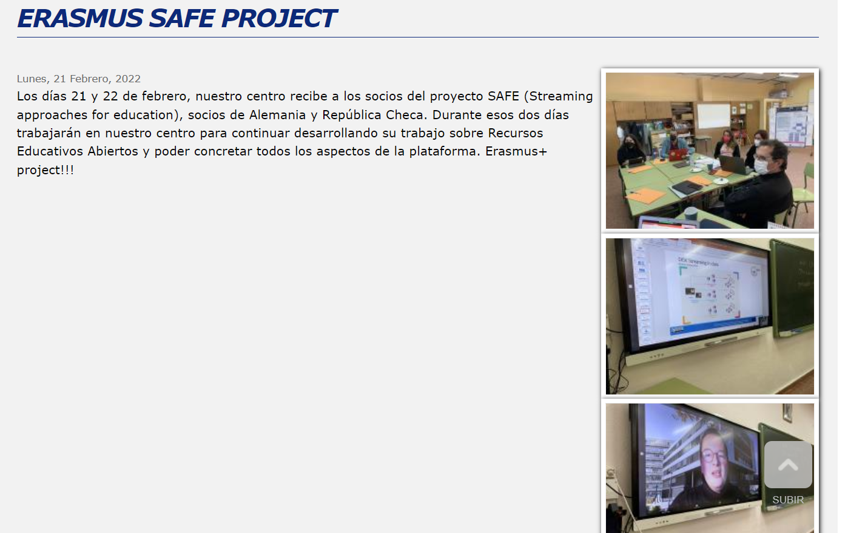  http://ceip-tomasromojaro.centros.castillalamancha.es/anuncios/erasmus-safe-project | L,R
Meetings with VET staff, teachers, VET trainees etc.
Titles, short description, names, web-addresses etc. |  | Date and Place: |  | Target Group(s): |  | Numbers Reached: | Kind of documentation available | Level (L = local; R = regional; N = national; E = EU; O = Outside EU )
Organised exhibitions of IDEAL GAME material
Titles, short description, names, web-addresses etc. |  | Date and Place: |  | Target Group(s): |  | Numbers Reached: | Kind of documentation available | Level (L = local; R = regional; N = national; E = EU; O = Outside EU )
Utilisation of project products in relevant settings
Titles, short description, names, web-addresses etc. |  | Date and Place: |  | Target Group(s): |  | Numbers Reached: | Kind of documentation available | Level (L = local; R = regional; N = national; E = EU; O = Outside EU )
Demonstrations of project material to stakeholders
Titles, short description, names, web-addresses etc. |  | Date and Place: |  | Target Group(s): |  | Numbers Reached: | Kind of documentation available | Level (L = local; R = regional; N = national; E = EU; O = Outside EU )
Other face-to-face activities/actions:

Other dissemination activities:

