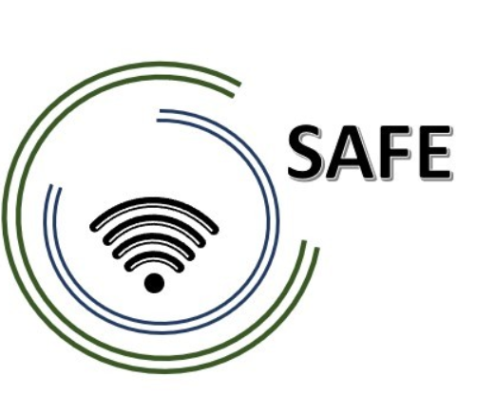
SAFE
Streaming Approaches for Europe
Reference Number:
2020-1-DE03-KA226-SCH-093590
Aktenzeichen der NA:
VG-226-IN-NW-20-24-093590

Dissemination Report Template
May 2021

University of Paderborn
Jennifer Schneider

Project Title: Streaming Approaches for Europe
Acronym: SAFE
Reference number: 2020-1-DE03-KA226-SCH-093590
Aktenzeichen der NA: VG-226-IN-NW-20-24-093590
Project partners: P0 – UPB – University Paderborn, DE (Coordinator)
P1 – IK – Ingenious Knowlegde, DE (Partner)
P2 – CEIP – CEIP Tomás Romojaro, ES (Partner)
P3 – ZEBRA – KURZY ZEBRA s.r.o., CZ (Partner)
Please fill in your dissemination activities and archive your work with screenshots (see example)

PARTNER: XXX
ONLINE
Publishing info/news on project’s website
Titles, short description, names, web-addresses etc. |  |  | Date and Place: |  |  |  | Target Group(s): |  | Numbers Reached: | Kind of documentation available |  |  | Level (L = local; R = regional; N = national; E = EU; O = Outside EU )
New poster are available |  |  | 11.06.2021  On Facebook |  |  |  | All interested readers, teachers, learners and students |  | >500 | … |  |  | L/ R/ N/ E
Establishment of relevant links to the SAFE website from other sites
Titles, short description, names, web-addresses etc. | Date and Place: |  |  |  | Target Group(s): |  |  | Numbers Reached: |  | Kind of documentation available |  |  | Level (L = local; R = regional; N = national; E = EU; O = Outside EU )
Distribution of digital newsletters, announcements, and info via e-mail
Titles, short description, names, web-addresses etc. | Date and Place: |  |  |  | Target Group(s): |  |  | Numbers Reached: |  | Kind of documentation available |  |  | Level (L = local; R = regional; N = national; E = EU; O = Outside EU )
Use of online social networks to disseminate SAFE info
Titles, short description, names, web-addresses etc. | Date and Place: |  |  |  | Target Group(s): |  |  | Numbers Reached: |  | Kind of documentation available |  |  | Level (L = local; R = regional; N = national; E = EU; O = Outside EU )
Other types of online activities/actions:
Titles, short description, names, web-addresses etc. |  | Date and Place: |  | Target Group(s): |  |  |  | Numbers Reached: |  |  | Kind of documentation available | Level (L = local; R = regional; N = national; E = EU; O = Outside EU )
PRINT
Distribution of print material and SAFE products at conferences, and meetings, events, etc.
Titles, short description, names, web-addresses etc. | Date and Place: |  |  |  | Target Group(s): |  |  | Numbers Reached: |  | Kind of documentation available |  |  | Level (L = local; R = regional; N = national; E = EU; O = Outside EU )
Publishing of SAFE info in newsletters, newspapers, magazines, etc.
Titles, short description, names, web-addresses etc. | Date and Place: |  |  |  | Target Group(s): |  |  | Numbers Reached: |  | Kind of documentation available |  |  | Level (L = local; R = regional; N = national; E = EU; O = Outside EU )
Publishing of articles in local and international journals
Titles, short description, names, web-addresses etc. | Date and Place: |  |  |  | Target Group(s): |  |  | Numbers Reached: |  | Kind of documentation available |  |  | Level (L = local; R = regional; N = national; E = EU; O = Outside EU )
Distribution of info letters and invitations via regular mail
Titles, short description, names, web-addresses etc. | Date and Place: |  |  |  | Target Group(s): |  |  | Numbers Reached: |  | Kind of documentation available |  |  | Level (L = local; R = regional; N = national; E = EU; O = Outside EU )
Other print activities/actions:

FACE-TO-FACE
Organised conferences
Titles, short description, names, web-addresses etc. | Date and Place: |  |  |  | Target Group(s): |  |  | Numbers Reached: |  | Kind of documentation available |  |  | Level (L = local; R = regional; N = national; E = EU; O = Outside EU )
Organised seminars, workshops, panels, symposia, etc.
Titles, short description, names, web-addresses etc. | Date and Place: |  |  |  | Target Group(s): |  |  | Numbers Reached: |  | Kind of documentation available |  |  | Level (L = local; R = regional; N = national; E = EU; O = Outside EU )
Presentations in local and international conferences
Titles, short description, names, web-addresses etc. | Date and Place: |  |  |  | Target Group(s): |  |  | Numbers Reached: |  | Kind of documentation available |  |  | Level (L = local; R = regional; N = national; E = EU; O = Outside EU )
Meetings with existing NGO leaders, potential new NGO leaders, local stakeholders, authorities, etc.
Titles, short description, names, web-addresses etc. | Date and Place: |  |  |  | Target Group(s): |  |  | Numbers Reached: |  | Kind of documentation available |  |  | Level (L = local; R = regional; N = national; E = EU; O = Outside EU )
Organised exhibitions of SAFE material
Titles, short description, names, web-addresses etc. | Date and Place: |  |  |  | Target Group(s): |  |  | Numbers Reached: |  | Kind of documentation available |  |  | Level (L = local; R = regional; N = national; E = EU; O = Outside EU )
Utilisation of project products in relevant settings
Titles, short description, names, web-addresses etc. | Date and Place: |  |  |  | Target Group(s): |  |  | Numbers Reached: |  | Kind of documentation available |  |  | Level (L = local; R = regional; N = national; E = EU; O = Outside EU )
Demonstrations of project material to stakeholders
Titles, short description, names, web-addresses etc. | Date and Place: |  |  |  | Target Group(s): |  |  | Numbers Reached: |  | Kind of documentation available |  |  | Level (L = local; R = regional; N = national; E = EU; O = Outside EU )
Other face-to-face activities/actions:

Other dissemination activities:

