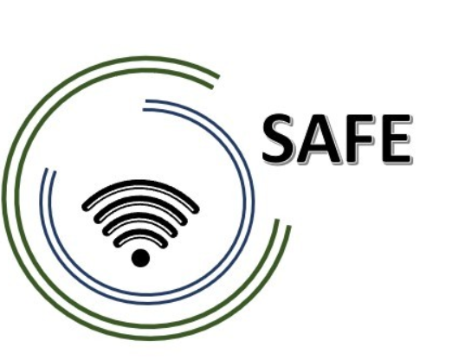
SAFE
Streaming Approaches for Europe
Reference Number:
2020-1-DE03-KA226-SCH-093590
Aktenzeichen der NA:
VG-226-IN-NW-20-24-093590

O4 SAFE – Implementation and evaluation at schools
March 2022

University of Paderborn
Jennifer Schneider

Project Title: Streaming Approaches for Europe
Acronym: SAFE
Reference number: 2020-1-DE03-KA226-SCH-093590
Aktenzeichen der NA: VG-226-IN-NW-20-24-093590
Project partners: P0 – UPB – University Paderborn, DE (Coordinator)
P1 – IK – Ingenious Knowlegde, DE (Partner)
P2 – CEIP – CEIP Tomás Romojaro, ES (Partner)
P3 – ZEBRA – KURZY ZEBRA s.r.o., CZ (Partner)
IO4 SAFE Implementation and evaluation at schools
Preface and background information regarding Intellectual Outcome 4

Regarding the cutting of several intellectual outcomes from the project approach of the ERASMUS+ Project SAFE, the consortium has to find a best solution to handle the reduction of costs without downgrade the entire project outcomes of the complete SAFE project.

Therefore, the consortium agreed to acquire the IO4 even without any further financial aids and to focus on one of two required implementations:

(a) The implementation of the teacher training course (here are teacher learning how to
handle streaming)

and

(b) The implementation of streaming in lessons with learners (here teachers implement the Streaming approach for schools in their lessons)

The consortium decided to focus on implementation of streaming in lessons with learners and evaluation at schools (b).

The idea behind (b) The implementation of streaming in lessons with learners
- teachers implement the Streaming approach for schools in their lessons

After teachers actively participated in the streaming course they will be able to do streaming on their own in their classes. The teachers will implement DISK1, DISK2, DISK3 or DISK4 or a specific adjustment of the DISK-online approach within their teaching.

The partners CEIP and ZEBRA implement the streaming approaches in their lessons with students and evaluated this with the following quantitative questionnaire.

Streaming Approach questionnaire
for learners and teachers

(Q1) Please select the group that is suitable for you

Code
1 | Teacher – Preschool
2 | Teacher – Primary School
3 | Teacher – Vocational education/ branch schools
4 | Learner – Preschool
5 | Learner – Primary School
6 | Learner – Vocational education/ branch schools

(Q2) You are:
Code
1 | male
2 | female
3 | diverse

(Q3) Age:
Code
1 | 6- 10 years
2 | 11- 14 years
3 | 15- 18 years
4 | 19-25 years
5 | 26-35 years
6 | 36-45 years
7 | 46-55 years
8 | 56- 65 years
9 | 66 years and older
(Q4) The region I live in is...
Code
1 | rural - completely rural
2 | rural - predominantly rural
3 | urban - metropolitan
4 | urban - medium urban
5 | urban - small town

(Q6) Working experience with Streaming like e.g. with Twitch, YouTube or Facebook live etc.:
Code
1 | Under one year
2 | 1 to 3 years
3 | 4 to 6 years
4 | 7 to 10 years
5 | More than 10 years

Using streaming platforms like Twitch…

 | Response options: | 1 | 2 | 3 | 4 | 5 | 6
 |  | Strongly disagree | Disagree | Somewhat disagree | Somewhat agree | Agree | Strongly agree
SQ001 | … makes me fun.
2 | … was easy for me.
3 | … helps me to work flexibly.
4 | .. makes it easier for me to exchange ideas with classmates and colleagues despite the physical distance.
5 | … is particularly suitable for recording learning content.

For me, the implementation of streaming approaches in my classroom was…

 | Response options: | 1 | 2 | 3 | 4 | 5 | 6
 |  | Strongly disagree | Disagree | Somewhat disagree | Somewhat agree | Agree | Strongly agree
SQ001 | … interesting.
2 | … motivating.
3 | … helpful.
4 | .. important.
5 | … easy to use in teaching.
6 | … easy to use in learning.

What are the opportunities of Streaming Approaches in Classrooms?

Opportunities of Streaming Approaches:

What are the challenges of Streaming Approaches in Classrom?

Challenges of Streaming Approaches

