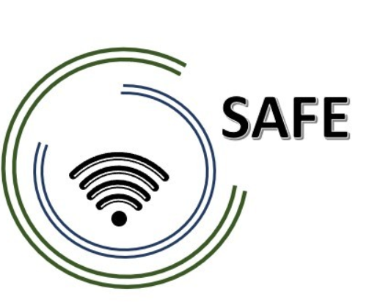
SAFE
Streaming Approaches for Europe
Reference Number:
2020-1-DE03-KA226-SCH-093590
Aktenzeichen der NA:
VG-226-IN-NW-20-24-093590

O1- A3 Desktop Research: Acceptance of Streaming
May 2021

University of Paderborn
Jennifer Schneider

Project Title: Streaming Approaches for Europe
Acronym: SAFE
Reference number: 2020-1-DE03-KA226-SCH-093590
Aktenzeichen der NA: VG-226-IN-NW-20-24-093590
Project partners: P0 – UPB – University Paderborn, DE (Coordinator)
P1 – IK – Ingenious Knowlegde, DE (Partner)
P2 – CEIP – CEIP Tomás Romojaro, ES (Partner)
P3 – ZEBRA – KURZY ZEBRA s.r.o., CZ (Partner)

Acceptance of Streaming – A desktop research

Table of content

(1) Acceptance of Streaming in partner countries 2
(2) Opportunities and Benefits of streaming approaches in learning and teaching environments 2
(3) Challenges and risks of streaming approaches in learning and teaching environments 2
(4) Teaching competences for streaming approaches 2

Acceptance of Streaming in partner countries
What streaming approaches are popular in your home country?

Opportunities and Benefits of streaming approaches in learning and teaching environments
What are opportunities of streaming approaches for learning and teaching?

Challenges and risks of streaming approaches in learning and teaching environments
What are challenges of streaming approaches for learning and teaching?

Teaching competences for streaming approaches
What competences has to be focused and supported by teacher education? Which competences are critical success factor for successful conclusion?

